Simple Diagnosis of Tropical Cyclone Structure via Pressure Gradients
John A. Knaff
NOAA/NESDIS Regional and Mesoscale Meteorology Branch
Fort Collins, Colorado

Patrick J. Fitzpatrick
Northern Gulf Institute
Mississippi State University
Stennis Space Center, Mississippi

Charles R. Sampson
Naval Research Laboratory
Monterey, CA

Yi Jin
Naval Research Laboratory
Monterey, CA

Christopher M. Hill
Geosystems Research Institute
Mississippi State UniversityStennis Space Center, Mississippi

Prepared for
Weather and Forecasting
Abstract

In 1980 the Holland tropical cyclone (TC) wind profile model was introduced. While originally intended to estimate the wind profile based on limited surface pressure information alone, the Holland B parameter, which determines the shape of the pressure gradient, can also serve as a powerful diagnostic tool for monitoring TC structure based on limited information. In this paper the Holland B parameter is introduced as a TC structure diagnostic and examples of its application are shown. Holland B has several beneficial qualities including its insensitivity to radius of maximum winds, its easy calculation from routinely available model output and historical datasets, and its ability to represent TC structure as a single parameter.

- Introduction
There are a number of situations where the diagnosis of tropical cyclone (TC) structure could be applied. Among these are quality control of real-time operational analysis provided by tropical cyclone warning centers (e.g., the National Hurricane Center), evaluations of model vortex initialization and studies of historical tropical cyclone records. Examination of surface wind field and pressure gradients within tropical cyclones is often complicated because it typically requires an accurate measure of the radii of maximum wind (RMW), which is difficult to diagnose without aircraft based reconnaissance (Mueller et al. 2006, Knaff and Zehr 2007, Knaff et al. 2007).
The Holland (1980) model, which estimates the wind field from parameters derived solely from the pressure field, was developed partly in response to issues with obtaining reliable RMW estimates. The Holland model assumes that the pressure gradient can be estimated using a family of rectangular hyperbolas, under the assumption of cyclostrophic balance. Furthermore, the shapes of the hyperbolas are independent of the radius of maximum winds. Two scaling parameters A and B can then be used to fit observed radial wind profiles associated with TCs. The Holland B parameter describes the shape of the pressure gradient and the Holland A parameter is a function of RMW and B. Most important for this study, is that the Holland Model wind fields are not as sensitive to the RMW as are those of other methods (e.g., the modified Rankine Vortex of Depperman 1947,Schwerdt 1979). Because of these reasons, the Holland Model has been used in risk modeling community as described in Vickery and Wadhera (2008). More information about this topic can be found in Holland (1980, 2008, 2010).
TC wind structures are estimated by several of the tropical cyclone warning centers worldwide. The US warning centers, which include the National Hurricane Center, the Central Pacific Hurricane Center and the Joint Typhoon Warning Center, routinely create a tropical cyclone structure or “bogus” that includes an estimate of location, maximum surface winds (MSW), central pressure (CP), radii of significant winds in quadrants (i.e., 34-, 50- and 64-kt winds) and the radii and pressure of the outer closed isobar (ROCI, POCI, respectively). The bogus information is specified early in the forecast process, in advance of the official advisory, and is used for initializing numerical weather prediction models and other forecast aids (see Rappaport and coauthors 2009).
How the bogus information is used by the individual models can differ substantially, but possibly more important to model diagnosis is assessing how well the model initialization represents the observed conditions, in this case information from the TC bogus. Despite the desire to diagnose the TC structure in models, TC wind structure (initializations and forecasts) from regional and mesoscale hurricane models and global models are often difficult to inter compare because they use different horizontal and vertical resolutions. In addition, as is the case in nature, the RMW is not only a function of resolution, but is difficult to diagnose and is not commonly included in routine model output. Common output from these models does however contain information about the MSW and the CP.
Similarly, historical records of TCs, best track files and extended best tracks (Demuth et al. 2006), contain information about the structure of the wind field. Some of these dataset contain estimates of RMW and slightly more reliable measures of radii of gale force winds (R34) in quadrants around the TC center. The most reliable information from these historical records is the MSWs as these are typically estimated by blending all the available information. However, these method are influenced by the use of satellite-based methods (Dvorak1984) with known accuracies (Knaff et al. 2010). CPs in best tracks are often assigned from look up tables (LUT) relating them to the MSW (Dvorak 1972, 1975, 1984). More reliable CPs (e.g., Knaff and Zehr 2007 and Courtney and Knaff 2009) can however be estimated from the MSW, latitude, translation speed, storm size and environmental pressure – all available in the historical records. Much like model output, the TC structure estimates in the historical records can be compiled in terms of estimated CPs and MSWs.
Using the MSW and estimates of CP, either directly from the model output or calculated from best track parameters, the structure of the TC can be diagnosed in terms of pressure gradients. The relative simplicity of the Holland Model has lead to its use in a number of applications where the wind profile is needed, but accurate measures of the wind field, particularly the RMW are not available. It is this characteristic of the Holland model, specifically the Holland B parameter that we propose as a simple diagnostic of pressure gradients and thus indirectly surface wind structure in TCs. How this diagnosis can be accomplished and applied is the focus of this paper. We will also demonstrate how a climatology of Holland B can be calculated using the Atlantic and East Pacific best tracks. We then demonstrate how this diagnostic may be used in operations to assist the estimation of bogus parameters, to evaluate model output and assess information in best track files from other basins. Few conclusions regarding differences between models and best tracks, which are treated anonymously, will be made as they are beyond the scope of this note.

- Diagnostic tools
  - Review of the Holland Model

Without going into great detail, the Holland Model that assumes that TC radial wind (V_{c}) profiles can be approximated as a family of rectangular hyperbolas in cyclostrophic balance and at a gradient level (1)
(1),
where r is the radius, Δp is the difference between the ambient or environmental pressure (EP) and the CP and A and B are scaling parameters. Solving for the radius of maximum wind (i.e., by setting dV_{c}/dr = 0), RMW can be found, as shown in (2).
(2)
According to Holland (1980) the RMW is independent of the relative values of EP and CP and is defined solely by the scaling parameters A and B. Substituting (2) into (1) an equation for V_{max} is obtained (3).
(3),
where e is the base of the natural logarithms and ρ is the air density. V_{srm} , in this case, is the maximum surface wind that does not include the effects of cyclone translation.
It is equation (3) that will be exploited to estimate the Holland B using estimates or observations of Δp and V_{srm}, and by assuming a constant ρ, as shown in (4).
(4)
Δp can be estimated from the CP and EP, and EP can be derived from the POCI information available in the working and final best tracks using EP= POCI + 2 hPa (see Courtney and Knaff 2009). MSW and positions are typically output by numerical weather prediction models (NWP) and is part of the post season best track estimates at many operational centers.

  - Review of Courtney and Knaff (2009)

Courtney and Knaff (CK09;2009) 1) adapted the results of Knaff and Zehr (KZ07; 2007) that related MSW to Δp as a function of latitude, translation speed, TC size, and EP to make use of routinely available (in operations) information to make estimates of EP and TC size and 2) modified the original KZ07 formula for storms located at low latitudes. The radius of gale force (i.e., 34-kt) winds (R34) were used to estimate TC size and the POCI is used to make an estimate of EP.
The Δp can be estimated using (5a) and (5b) given the latitude φ.

For φ < 18º
(5a)
For φ≥18º
(5b),
where V_{srm} is the storm relative MSW in units of kt (kt; where 1kt=0.514 ms⁻¹) defined by V_{srm}=MSW -1.5c^{0.63}, where c is the translation speed of the TC, S is a TC size parameter, and φ is degrees latitude. S is defined as the ratio of the azimuthal mean tangential wind at r=500 km (Vt₅₀₀) to the climatological value (Vt_{500c}). In CK09 the Vt₅₀₀ is estimated directly from the non-zero quadrant average of the R34, where Vt₅₀₀=R34/9 -3. CK09 applied a lower limit to S of 0.4 to ensure operational stability, here we will limit S calculated in this manner to 0.1, roughly 2 standard deviations of the KZ07 observations; allowing for very small TCs. Vt_{500c} is defined by (6), which comes from the Atlantic Basin climatology developed in the Knaff et al. (2007).

(6)

Since POCI, MSW, φ, c, and R34 are routinely available in the databases of the Automated Tropical Cyclone Forecast System (ATCF; Sampson and Schrader 2000), CP and Δp can be calculated, where CP= Δp+POCI+2 [hPa]. For model output Δp = CP - EP and for best track data an improved CP can be estimated from MSW, φ, c, and R34 using CK09. In both cases, the necessary information to estimate Holland B is available.

- Climatology of Holland B
To show how Holland B likely varies in nature and between basins, the Holland B parameter is estimated from the information available in the Atlantic and East Pacific best track data available in the ATCF. To estimate Holland B, the CK09 algorithm is used to estimate a CP and Δp as described in section 2.b. The storm relative maximum surface wind [i.e., V_{srm} in (3), (5a), and (5b)] is again calculated using the Schwerdt et al. (1979) asymmetry factor; subtracting 1.5c^{0.63} of the MSW, where c is the 6-hour translation speed and the units are kt. Using these best track estimates of V_{srm} and Δp, Holland B is estimated using (3). The results for the 2003-2009 Atlantic and East Pacific best tracks are shown in Figure 1.
A simple interpretation of Figure 1 would be that smaller and more intense TCs have larger pressure gradients and thus larger Holland B. It has been documented that TCs in the East Pacific are smaller (Knaff et al. 2007, Knaff et al. 2010), have smaller range of latitudes, and tend to have slower mean motions (Neumann 1993). In terms of Holland B there is also greater variability in the Atlantic basin when compared to the East Pacific. These differences can be explained in terms of climatology. In addition to the size differences, storms rarely recurve into the mid-latitudes in the East Pacific, but can maintain high intensities post recurvature in the Atlantic (Knaff 2009). TCs in the East Pacific remain at relatively low latitude (Neumann 1993, Blake et al. 2009), but rarely recurve into the mid-latitudes (Knaff 2009). Storms tend to grow and weaken as they move poleward (Merrill 1984, Knaff et al. 2007,Vickery and Wadhera 2008). TCs also tend to grow even while intensifying during interaction with moderate vertical wind shears that are more common at higher latitudes (Maclay et al. 2008). These climatologically distributions contain key information on both the bounds of Holland B with respect to intensity, and inter-basin climatological differences. Such information will be exploited in the next section.

- Applications
  - Operational Bogus Guidance
At the US warning centers a TC bogus is created in the first hour of the forecast process which starts at the synoptic hours of (00, 06, 12, and 18 UTC) and ends three hours later when TC advisories are issued (see Rappaport and Coauthors 2009 for products at the National Hurricane Center). The TC bogus includes information about MSW, location and operationally important wind radii. Estimates of these operationally important wind radii are often less certain than estimates of other parameters. With the Holland B ranges shown in Figure 1 a forecaster dialog could be developed that notifies the forecaster when the bogus produces Holland B values outside observed ranges, and return reasonable values of R34 that correspond to small, average and large TCs .
A dialog such as that described above could be developed to work within current operational platforms. This very simple diagnostic would likely lead to more consistent and realistic TC structure estimates being provided to NWP models and other applications. These improved estimates should presumably then result in improved track and possibly intensity forecasts. Finally improved TC structure information provided in real-time heavily influences the post-season best tracks, so these diagnostic results could also positively influence tropical cyclone climatologies. This application of Holland B would probably provide most impact for inexperienced forecasters and those making forecasts in poorly observed TC basins.

  - Model Diagnosis of TC Structure
Just as the Holland B can be used to provide guidance on TC bogus parameters, details concerning how Holland B compares with the TC bogus information and how Holland B evolves during forecasts can be elucidated. Furthermore since Holland B is not influenced by the RMW models with similar, but different resolutions can be easily compared using this diagnostic. The diagnostic can be used to assess particular behaviors of the model including how well the model compares with the best track values, how does the initialization compare with the bogus, does the pressure gradient evolve in a reasonable or anticipated manner.
Examples of how Holland B could be used to diagnosis issues with initialization of a hurricane models are shown in Figure 2, which compares the Holland B associated with the TC bogus to those of three hurricane models (Models A-C) and one global model Model D) at t=0. To calculate the values in Figure 2, 1) we used the working best track files to obtain the initial 6-hourly motion, MSW, Latitude, non-zero average R34 and the POCI (to estimate EP) at the initial times and the POCI for all forecast times of the model, and 2) we use the model’s forecasts of 6-hourly translation speed, MSW, CP and latitude. Model forecasts of Δp is calculated using the best track POCI to estimate EP and the model’s CP For the remainder of the discussion we will just call these Model A, Model B, Model C and Model D, since the purpose of this paper is to introduce the Holland B as TC diagnostic.
In Figure 2 the asterisks are the TC bogus at t=0 and the crosses are the initial conditions of Model A (top left), Model B (top right), Model C (bottom left) and Model D (bottom right). One would expect both models to more closely match the TC bogus. In all of the models there are a number of values of Holland B that are outside both the higher (greater pressure gradients) than observed ranges (Fig. 1) and that are quite different than the TC bogus would indicate they should be. Model D, the global model, shows its inability, due to resolution constraints, to be initialized with intensities much greater than 85 kt. As a result it looks like the more intense storms have relatively tight pressure gradients when compared to the mesoscale hurricane models. It is curious however that in the intensity ranges where this high bias occurs (25-80kt), significant wind radii are not always available for each quadrant. This observation gives model developers a working hypothesis for what may be causing these differences. For the more intense TCs, Model A seems to be biased toward low Holland B (broader pressure gradients). Model B has a similar tendency, but also better covers the observed structure from the TC bogus. Model C, on the other hand, generally look high biased for higher intensities This suggests that Model A has a tendency to make weaker pressure gradient than observed for more intense storm or at least weaker than Model B or Model C. This issue may solely be a result of resolution and could lead researchers to test initialization sensitivities to resolution to confirm or deny this suspicion.
In addition to the initialization, how Holland B changes from the initial conditions may also be of interest. Figure 3 show the same set of storms forecast whose initialization is shown in Figure 2, but at t=12. In this case the asterisks represent the best track Holland B valid at the time of the forecast. In comparing Figure 2 and 3, notice how quickly the initial Holland B conditions change, particularly in Model B and to a lesser extent in Model C. All models appear weaker than observed. Model A has a tendency toward both weakening the pressure gradient for TC with forecast intensities above 60 kt and strengthening of the pressure gradient for stormswith intensities below 60 kt. Model B seems to weaken the pressure gradients more uniformly while TCs seem to have a pronounced low intensity bias. Model C also weaken the pressure gradients and intensities. The 12-h Holland B distributions seems to be fairly close to the climoatological distributions for both Model A and Model C. Model D is nearly unchanged with a tendency to tighten pressure gradients. While intensity biases are routinely monitored, the Holland B parameter can show additional TC structure tendencies, and shortcomings.
While Fig. 2 and 3 provide a general picture of how good the initialization is and how the model TC structure changes in the first 12 hours of integration, respectively, specific forecasts can also be examined as are shown in Figure 4 and 5. Since our purpose here is to demonstrate the utility of Holland B, we have chosen some representative cases from the Atlantic. For both Figure 4 and 5 intensity forecast comparisons are shown at top and Holland B forecast comparisons are shown in the bottom panel. Figure 4 shows a typical rapid intensification case where the TC increases from 65 kt to 130 kt during between the 24-hour and 48-hour forecast. In this case, Model B and Model C produce better forecast in terms of intensity. However, in terms of Holland B the storm has weaker pressure gradients than Model A, which for this case forecasts much lower intensities. Model B and Model C also seem to settle into a rather narrow range of Holland B even while it is intensifying. Model D shows that while this global model cannot produce rapid intensification, it does show a rapid increase in Holland B. Model A’s Holland B forecast shows that the modeled storm is initialized well, but quickly relaxes the pressure gradient by the 12 hour forecast. Model A then shows a contraction of the pressure field with only 15 kt of intensification, possibly signaling eye formation in that model. Model C shows a similar rapid decrease in Holland B from t=0 to t=12.
Figure 5, on the other hand, demonstrates model forecasts during steady observed conditions that lead to weakening. In this case the observations show that Holland B becomes smaller as the pressure gradients relax and the storm weakens. Both Model A and B’s forecast of intensity is low biased, but it’s trends follow the observations. Model B shows a rapid weakening in the first 12 hours, followed by a trend that closely matches the observations in time. In terms of Holland B, all models have low biases, indicating that the pressure gradients in the TC are weaker than nature. Models A-C show a tendency for Holland B to decrease during its period of nearly constant intensity; noting that this storm is moving poleward. Model D’s Holland B increases from the initialization during the first 24 hours then starts a steady decrease like the other models. It is also interesting to note that while Figure 5 implies that Holland B is well correlated with intensity, Figure 4, especially in the case of Model A, Holland B is suggesting a fundamental change in the pressure gradient between the 24-hour and 48-hour forecast periods with little intensification.
  - Best Track Comparisons
The Holland B information shown in Figure 1 can also be displayed in terms of a probability distribution as shown in the top panel of Figure 6. In this case one can see that1) the Atlantic Basin has greater variability in Holland B than the East Pacific basin, 2) storms in the Atlantic tend to have weaker pressure gradients than their East Pacific counter parts, and 3) the frequency of high values of Holland B is much greater in the East Pacific where there are generally more compact storms. These basin-to-basin differences suggest that the TC structures in the North Atlantice are quite different than they are in the East Pacific;however, when we consider only TCs that were located equatorward of 20ºN in both basins, the distributions appear more similar (Fig.6,bottom). The Atlantic storms are still more variable in Holland B, indicating generally weaker pressure gradients and less compact storms in the low-latitude Atlantic. Analyses such as these may be useful for engineering applications as applied by Vickery and Wadhera (2008) or for comparing analyses from different agencies – a task particularly relevant to future efforts like the International Best Tracks Archive for Data Stewardship (see Knapp et al. 2010).

- Summary
In previous sections the Holland B parameter is introduced as a TC structure diagnostic. Holland B has several beneficial qualities including its relative insensitivity to the RMW, its easy calculation from routinely available model output and historical datasets (CP,POCI and MSW), and its straightforward representation of TC structure as a single parameter.
These qualities make Holland B extremely useful for a number of diagnostic applications. In operations such diagnostics could help forecasters prepare the wind radii for the forecast advisory and the model bogus. Holland B also allows for quick model inter comparison and diagnosis of TC structure. This could be particularly useful in the National Oceanic and Atmospheric Administration’s Hurricane Forecast Improvement Program (HFIP), which is designed to improve hurricane forecasts over a ten year period and which strongly emphasizes the improvement of NWP models. This diagnostic is also useful for historical data comparisons and climatological studies focused on tropical cyclone size, structure and intensity. Holland B may be principally useful for comparing basin-to-basin and interagency best track information. While this is not a comprehensive list of potential uses for Holland B, we feel the meteorological community should be aware of its potential applications.

Acknowledgments: This project is supported by the NOAA Hurricane Forecast Improvement Project (NA09AANWG0149) and the Northern Gulf Institute (NA06OAR4320264), and by the U.S. Department of Homeland Security under Award Number 2008-ST-061-ND 0001. The views, opinions, and findings contained in this report are those of the authors and should not be construed as an official National Oceanic and Atmospheric Administration or U.S. government position, policy, or decision.

References:

Courtney, J. and J. A. Knaff, 2009: Adapting the Knaff and Zehr wind-pressure relationship for operational use in tropical cyclone warning centers. Aus. Meteor. and Oceanogr. J., 58, 167-179.
Demuth, J., M. DeMaria, and J. A. Knaff, 2006: Improvement of advanced microwave sounding unit trypical cyclone size estimation algorithms. J. App. Meteor. And Clim., 45, 1573-1581.
Depperman, C. E., 1947: Notes on the orgin and structure of Philippine typhoons. Bull. Amer. Meteor. Soc., 28, 399-404.
Dvorak, V. F., 1972: A technique for the analysis and forecasting of tropical cyclone intensities from satellite pictures. NOAA Tech. Memo. NESS 36, 15 pp. [Available from NOAA/NESDIS, 5200 Auth Rd., Washington, DC, 20333.]
____, 1975: Tropical cyclone intensity analysis and forecasting from satellite imagery. Mon. Wea. Rev., 103, 420–430.
____, 1984: Tropical cyclone intensity analysis using satellite data. NOAA Tech. Rep. 11, 45 pp. [Available from NOAA/NESDIS, 5200 Auth Rd., Washington, DC, 20333.]
Holland, G. J. 1980: An analytic model of the wind and pressure profiles in hurricanes. Mon. Wea. Rev., 108, 1212–1218.
____, 2008. A revised hurricane pressure-wind model. Mon. Wea. Rev. 136, 3432-3445.
____, J. I. Belanger, A. Fritz, 2010: A revised model for radial profiles of hurricane winds. Mon. Wea. Rev., early online release.
Knaff, J .A., 2009: Revisiting the maximum intensity of recurving tropical cyclones. Int. J. Climatology. 29, 827-837.
____, and R.M. Zehr, 2007: Reexamination of tropical cyclone wind-pressure relationships. Wea Forecasting, 22, 71–88. DOI: 10.1175/WAF965.1
____, D. P. Brown, J. Courtney, G. M. Gallina, J. L. Beven II, 2010: An Evaluation of Dvorak Technique-Based Tropical Cyclone Intensity Estimates. Wea. Forecasting, 25, 1362-1379.
____, C. R. Sampson, M. DeMaria, T. P. Marchok, J. M. Gross, and C. J. McAdie, 2007: Statistical Tropical Cyclone Wind Radii Prediction Using Climatology and Persistence, Wea. Forecasting, 22, 781–791.
Knapp, K. R., M. C. Kruk, D. H. Levinson, H. J. Diamond, and C. J. Neumann, 2010: The International Best Track Archive for Climate Stewardship (IBTrACS): Unifying tropical cyclone best track data. Bull. Amer. Meteor. Soc., 91, 363-376. doi:10.1175/2009BAMS2755.1
Maclay, K.S., M. DeMaria and T.H. Vonder Haar, 2008: Tropical cyclone inner core kinetic energy evolution. Mon. Wea. Rev., 136, 4882-4898.
Merrill, R. T., 1984: A comparison of large and small tropical cyclones. Mon. Wea. Rev., 112, 1408–1418.
Mueller, K. J., M. DeMaria, J. Knaff, J. P. Kossin, and T. H. Vonder Haar, 2006: Objective estimation of tropical cyclone wind structure from infrared satellite data. Wea. Forecasting, 21, 990-1005.
Neumann, C.J. (1993): "Global Overview" - Chapter 1" Global Guide to Tropical Cyclone Forecasting, WMO/TC-No. 560, Report No. TCP-31, World Meteorological Organization; Geneva, Switzerland. [Available on-line at http://www.cawcr.gov.au/bmrc/pubs/tcguide/ch1/ch1.htm]
Rappaport, Edward N., and Coauthors, 2009: Advances and Challenges at the National Hurricane Center. Wea. Forecasting, 24, 395–419. doi: 10.1175/2008WAF2222128.1
Schwerdt, R. W., F. P. Ho, and R. R. Watkins, 1979: Meteorological criteria for standard project hurricane and probable maximum hurricane wind fields, Gulf and East Coasts of the United States. NOAA Tech. Rep. NWS 23, 317pp. [Available from National Hurricane Center, Library, 11691 SW 117 St, Miami 33165-2149, USA]
Sampson, C. R. and A. J. Schrader, 2000: The automated tropical cyclone forecasting system (Version 3.2). Bull. Amer. Meteor. Soc., 81, 1231-1240.
Vickery, P. J., and D. Wadhera, 2008: statistical models of Holland pressure profile parameter and radius to maximum winds of hurricanes from flight-level pressure and H*Wind data. J. Appl. Meteor. Climatol., 47, 2497–2517. doi: 10.1175/2008JAMC1837.1

Figure Captions:

Figure 1. The Holland B distribution as a function of storm relative maximum surface winds (V_{srm}) for the North Atlantic (top) and Eastern Pacific (bottom) based on 2003-2009 best track data. For this figure Δp was calculated using the method described in Courtney and Knaff (2009) and Vsrm was estimated using 6-hourly motion using the asymmetry factor described in Schwerdt et al. (1979).
Figure 2. Holland B values as a function of V_{srm} for the initial TC bogus (blue asterisk) and for model initial conditions (red crosses). Results are shown for Model A (top left),Model B (top right), Model C (bottom left), and Model D (bottom right). See text for further descriptions of these comparisons.
Figure 3. Holland B values as a function of V_{srm} for the valid best track time (blue asterisk) and for model 12-hour forecasts (red crosses). Results are shown for Model A (top left),Model B (top right), Model C (bottom left), and Model D (bottom right). See text for further descriptions of these comparisons.
Figure 4. Typical TC model forecasts during a period of rapid intensification. The forecasts in terms of MSW and Holland B are shown in the top and bottom panel respectively.
Figure 5. Typical TC model forecasts during a period of steady or weakening intensities. The forecasts in terms of MSW and Holland B are shown in the top and bottom panel respectively.
Figure 6. Frequency distributions of Holland be for the Atlantic and East Pacific TC basins 2003-2009 (top) and the same analysis, but constrained to TCs equatorward of 20ºN.

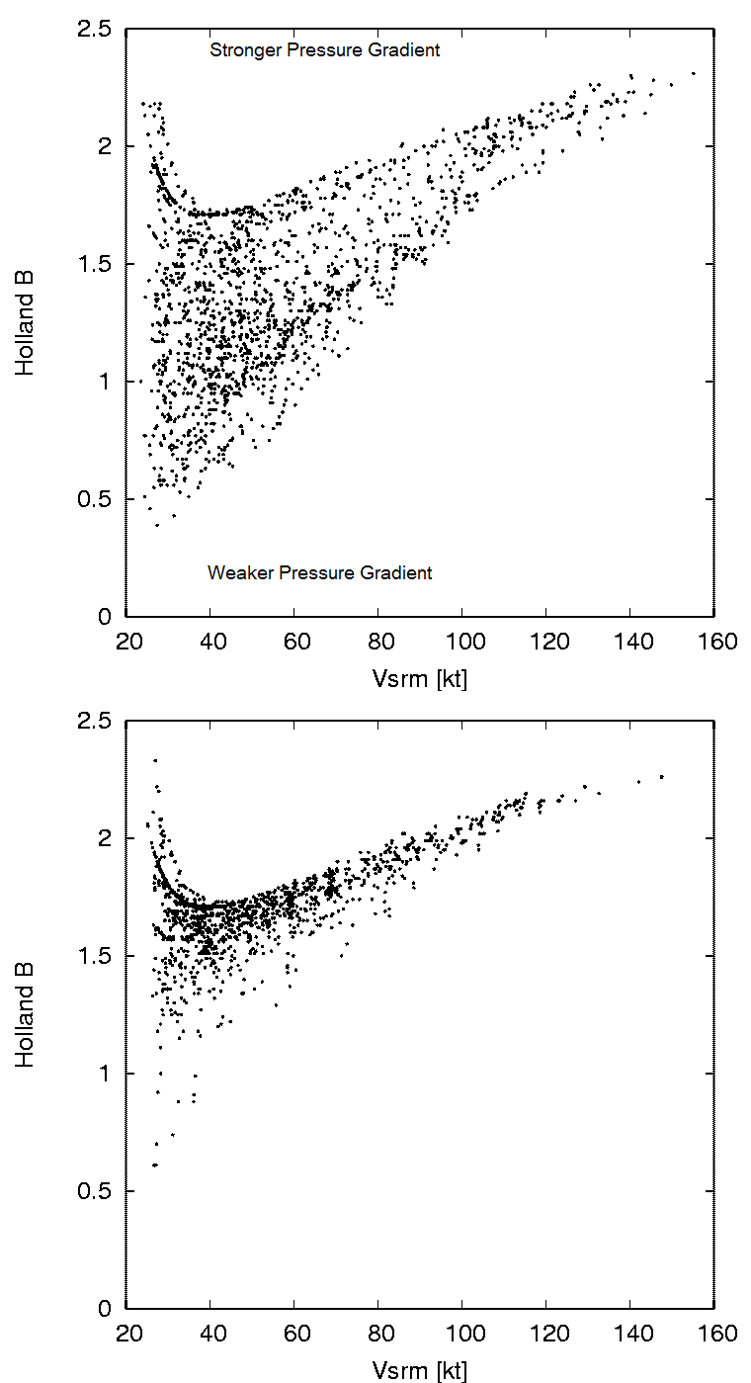
Figure 1. The Holland B distribution as a function of storm relative maximum surface winds (V_{srm}) for the North Atlantic (top) and Eastern Pacific (bottom) based on 2003-2009 best track data. For this figure Δp was calculated using the method described in Courtney and Knaff (2009) and V_{srm} was estimated using 6-hourly motion using the asymmetry factor described in Schwerdt et al. (1979).

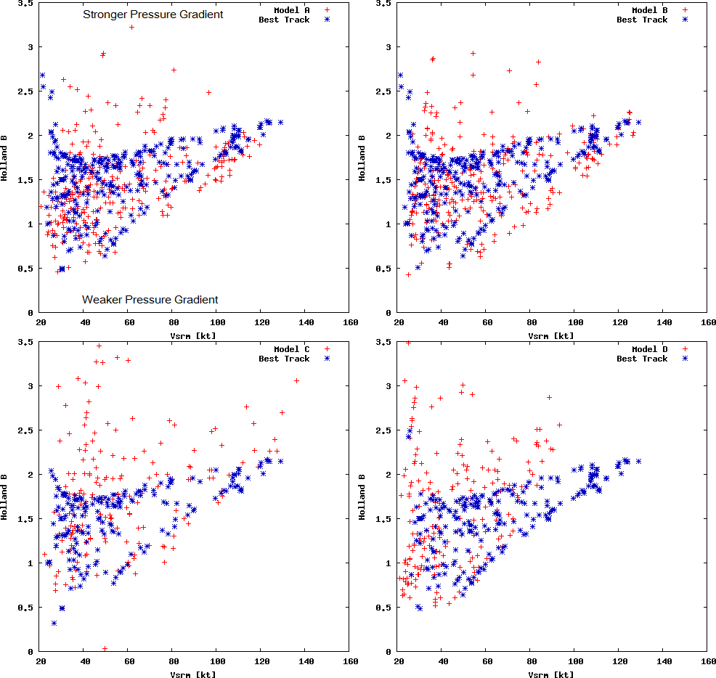
Figure 2. Holland B values as a function of V_{srm} for the initial TC bogus (blue asterisk) and for model initial conditions (red crosses). Results are shown for Model A (top left),Model B (top right), Model C (bottom left), and Model D (bottom right). See text for further descriptions of these comparisons.

Figure 3. Holland B values as a function of V_{srm} for the valid best track time (blue asterisk) and for model 12-hour forecasts (red crosses). Results are shown for Model A (top left),Model B (top right), Model C (bottom left), and Model D (bottom right). See text for further descriptions of these comparisons.

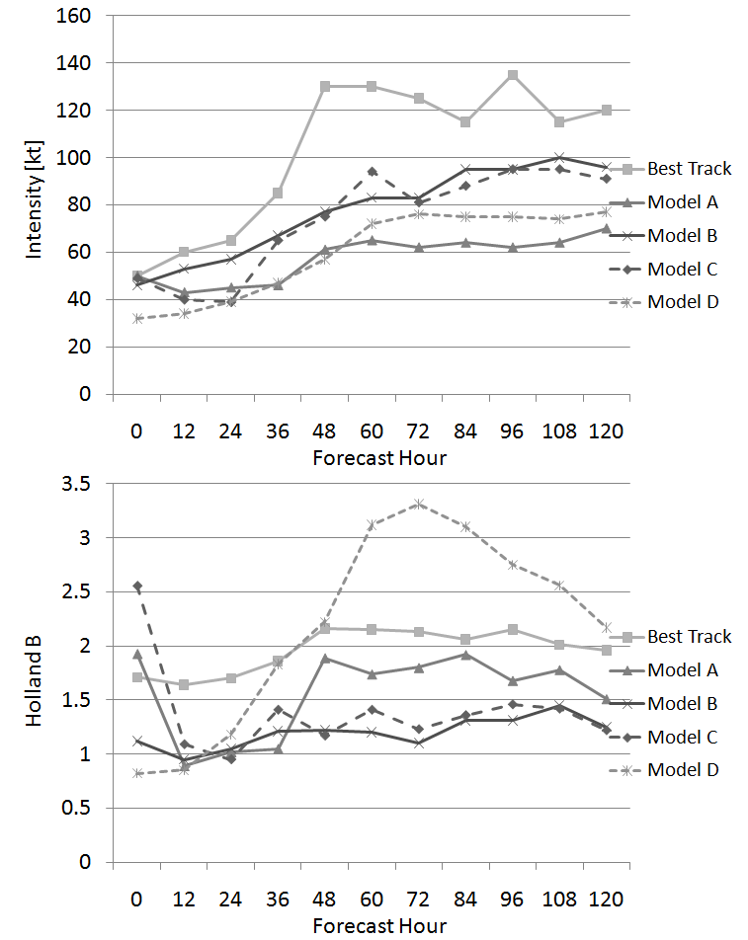

Figure 4. Typical TC model forecasts during a period of rapid intensification. The forecasts in terms of MSW and Holland B are shown in the top and bottom panel respectively.

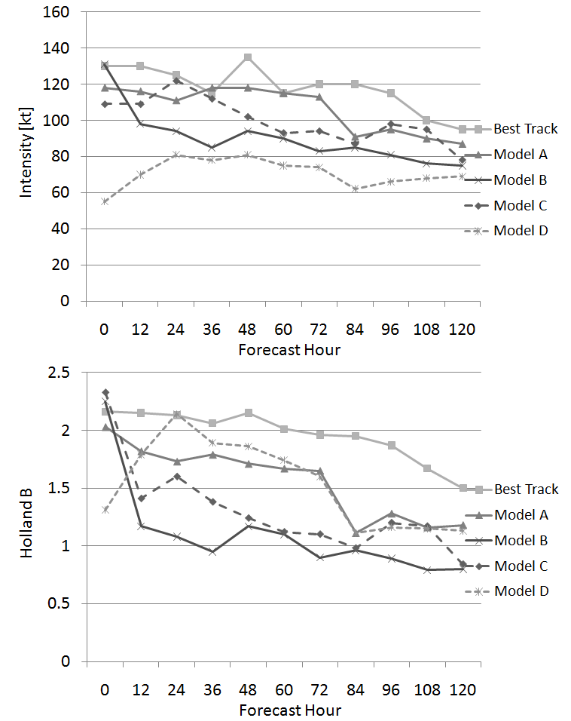

Figure 5. Typical TC model forecasts during a period of steady or weakening intensities. The forecasts in terms of MSW and Holland B are shown in the top and bottom panel respectively.

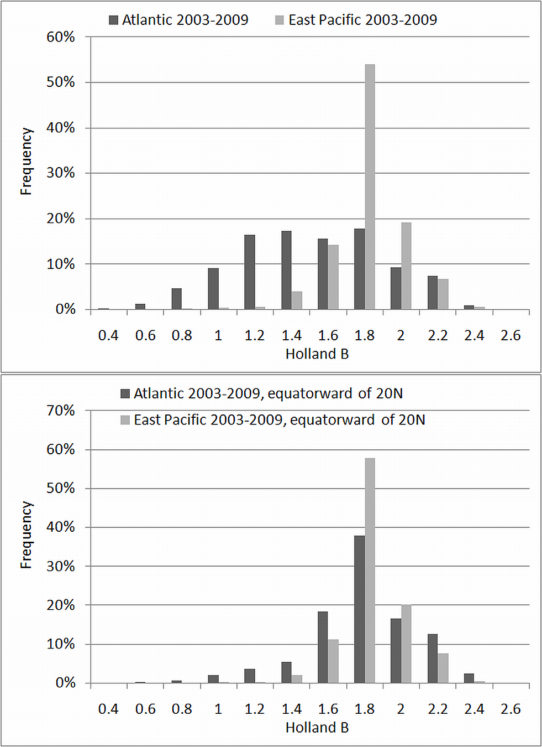

Figure 6. Frequency distributions of Holland be for the Atlantic and East Pacific TC basins 2003-2009 (top) and the same analysis, but constrained to TCs equatorward of 20ºN.

Corresponding author: John Knaff, NOAA/NESDIS RAMMB, Colorado State University, Campus Delivery 1375, Fort Collins, CO 80523-1375, USA, John.Knaff@noaa.gov; 970-491-8881

