Upper Oceanic Energy Response to Tropical Cyclone Passage

John A. Knaff and Mark DeMaria
NOAA/NESDIS –Regional and Mesoscale Meteorology Branch
Fort Collins, Colorado

Charles R. Sampson, James E. Peak and James Cummings
Naval Research Laboratory
Monterey, California

Wayne Schubert
Department of Atmospheric Science, Colorado State University,
Fort Collins, CO

Prepared for
Journal of Climate

Abstract

The upper oceanic response to tropical cyclone (TC) passage is investigated using a six-year daily record of daily analyses of several measures of upper ocean energy content in combination with the historical TC records. Composite analyses of these data are used to investigate the type, magnitude, and persistence of upper ocean response to TC passage, and to infer possible relationships between the TCs and the upper ocean response. Results show that the typical SST cooling is approximately 0.6 for an average-sized, hurricane-strength or “typical” TC persists on the order of 30 days or more as shown by other studies. Average temperatures in the mixed layer display a behavior similar to the SSTs with a “typical” TC resulting in decreases of upper oceanic energy about 12 kJ cm⁻² based on median ocean heat content integrated to the depth of the 26 ºC isotherm and a 0.5 ºC cooling of 100 m average temperatures. Upper oceanic energy decreases were also shown to persist for up to 60 days. Results also indicate that TC size should be considered when assessing TC impacts on the upper ocean, and that existing TC best track size information is sufficient for such endeavors. Analyses also lead to recommendations concerning metrics of upper ocean energy. Finally, simple parameterizations for SST cooling and upper ocean energy decreases associated with TC passage are developed from the composite results and show that the former is best described by the kinetic energy of the TC and the latitude whereas the parameterization of the latter is a function of KE, initial conditions and translation speed. These rough estimates allow for simple energy budgets to be constructed based on the number of storms, their tracks, and their sizes.

Introduction

It has been long recognized that the primary energy source for tropical cyclones (TCs) is the ocean (e.g., Riehl 1950). Latent and sensible heat is readily drawn from the ocean over the warm tropical and subtropical waters. These energy fluxes are functions of air-sea temperature differences, wind speeds and relative humidity. As a TC wind field increases in size and magnitude, the TC extracts an increased amount of energy from the ocean. To continue its intensification, a TC requires an ever increasing reservoir of energy. If that increased energy is not available in the ocean (i.e. when the ocean interface is cooler than the surface air in the TC) intensification is halted, except in cases when significant energy is being drawn from the mean flow (i.e. during tropical to extra tropical transition).
The scenario above led to the development of TC potential intensity, an important concept where the potential intensity of a TC is determined primarily by the sea surface temperature (SST). Empirical relationships have been developed that describe TC potential intensity as a function of SSTs (Merrill 1987, DeMaria and Kaplan 1994, Whitney and Hobgood 1997, Knaff et al. 2005; Knaff and Sampson 2009) for various TC basins. Many empirical and theoretical models of potential intensity also have been developed (e.g., Miller 1958, Emanuel 1986, 1991; Holland 1997 and other references contained therein), which further highlight the importance of the ocean as the ultimate TC energy source. The theoretical models also include the influence of the atmosphere on the potential intensity, but under most circumstances, the ocean influence is comparable or greater than that of the atmosphere.
SSTs typically drop with TC passage; being cooled by fluxes of latent and sensible heat, ocean mixing resulting from wind stresses and wind driven heat fluxes (Price 1981, 2009) and upwelling. This SST cooling reduces the ocean heat flux into the TC and thus limits further intensification (Cione and Uhlhorn 2003, Lin et al. 2008). However, it is the turbulent vertical mixing in the ocean that is the primary mechanism for cooling the ocean below a TC (Price 2009, Jansen et al. 2010 and references therein). In fact the vertical mixing is typically ten times more effective at cooling the ocean than the wind driven fluxes (Jacob et al. 2000, Cione and Uhlhorn 2003). The cooling of the ocean surface under a TC is an extremely complicated function of the wind-driven forcing, energy flux out of the ocean, the vertical mixing, and the oceanic conditions in the upper portions of the ocean – particularly the heat content and static stability.
The importance of the upper ocean energy content to TCs, particularly their intensification, has been known for several decades (e.g., Perlroth, 1967, Price 1981, Gray 1979, Holliday and Thompson 1979), but only relatively recently, with the advent of satellite altimeters (circa 1993) was it possible to study more than a few cases. A quantification of upper oceanic heat content for TC development was first presented by Leipper and Volgenau (1972) as the integrated temperature in excess of 26º C isotherm (the commonly agreed upon lower limit for TC development) from the depth of the 26º C isotherm ($Z_{26℃}$) to the surface (0), which we will referred to as Oceanic Heat Content (OHC) as defined by .
$OHC\left(x,y\right)=ρ_{o}C_{p}\int_{Z_{26℃}}^{0}{\left[T\left(x,y,z\right)-26\right]dz}$, (1)
where ρ₀ = 1025 kg m⁻³ and C_{p} = 4025 J kg⁻¹ are the mean density of and heat capacity of sea water, respectively. OHC has been used in a variety of TC research and operational applications as reviewed in Goni et al. (2009). However, Price (2009) pointed out that OHC has shortcomings (OHC is limited to regions of SST ≥ 26º C, OHC can misrepresent oceanic conditions in shallow waters, and the OHC does not address static stability changes with depth in salt-stratified waters). Price proposes that a more relevant measure of upper oceanic energy may be obtained from an average upper ocean temperature as defined by
${\overline{T_{d}}}_{}\left(x,y\right)=\frac{1}{d}\int_{-d}^{0}{T\left(x,y,z\right)dz}$, (2)
where the d is the depth of vertical mixing caused by a TC. Price (2009) further described two ways to define the mixing depth d in equation (2). The first assumes that the typical mixing depth associated with TC passage is 100 m – a simple yet realistic assumption, and the second calculates the mixing depth directly from the ocean sounding.
The SST cooling associated with TC passage can persist for several weeks and can affect the atmospheric general circulation. Hart et al. (2007) introduced the concept of combined atmospheric and ocean “local memory” due to TC passage via calculation of potential intensities [i.e., MPI as described in Emanuel (1986)]. Hart et al. (2007) found that SST cooling resulting from TC passage lasted approximately 40 days, the magnitude of the cooling was a function of TC intensity, and the atmosphere recovers in about 10 days. Their calculation of MPI, however, shows that the combined ocean-atmospheric memory lasted longer than 30 days. We will revisit the Hart et al. (2007) SST results, and go further by examining the upper ocean energy changes in search of other explanations for this curiosity.
In this study we seek to answer a number of questions related to the air-sea energy exchanges with TCs by using a six-year daily record of various measures of upper ocean energy content (i.e., OHC and T_{d}) and the historical TC records. Those datasets are described in section 2. The specific questions we address are as follows.
- How much does the energy of the upper ocean decrease after tropical cyclone passage and what are the most important observable factors related to the decrease?
- How much does the ocean typically cool at the surface versus in the mixed layer with TC passage?
- How long do these mixed layer temperature changes persist?
- Are there any detectable differences between the ocean responses to TCs occurring in different basins?
Methods used to address these questions are discussed in Section 3 and the results are presented in Section 4. Finally a summary and discussion is presented in section 5.

Data Description

For a six-year period 2005 – 2010, a 0.25 x 0.25 latitude by longitude daily ocean analyses were constructed in a continuous longitudinal domain bounded by 65º north and south latitude. The analyses were constructed using the Navy Coupled Ocean Data Assimilation (NCODA) system (Cummings, 2005) for data assimilation. In constructing the ocean analyses, NCODA uses the previous analysis, rather than a model forecast, as a first guess in a multi-variate Optimal Interpolation (MVOI) scheme. The observational data for the NCODA analysis were taken from the Global Ocean Data Assimilation Experiment (GODAE) data server (http://www.usgodae.org). NCODA assimilates available satellite altimeter observations, satellite and in-situ SST, as well as available in-situ vertical temperature and salinity profiles from XBTs, ARGO floats and moored buoys. Thus, the analyses are a result of data fitting approach via the NCODA MVOI and are not influenced/contaminated by model errors, especially those associated with physical parameterization of mixing.
The resulting ocean analyses were used to calculate various measures of upper oceanic energy content. These include OHC using equation (1) and a variant of OHC that integrates from the ocean surface to the depth of the 20 ºC isotherm, referred to as OHC26C and OHC20C, respectively. Equation (2) was employed to calculate four average temperature measures. The first, (T100M), assumes d in (2) is a fixed value of 100 m, or to the ocean’s bottom if it is shallower, following Price (2009). Three other average temperature measures allow d to be determined by three common measures of ocean static stability including the depth of the 0.5 temperature gradient (TMLDT), the depth of the 0.15 density gradient (TMLDD), and the depth of the maximum stability (TMAXE). Files containing daily sea surface temperature (SST) and the ocean depths used to calculate TMLDT, TMLDD and TMAXE were also constructed. Figure 1 shows examples of the SST, OHC26C, and T100M fields valid September 15, 2005.
Six-year climatologies of the upper ocean energy metrics were constructed using the daily files. Because we only had six years of data, 16 passes of a nine point Gaussian filter was employed to remove mesoscale features (scales of ~150 km) from the monthly averages. Missing data and points over land were excluded from the filtering. The climatology on a given date is estimated by applying linearly weights to the monthly averages. The weights were calculated by assuming that the monthly climatologies were valid at the median year day of that month. Figure 2 shows the 5-year climatologies matching the dates/times of the SST, OHC26C and T100M fields in Fig. 1.
Tropical cyclone location, intensity, and operationally important wind radii information comes from the best track archives. The Joint Typhoon Warning Center (JTWC) maintains best track datasets for TCs occurring in the western North Pacific and Southern Hemisphere. The National Hurricane Center (NHC), which is the World Meteorological Organization’s Regional Specialized Meteorological Centre (RSMC), maintains best tracks for the Eastern North Pacific and North Atlantic TC basin. The Central Pacific Hurricane Center, also an RSMC, maintains records from the dateline to 140ºW. These datasets are stored in the Automated Tropical Cyclone Forecast system (ATCF; Sampson and Schrader 2000) with at least a six-hourly time resolution. The best tracks represent the best post-storm analysis available at the end of each tropical cyclone season, but like any subjectively generated record, they have systematic and random errors due to the way they were constructed as noted by Landsea et al. (2006). This study makes use of the intensity, positions and operationally important wind radii contained in the best track files at six-hourly intervals and because intensity is reported in kts (kts; 1 kt = 0.514 ms-1) both intensity and translation speed will use this unit for speed throughout this study.

Methods

To study the typical ocean response to a tropical cyclone a compositing technique is used. For each six-hourly over-ocean tropical cyclone track position, the ocean variables described in section 2 are interpolated to that point at ten separate times including the concurrent time. Lead/lag times used in this study were 20, 10, and 5 days before storm passage, the time of storm passage, and 5, 10, 20, 30,60 and 90 days following storm passage. Lead and lag times were purposely chosen with a minimum of 5-day intervals since ocean data especially that from altimetry, have long refresh times so it takes a little time for the NCODA analysis to respond to the post-storm ocean data (also mentioned in Jansen et al. 2010). It is recognized that maximum cooling associated with TC passage is left (right) of track in the Northern (Southern) Hemisphere, and that poleward moving storms generate westward propagating eddies (Jansen et al. 2010); however, for simplicity and because we are most interested in the typical resolvable oceanic response to TC passage, we use the point values associated with the six-hourly best track positions. The authors feel that a composite average/median of single points provides a representative estimate of the ocean response and that using averaging areas would likely not improve composite results. This point assumption also allows for a greater number of cases, noting that Jansen et al. (2010) used 15ºx 15º areas that would remove cases in key TC formation/occurrence areas such as the Gulf of Mexico, Bay of Bengal, South China Sea, Tasman Sea, Mozambique Channel Caribbean Sea and the eastern North Pacific. Note that the current study will not address question related to ocean energy transports.
The compositing approach discussed above is applied to both the daily ocean variables and the six-year climatologies. We are most interested in the temporal changes of ocean variables prior to and following TC passage and must therefore account for the seasonal cycle. To remove the seasonal cycle from these differences the six-year climatological changes are first subtracted from the daily observation and then the difference between the anomalies, one at t=0 and the other at a different time, is then calculated. Thus for each point along each TC track we can calculate the changes in the ocean at leads of 20, 10 and 5 days and lags of 5, 10, 20, 30, 60, and 90 days. Since we want our results to be homogeneous, only cases that contain data for all the lead and lag times are included in our statistics.
Using the resulting homogenous six-year dataset of oceanic changes along over-ocean TC tracks, composites based on 1-minute sustained maximum wind speed estimates at 10 m, latitude, storm translation speed, initial ocean conditions, a simplified estimated of kinetic energy, and by TC formation basin are then formed.
The simplified kinetic energy is calculated from the operationally important wind radii and intensity information available in the best track datasets with some simple assumptions regarding the size of the radius of maximum winds. The radius of maximum winds follows the calculations in Knaff et al. (2007) as shown in (3). $r_{max}=0.85C[36.1-0.0492v_{srm}+0.57\left(\left|φ\right|-25\right)]$, (3) where C is the conversion from nautical miles to km, v_{srm} = v_{max} – 1.5 c^{0.63} is the storm relative intensity in kts, and φ is latitude in degrees. A factor of 0.85 is used to account for some of the high bias in r_{max} estimates (Knaff et al. 2007). The formula v_{srm} = v_{max} – 1.5 c^{0.63} assumes the intensity (v_{max}) and translation speed (c) have units of kts following the Schwerdt et al. (1979) asymmetry factor. This implies that rapidly translating TCs will result in slightly larger radii of maximum winds. Best track average values of the operationally important wind radii, non-zero (i.e. no wind radii in that quadrant) are then calculated. For instance if only two of the four wind radii quadrants are reporting and they have values of 50 and 100 nautical miles, the non-zero average would be 75 nautical miles.
To calculate a simplified kinetic energy (hereafter referred to as KE), a linear piecewise approach is used to create a wind field using all available wind radii values. The wind speed is assumed to increase from zero at r=0 to V_{srm} at r=r_{max} (the radius of maximum winds). It then decreases to 64 kt at the non-zero average 64-kt wind radius, and so on to the 34-kt non-zero wind radius. I then decreases to zero at r= 650km The use of 650 km as the radii of zero TC wind is an estimate based on observations and experience. Fewer linear segments are used if some wind radii are zero. The minimum number of linear segments is two (i.e., r=0 to r=r_{max} and r=r_{max} to r=650 km. For all the KE computations, the density of air is assumed to be 1 kg m⁻³ and a 1 m vertical depth is used for the calculation.
For the remainder of this paper, we will primarily concentrate on the ocean response to TC passage in term of three measures of oceanic energy, namely SST, OHC26C and T100M. Results related to other metrics for ocean energy (i.e., TMLDT, TMLDD and TMAXE) will be discussed, but not presented. For our composites of SST, OHC26C and T100M that are based on maximum wind speed, latitude, storm translation speed, initial ocean conditions, and kinetic energy we use six bins to calculate statistics. Table 1 shows the thresholds associated with each bin in our composite analyses. Note that the first bin contains the composites associated with values less than that of bin threshold 1 and that the sixth bin contains composites associated with values greater than or equal to bin threshold 5. We will use means and standard deviations in composites of the continuous SST and T100M, but medians and quartiles in the composites of positive semi-definite OHC26C. Table 2 shows the number of cases available for each bin and compositing variable (see Table caption for details), noting that the positive semi-definite nature of OHC26C reduces the number of cases.

Results

Initial Ocean Response

Our results concentrate initially on the time periods 10 days following TC passage since some of the datasets used by NCODA, particularly the satellite-based altimetry that have refresh times of approximately five days. Altimetry data is important in assessing the upper ocean’s temperature structure including eddies and fronts with warmer regions of the ocean associated with elevated sea surface heights. This 10-day window also allows the relatively sparse sounder data to propagate through the analysis via the variational data assimilation (i.e., NCODA).
Figure 3 shows the 10-day response (means with 1 sigma bars) of the SST as a function of initial SST, storm speed, intensity and KE and further stratified by TC basin. Greater SST cooling appears to be a function of warmer initial SSTs. This is thought to be a result of two factors including the tendency for stronger TCs over warmer waters, and that very warm SSTs (>29 ºC) are often associated with very warm shallow stable bodies of water that are rapidly cooled by any strong wind. It also appears that slower moving storms result in greater SST cooling (Fig 3, top right). This is likely due to the occurrence of prolonged upwelling, evaporation and mixing with the slower moving storms. Greater cooling is anticipated with more intense TCs as the stronger winds would result in greater mixing. In Fig 3 (bottom left) the intensity-based composites show that the 10-day cooling associated with a strong tropical storm is 0.4 ºC but nearly twice that for a hurricane/typhoon. Another interesting feature is the greater cooling in the Atlantic storms in the 60 to 100 kt range of intensities, which may be an artifact related to the tendency for hurricanes to grow while weakening and moving northward (Knaff et al. 2007, Merrill 1984, Maclay et al. 2008). In the western North Pacific results show that the most cooling is associated with the most intense TCs, which may suggest that the most intense TCs in that basin occur in a region more susceptible to mixing, move slower, or have larger wind fields than in other basins. It appears from the global result that tropical storms cool the SSTs about half as much as hurricane-strength TCs, which cool the SSTs on average by about 0.6 ºC.
Figure 3, bottom right, shows the SST changes as a function of TC KE, as defined in section 3. This allows us to account for some of the variations in the size and overall strength of the wind field and how those are related to post-TC SST changes accepting that the response to a given wind field is also a function of ocean structure. It is evident in this figure that the wind radii estimates created by JTWC (SHEM and WPAC) and NHC (ATL and EPAC) are systematically different. These differences aside, we get the expected result, namely that TC with larger values of KE result in greater SST cooling. The relationship between KE and SST cooling appears to be nearly linear, accepting that the highest values of KE have the greatest basin-to-basin variability. This result along with the adjacent intensity composite suggests that the size of the wind field is more strongly related to SST cooling. It appears that the largest and most energetic TCs result in an average 10-day SST cooling of around 1 ºC – larger than the 0.6 to 0.7 ºC associated with the most intense storms.
The SSTs only provide insight into what happens near the surface, so we examined the cooling in the upper ocean with composites of OHC26C and T100M, shown in Fig. 4 (medians and quartile range bars), and Fig. 5 (means and 1 sigma bars), respectively. These figures along with Fig. 3 help address several of the questions posed in section 1 about the cooling of the mixed layer and the energy decrease of the upper ocean during TC passage. In some respects the composite results shown in Fig.4 and 5 are easier to interpret than those shown in Fig. 3. The results show a clearer relationships with respect to storm translation (non-linear) and intensity and KE (linear). There is also a clear signal associated with the initial OHC26C values, suggesting that larger energy decreases are associated with those TCs with larger initial values of OHC26C.
Figure 4 shows 10-day changes in OHC26C. Results are similar to those associated with SSTs. OHC26C changes as a function of initial OHC26C. This relationship may be enhanced by the positive semi-definite nature of OHC26C. Greater energy decreases are associated with slower moving storms; echoing the findings of Lin et al. (2009). The energy decrease appears non-linear, suggesting that upwelling may be more important for nearly stationary storms. Higher intensity and KE storms also tend to result in greater decreases of energy from the upper ocean. The results suggest that the upper ocean energy decrease for a typical global hurricane-strength TC that is moving at typical speeds and has average size is about 0-25 kJ cm⁻² with a median of approximately 10 kJ cm⁻². These results are in line with in-situ results obtained by Shay and Ehlhorn (2008).
More interesting are the inter basin differences. It is clear that the typical TC in western North Pacific results in greater decreases in upper ocean energy, nearly twice as much as eastern North Pacific TC cases. This result is evident in all composites of OHC26C. So it appears that TCs of equal size and intensity can result in greater decreases the upper ocean energy in the western North Pacific. It is interesting to note that the energy decreases associated with east Pacific TCs are the smallest and that the energy decreases that occur in the Atlantic and Southern Hemisphere cases are closer to the median/mean values. This difference is likely caused by differences in upper ocean static stability as discussed in general in Price (2009) and detailed specifically for the eastern North Pacific by Shay and Brewster (2010). This result suggests that more investigation is needed to determine the specific causes of these differences.
One would initially expect the T100M results (Fig.5) to be nearly identical to those in Fig. 4, and they are for the global result. Globally the typical hurricane-strength TC will cool the upper ocean on average by about 0.3 to 0.5 ºC. A “back of the envelope” calculation of heat content assuming 100 m depth is that 1 ºC cooling is approximately 41 kJ cm⁻². So these numbers are consistent, but a little larger than the OHC26C composites. However the inter-basin results are different. Notable differences include the similar (different) behavior of the East and West Pacific with respect to T100M (OHC26C), and the relationships to the initial conditions in which T100M composites have larger inter-basin variability. Some of the difference is due to plotting means in Fig. 5 vs. medians in Fig. 4, but the notable difference, primarily in the East Pacific, suggests that interannual variation of the upper ocean (i.e., thermocline depth variations associated with El Nino/Southern Oscillation) may result in greater variability in the measurement of T100M– noting here that TC activity in the East Pacific is generally enhanced and the thermocline is also deeper in El Nino conditions.
The ocean energy was also examined using TMLDD, TMLDT, and TMAXE (not shown). Composites constructed in the same manner as Fig. 3 show that these generally shallower mixed layer average temperature metrics behaved remarkably similar to the SST composites shown in Fig. 3 and did not have the variability displayed in T100M. The observations and the results of Fig. 5 that show T100M has a different response, particularly in the eastern North Pacific suggest that using a uniform 100 m depth for estimating ocean energy, while simple, may introduce additional errors because the 100m depth is likely too deep in some situations. On the other hand, because these mixed layer average temperatures are better related to the SSTs observed under a TC (i.e., representing the temperature in the mixed layer), TMLDDD, TMLDT, and TMAXE are likely better suited for applications like potential intensity as suggested by (Price 2009). The differences between SST and these mixed layer temperature metrics is being examined in a separate study.
Potentially useful exercises for climate applications would be to determine the measurable factors (those examined above plus TC latitude) that are most important to the initial post-TC ocean responses and derive a mean response based on those factors. Ocean response estimates for instance include the amount of SST cooling and the decrease in upper ocean energy. In this exercise we accept that these relationships would likely poorly represent responses associated with individual or specific cases as many of the important factors are immeasurable given current observational capabilities and/or are beyond the scope of this study. Since the factors examined co-vary to a large degree and we are interested in a stable yet simple result, the composited results (i.e., multiple composites) will be used to develop the simplest and most skillful multiple regression.
Regression equations based on our composite results suggest that 10-day SST cooling is best related to two factors that were composited namely the KE and the latitude, and that the regression explains roughly 60% of the variance in these dependent composited data. The resulting parameterization of SST cooling is
$∆SST=(-3.7937x{10}^{-9})KE-(1.0057x{10}^{-2})\left|∅\right|$ (3).
This result because of linear relationship with latitude (φ) and KE suggests the wind driven upwelling (a function of 1/f) is fairly important for SST cooling. For instance, this implies that a strong average sized TC (KE=1.0e8) at 30º latitude cools the SST by 0.68ºC on average.
On the other hand, the 10-day changes in OHC26C and T100M appear most related to three factors including translation speed, KE and initial conditions. The regressions explain 92% and 81% of the variance of the median OHC26C and mean T100M, respectively. The resulting parameterizations for OHC26C and T100M are shown in equation (4) and (5), respectively.
$∆OHC26C=(0.3548)SPD-(7.0119x{10}^{-8})KE-(0.1640)OHC26C$ (4)
$∆T100M=(1.8157x{10}^{-2})SPD-(2.3000{x10}^{-9})KE-(1.7052x{10}^{-2})T100M$ (5)
These equations implies that a strong average sized TC (KE=1.0e8) moving at 10 kts with initial OHC26C equal to 50 kJ cm⁻² and initial T100M of 28ºC typically results in OHC26C and T100M changes of -11.7 kJ cm⁻² and -0.53 ºC, respectively. Note here that the number of cases for the two regressions are different and that T100M is defined everywhere whereas OHC26C is only valid where SSTs are greater than 26⁰C.

Persistence of observed changes

Shifting focus to the length of time the mean cooling of the ocean lags we first examine the persistence of SST changes. Fig. 6 shows SST anomalies for 10, 20, 30 and 60 days following TC passage as a function of KE. Here we show that the Hart et al. (2007) result holds (i.e. the red lines), but because KE accounts for both the size and strength of the TC, the results here imply that larger and stronger TCs result not only in more initial cooling, but that cooling tends to persist for a longer period of time. However, even the lower values of KE show persistent cooling through 60 days, and the cooling for the high KE systems is on the order of 0.5ºC, even after 60 days. Note that while composites of 90-day persistence showed SST anomalies for the globe were negative, these were much more difficult to interpret as the intra-basin comparison from one time to the next is not always consistent, suggesting inter annual differences begin to be more important. As a result, it appears that the persistence of SST changes is on the order of 60-days and there is evidence that those negative SSTs do not fully recover even through 90-days (not shown).
Figure 7 shows the OHC26C persistence in the same manner as Fig. 6. Here the typical changes in OHC26C, much like the SSTs were found to persist through roughly 60 days. Again there is an indication that there is a net extraction of energy from the ocean and that the greater the KE, the greater the initial decrease in OHC26C and the slower the recovery to near, if not slightly less energetic ocean conditions. It is interesting to note that even at 90-days (not shown) negative OHC26C changes are still present in global medians, suggesting that TC passage effects continue to linger after the season; however, not all basins show negative anomalies, suggesting that inter-annual differences begin to dominate the signal. While this result looks robust it is difficult to know how results are impacted by the positive semi-definite nature of OHC26C and particularly potential contamination of these results by cases where OHC26C vanishes seasonally.
Examining the upper ocean temperature changes using T100M offers a different perspective. Fig. 8 shows the lag time composite of T100M versus KE. Here the net cooling is evident though 30-days and there is some evidence, that this persistence last through 60 days. The 60-day composite however, indicates that the intra-basin persistence of T100M is less than in OHC26C and SST. This indicates that using 100 m depth as a proxy for the mixed layer may be a poor assumption where the thermocline is shallow (the eastern North and South) Pacific or where there is great variability in thermocline depth throughout the season.
- Individual TC examples

Subsections a. and b. showed (based on composites of large numbers of cases) the average SST, OHC26 and T100M responses (i.e. 10-days after) to TC passage, and that those responses persist for 30 days or longer. To get a better sense of the effects in individual cases, three relatively long-lived individual TC cases from 2011 are now examined. Figure 9 shows the best track locations and 34-kt wind radii of Typhoon Megi in the western North Pacific (15W), Tropical Cyclone Ului in the Southwest Pacific (20P), and Hurricane Igor in the North Atlantic (11L).
Figures 10, 11 and 12 show time series data for Typhoon Megi, Tropical Cyclone Ului, and Hurricane Igor, respectively. In each of these figures the temporal evolution of the intensity and KE are shown in the top panel and T100M at 5-day lead and 5-day, 10-day, 30-day and 60-day lag times are shown in the subsequent panels.
In the case of Typhoon Megi (Fig. 10), the T100M changes 5 and 10 days following TC passage show remarkable correspondence with the time series of KE. The maximum cooling at 10-days is on the order of 4-5 ºC and is associated with the KE maximum. Following those times the effects of advection, upwelling, mixing, and solar heating act to relax the changes, but even after 60-days the times associated with maximum intensity and maximum KE still show the cool signature related to the passage this typhoon.
A similar evolution is seen with Tropical Cyclone Ului (Fig. 11), which shows that the T100M cools approximately 2 ºC at 5 and 10 days following TC passage, and that the magnitude of those changes closely correspond to the time series of KE. Again, as was the case with Megi, other processes erode the residual cooling, which is only barely evident at 30 and 60 day lags.
In contrast to Megi and Ului, the upper ocean response to Igor (Fig. 12) is more pronounced and appears to be better correlated to the intensity than the KE, whose wind field continues to grow as the storm becomes post tropical (see the large 34-kt wind radii in Fig 9). The maximum cooling is on the order of 2-3 ºC. Also different from the other cases is the persistent nature of the ocean response. The resulting TC induced cooling signature in the tropics remains intact even 60 days after TC passage. It also appears that the higher latitude changes persist less than the subtropical portions of the track, suggesting that wind stresses in addition to advection play a role in ocean recovery. In the higher latitudes wind stresses due to the passage of mid-latitude cyclones and the strengthening of westerly winds associated with the annual cycle will more quickly act to obscure the TC-forced anomalies. This higher latitude response may also be due to the propagation of the resulting eddies away from our point analyses in the poleward moving portions of Igor’s track (Jansen et al. 2010), which is evident to some degree in these NCODA based analyses.

Summary and Discussion

In this study we investigated a number of questions about ocean responses to TCs by using a six-year daily record of daily analyses of various measures of upper ocean energy content (i.e., OHC and T_{d}) in conjunction with the historical TC records. The investigation focused on the type, magnitude, and persistence of upper ocean response to TC passage, and then discussed possible relationships between the TCs and the upper ocean response.
Previous results suggesting the “local memory” to TC passage with respect to SSTs was confirmed. Average temperatures in the mixed layer were examined and they showed similar behavior to the SSTs. The decrease of energy in the upper ocean was observed to be between about 5 and 20 kJ cm⁻² based on median OHC26C and mean T100M values. We also found that TC size should be considered when assessing TC impacts on the upper ocean, and that existing size information in the TC best tracks is sufficient for such endeavors.
Parameterizations for forecasting changes in ocean heat content and SST based on routinely available data were also created using regression analysis and the composited data. These parameterizations suggest that SST cooling is mostly a function of latitude and our simplified KE (as defined in section 3). The latitudinal dependence suggests that storm-induced Ekman processes are likely more important for SST cooling at higher latitude. On the other hand, cooling in the entire mixed layer is best forecast with KE, translation speed, and the initial upper ocean conditions.
According to these simple relationships, a typical hurricane extracts about 12 kJ cm⁻² (based on OHC26C), and cools the ocean 0.5ºC (based on T100M) and cools the local SST 0.6 ºC. These rough estimates allow for a simple energy budget to be constructed based on the number of storms, their tracks, and their sizes. At the very least these results suggest that there is likely a negative feedback between the number and intensity of TCs and the ocean energy available for additional TCs during a single TC season.
Findings suggest that the depressed ocean heat content, much like lower SST, persists for at least 30 days and possibly as long as 60 days. Results also suggest that the ocean recovers slow enough (means and medians do not recover fully in 90 days) that the interannual (e.g., ENSO) and inter seasonal (e.g., winter) signals mask the TC effects. These results reiterate the statements made in Jansen et al. (2010) that the upper ocean cold anomaly is on average not fully restored by surface fluxes before the mixed layer deepens in winter.
In our examination of the T100M metric for ocean energy, we find evidence that the 100 m depth (used as a proxy for the mixed layer depth) may not be appropriate for basins where the thermocline is relatively shallow (e.g., eastern Pacific). This inference suggests that metrics that directly determine the average temperature in the mixed layer, which were only briefly discussed here, are more universally applicable to TC applications. This finding will guide our future TC work, especially with respect to potential intensity relationships used in TC forecast applications (e.g., operational models like SHIPS, STIPS, and LGEM; DeMaria et al. 2005, Knaff et al. 2005, DeMaria 2009).

Acknowledgements: The views, opinions, and findings contained in this report are those of the authors and should not be construed as an official National Oceanic and Atmospheric Administration or U.S. government position, policy, or decision. This work is funded by the Office of Naval Research.

References:

Cione, J. J., E. W. Uhlhorn, 2003: Sea surface temperature variability in hurricanes: implications with respect to intensity change. Mon. Wea. Rev., 131, 1783–1796.
Cummings, J.A., 2005: Operational multivariate ocean data assimilation. Quart. J. Royal Met. Soc., 131, 3583-3604.
DeMaria, M., 2009: A Simplified Dynamical System for Tropical Cyclone Intensity Prediction. Monthly Weather Review. 137:1, 68–82.
____, J. Kaplan, 1994: Sea surface temperature and the maximum intensity of Atlantic tropical cyclones. J. Climate, 7, 1324–1334.
____, M. Mainelli, L.K. Shay, J.A. Knaff, J. Kaplan, 2005: Further Improvement to the Statistical Hurricane Intensity Prediction Scheme (SHIPS).Wea. Forecasting, 20:4, 531-543.
Emanuel, K. A., 1986: An air–sea interaction theory for tropical cyclones. Part 1: Steady-state maintenance. J. Atmos. Sci., 43, 585–604.
____, 1991: The theory of hurricanes. Annu. Rev. Fluid Mech., 23, 179–196.
Goni, G. , M. DeMaria, J. Knaff, C. Sampson, I. Ginis, F. Bringas, A. Mavume, C. Lauer, I.-I. Lin, M.M. Ali, P. Sandery, S. Ramos-Buarque, K. Kang, A. Mehra, E. Chassignet, and G. Halliwell, 2009: Applications of Satellite-Derived Ocean Measurements to Tropical Cyclone Intensity Forecasting, Oceanography, 22:3, 190-197.
Hart, R. E., R. N. Maue, M. C. Watson, 2007: Estimating local memory of tropical cyclones through MPI anomaly evolution. Mon. Wea. Rev., 135, 3990–4005.
Holland, G. J., 1997: The maximum potential intensity of tropical cyclones. J. Atmos. Sci., 54, 2519–2541.
Holliday, C. R., A. H. Thompson, 1979: Climatological characteristics of rapidly intensifying typhoons. Mon. Wea. Rev., 107, 1022–1034.
Jacob, S. D., L. K. Shay, A. J. Mariano, and P. G. Black, 2000: The 3-D ocean mixed layer response to hurricane Gilbert, J. Phys. Oceanogr., 30, 1407-1429.
Jansen, M. F. , R. Ferrari, and T. A. Mooring, 2010: Seasonal versus permanent thermocline warming by tropical cyclones. Geophys. Res. Let., 37, L03602.
Knaff, J.A., and C.R. Sampson, 2009: Southern Hemisphere tropical cyclone intensity forecast methods used at the Joint Typhoon Warning Center, Part II: Statistical – dynamical forecasts. Australian Meteorological and Oceanographic Journal, 58:1, 9-18.
____, C.R. Sampson, M. DeMaria, 2005: An operational statisical typhoon intensity prediction scheme for the Western North Pacific.Wea. Forecasting, 20, 688-699.
____, C. R. Sampson, M. DeMaria, T. P. Marchok, J. M. Gross, and C. J. McAdie, 2007: Statistical tropical cyclone wind radii prediction using climatology and persistence, Wea. Forecasting, 22, 781–791.
Landsea, C.W., B.A. Harper, K. Hoarau, J.A. Knaff, 2006: Can we detect trends in extreme tropical cyclones? Science, 313, 452-454.
Leipper, D. and D. Volgenau, 1972: Upper ocean heat content of the Gulf of Mexico. J. Phys. Oceanogr., 2, 218-224.
Lin, I. I., I. F. Pun, and C. C. Wu, 2009: Upper ocean thermal structure and the western North Pacific category-5 typhoons Part II: Dependence on translation speed, Mon. Wea. Rev., 137, 3744-3757.
Lin, I-I., C..C. Wu, I. F. Pun, D. S. Ko, 2008: Upper-Ocean Thermal Structure and the Western North Pacific Category 5 Typhoons. Part I: Ocean Features and the Category 5 Typhoons’ Intensification. Mon. Wea. Rev., 136, 3288–3306.
Maclay, K. S., M. DeMaria and T.H. Vonder Haar, 2008: Tropical cyclone inner core kinetic energy evolution. Mon. Wea. Rev., 136, 4882-4898.
Merrill, R. T., 1984: A comparison of large and small tropical cyclones. Mon. Wea. Rev., 112, 1408–1418.
____ 1987: An experiment in statistical prediction of tropical cyclone intensity change. NOAA Tech memo, NWS NHC-34, 34pp.
Miller, B. I., 1958: On the maximum intensity of hurricanes. J. Meteor., 15, 184-195.
Perlroth, I., 1967: Hurricane behavior as related to oceanographic environmental conditions. Tellus, 19, 258-268.
Price, J. F., 1981: Upper ocean response to a hurricane. . J. Phys. Oceanogr., 11, 153-175.
Price, J. F., 2009: Metrics of hurricane-ocean interaction: vertically-integrated or vertically-averaged ocean temperature? Ocean Sci., 5, 351-368.
Riehl, H., 1950: A model for hurricane formation. J. Appl. Phys., 21, 917-925.
Sampson, C. R., and A. J. Schrader, 2000: The automated tropical cyclone forecasting system (Version 3.2). Bull. Amer. Meteor. Soc., 81, 1231-1240.
Shay, L. K., and J. K. Brewster, 2010: Eastern Pacific oceanic heat content estimation for hurricane intensity forecasting. Mon. Wea. Rev., 138, 2110-2131.
____., E. W. Uhlhorn, 2008: Loop current response to Hurricanes Isidore and Lili. Mon. Wea. Rev., 136, 3248–3274.
Schwerdt, R. W., F. P. Ho, and R. R. Watkins, 1979: Meteorological criteria for standard project hurricane and probable maximum hurricane wind fields, Gulf and East Coasts of the United States. NOAA Tech. Rep. NWS 23, 317 pp. [Available from National Hurricane Center, Library, 11691 SW 117 St, Miami 33165-2149, USA]
Whitney, L. D., and J. S. Hobgood, 1997: The relationship between sea surface temperatures and maximum intensities of tropical cyclones in the eastern North Pacific Ocean. J. Climate, 10, 2921–2930.

Figure Captions:

Figure 1. Panels show examples of daily analysis of (top) SST, (middle) OHC26C, and (bottom) T100M valid on 15 September 2005. Units are ºC for SST and T100M and kJcm⁻² for OHC26C.
Figure 2. Panels show examples of 5-year climatological analyses of (top) SST, (middle) OHC26C, and (bottom) T100M valid on 15 September. Units are ºC for SST and T100M and kJcm⁻² for OHC26C. Color scaling is the same as in Fig. 1.
Figure 3. The 10-day SST response to the passage of a tropical cyclone as a function of (top left) initial SST, (top right) storm speed, (bottom left) intensity and (bottom right) kinetic energy. Mean values are indicated by the points and the bars indicate the 1 sigma value from the mean. Results are shown for the Atlantic (ATL, red), the east and central Pacific (EPAC, green), the northwest Pacific (WPAC, blue) and Southern Hemisphere (SHEM, magenta) TC basins as well as the global response (GLOBE, black).
Figure 4. The 10-day OHC26C response to the passage of a tropical cyclone as a function of (top left) initial, OHC26C, (top right) storm speed, (bottom left) intensity and (bottom right) kinetic energy. Median values are indicated by the points and the bars indicate the quartiles of the distribution. Results are shown for the Atlantic (ATL, red), the east and central Pacific (EPAC, green), the northwest Pacific (WPAC, blue) and Southern Hemisphere (SHEM, magenta) TC basins as well as the global response (GLOBE, black).
Figure 5. The 10-day T100M response to the passage of a tropical cyclone as a function of (top left) initial T100M, (top right) storm speed, (bottom left) intensity and (bottom right) kinetic energy. Mean values are indicated by the points and the bars indicate the 1 sigma value from the mean. Results are shown for the Atlantic (ATL, red), the east and central Pacific (EPAC, green), the northwest Pacific (WPAC, blue) and Southern Hemisphere (SHEM, magenta) TC basins as well as the global response (GLOBE, black).
Figure 6. Mean SST changes as a function of KE (upper left) 10 days, (upper right) 20 days, (lower left) 30 days and (lower right) 60 days following TC passage. Mean values are indicated by the points and the bars indicate the 1 sigma value from the mean. Results are shown for the Atlantic (ATL, red), the east and central Pacific (EPAC, green), the northwest Pacific (WPAC, blue) and Southern Hemisphere (SHEM, magenta) TC basins as well as the global response (GLOBE, black).
Figure 7. Typical OHC26C changes as a function of KE (upper left) 10 days, (upper right) 20 days, (lower left) 30 days and (lower right) 60 days following TC passage. Median values are indicated by the points and the bars indicate the quartile values from the median. Results are shown for the Atlantic (ATL, red), the east and central Pacific (EPAC, green), the northwest Pacific (WPAC, blue) and Southern Hemisphere (SHEM, magenta) TC basins as well as the global response (GLOBE, black).
Figure 8. Identical to Fig. 6, except for T100M.
Figure 9. Best track locations and 34-kt wind radii for Typhoon Megi (15W, Western North Pacific), Tropical Cyclone Ului (20P, Southwest Pacific), and Hurricane Igor (11L, North Atlantic).
Figure 10. Time series associated with Typhoon Megi (15W). Shown are the (top panel) intensity and KE followed by the T100M changes observed 5 days prior to TC passage and 5, 10, 30, 60 days following TC passage.
Figure 11. Same as Figure 10, except for Tropical Cyclone Ului (20P).
Figure 12. Same as Figure 10, except for Hurricane Igor (11L).

Table 1: Bin thresholds associated with the composite analysis used in this study and presented in section 5. Units for SST, OHC26C, T100M, storm speed, storm intensity, and storm KE are given in units of ºC, kJ cm⁻², ºC, kts, kts and J (x10⁷), respectively.
Bin  Threshold | Initial  SST | Initial  OHC26C | Initial  T100M | Storm  Speed | Storm  Intensity | Storm  KE | Storm  Latitude
1 | 25 | 10 | 23 | 4 | 35 | 3.0 | 12.5
2 | 26 | 30 | 24 | 8 | 55 | 6.0 | 17.5
3 | 27 | 50 | 25 | 12 | 77 | 9.0 | 22.5
4 | 28 | 70 | 26 | 16 | 102 | 12.0 | 27.5
5 | 29 | 100 | 27 | 20 | 127 | 16.0 | 32.5

Table 2: Table shows the number of cases contained in each compositing bin as a function of compositing variable. Note there are two columns of numbers for the storm speed, intensity, KE and latitude composites. The first is valid for SST and T100M composites and the second for OHC26C composites.

Bin | Initial  SST | Initial  OHC26C | Initial  T100M | Storm  Speed | Storm  Intensity | Storm  KE | Storm  Latitude
Atlantic
1 | 229 | 37 | 408 | 161, 86 | 933, 721 | 1032, 797 | 159, 159
2 | 117 | 307 | 257 | 540, 354 | 629, 383 | 555, 366 | 569, 540
3 | 199 | 402 | 296 | 646, 421 | 404, 173 | 255, 121 | 487, 446
4 | 421 | 346 | 286 | 479, 360 | 118, 81 | 114, 53 | 356, 238
5 | 619 | 294 | 357 | 282, 207 | 96, 84 | 76, 45 | 342, 74
6 | 627 | 69 | 609 | 104, 45 | 32, 31 | 180, 91 | 299, 16
Eastern North Pacific
1 | 260 | 130 | 1296 | 299, 209 | 1320, 912 | 1483, 1054 | 332, 332
2 | 191 | 753 | 444 | 843, 578 | 559, 414 | 654, 483 | 1274, 1121
3 | 283 | 549 | 353 | 840, 609 | 327, 223 | 178, 106 | 628, 267
4 | 530 | 166 | 178 | 379, 276 | 137, 100 | 64, 43 | 158, 7
5 | 808 | 53 | 77 | 70, 50 | 65, 50 | 32, 16 | 36, 1
6 | 365 | 7 | 89 | 6, 6 | 29, 29 | 26, 26 | 9, 0
Western North Pacific
1 | 57 | 21 | 168 | 226, 200 | 1097, 976 | 1372, 1201 | 495, 495
2 | 63 | 139 | 111 | 764, 670 | 684, 488 | 677, 484 | 781, 758
3 | 103 | 304 | 240 | 918, 753 | 532, 408 | 315, 245 | 877, 766
4 | 267 | 451 | 334 | 623, 509 | 322, 242 | 210, 142 | 389, 257
5 | 821 | 765 | 441 | 230, 153 | 193, 139 | 150, 103 | 220, 46
6 | 1596 | 622 | 1613 | 146,39 | 79, 71 | 183, 149 | 145, 2
Southern Hemisphere
1 | 146 | 123 | 131 | 433, 398 | 1364, 1157 | 1665,1429 | 694, 672
2 | 190 | 602 | 130 | 1254, 1112 | 812, 675 | 851, 707 | 1279, 1193
3 | 428 | 812 | 274 | 818, 694 | 488, 414 | 282, 234 | 781, 644
4 | 772 | 551 | 788 | 391,309 | 229, 202 | 164, 146 | 263, 104
5 | 853 | 341 | 970 | 98, 63 | 157, 145 | 73, 69 | 55, 2
6 | 683 | 83 | 779 | 78, 39 | 22, 22 | 37, 30 | 0, 0
Global
1 | 692 | 315 | 2006 | 1194, 966 | 4895, 3944 | 5782, 4708 | 1877, 1852
2 | 561 | 1863 | 954 | 3606, 2916 | 2834, 2107 | 2877, 2177 | 4042, 3748
3 | 1023 | 2167 | 1216 | 3327, 2581 | 1807, 1274 | 1055, 731 | 2834, 2184
4 | 2058 | 1624 | 1657 | 1897, 1479 | 814, 633 | 556, 388 | 1184, 624
5 | 3259 | 1554 | 1960 | 685, 478 | 526, 433 | 341, 243 | 653, 123
6 | 3450 | 812 | 3253 | 334, 129 | 167, 158 | 432, 302 | 453, 18

Figure 1. Panels show examples of daily analysis of (top) SST, (middle) OHC26C, and (bottom) T100M valid on 15 September 2005. Units are ºC for SST and T100M and kJcm⁻² for OHC26C.
Figure 2. Panels show examples of 5-year climatological analyses of (top) SST, (middle) OHC26C, and (bottom) T100M valid on 15 September. Units are ºC for SST and T100M and kJcm⁻² for OHC26C. Color scaling is the same as in Fig. 1.

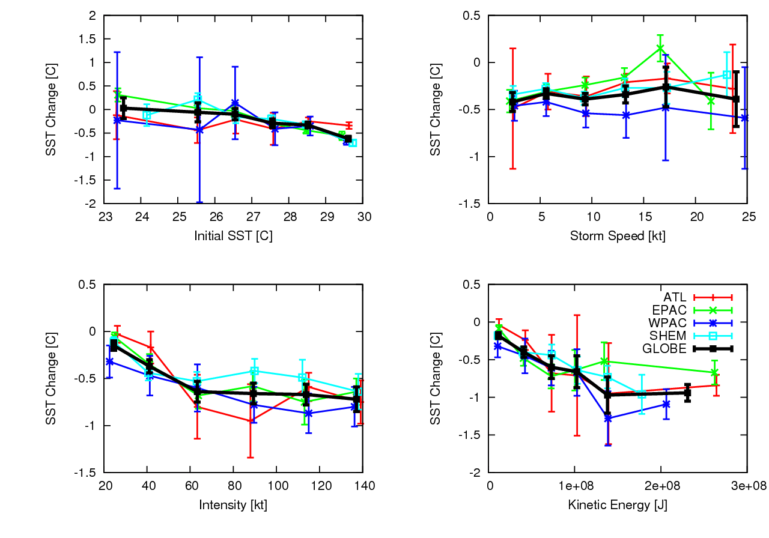
Figure 3. The 10-day SST response to the passage of a tropical cyclone as a function of (top left) initial SST, (top right) storm speed, (bottom left) intensity and (bottom right) kinetic energy. Mean values are indicated by the points and the bars indicate the 1 sigma value from the mean. Results are shown for the Atlantic (ATL, red), the east and central Pacific (EPAC, green), the northwest Pacific (WPAC, blue) and Southern Hemisphere (SHEM, magenta) TC basins as well as the global response (GLOBE, black).

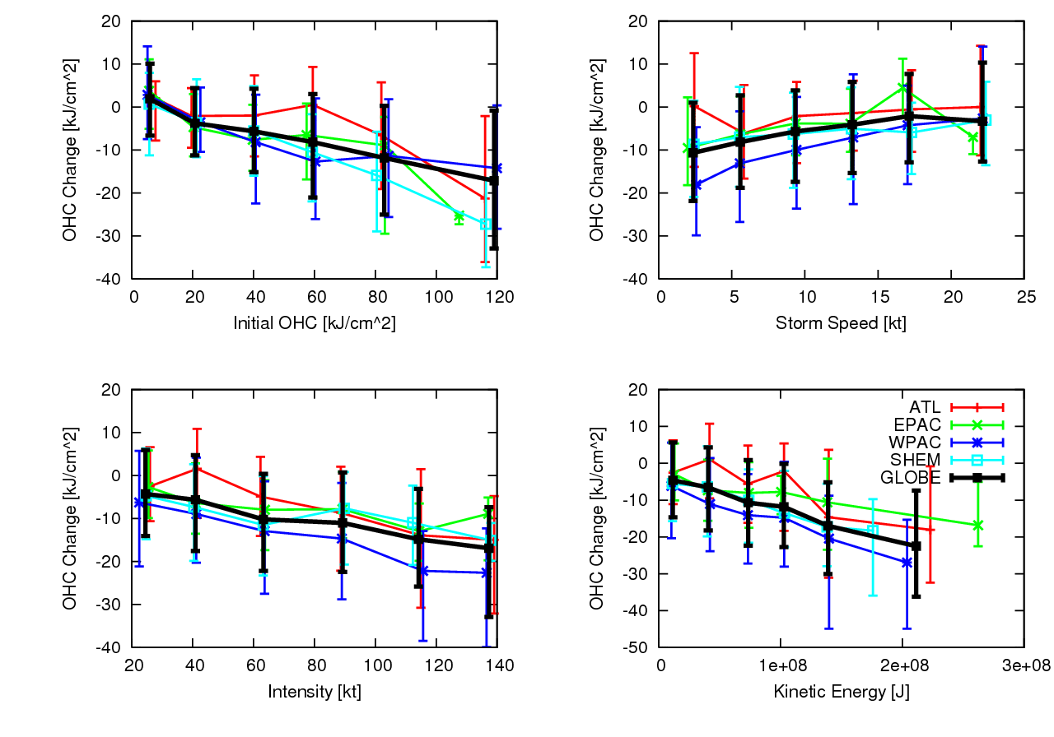
Figure 4. The 10-day OHC26C response to the passage of a tropical cyclone as a function of (top left) initial, OHC26C, (top right) storm speed, (bottom left) intensity and (bottom right) kinetic energy. Median values are indicated by the points and the bars indicate the quartiles of the distribution. Results are shown for the Atlantic (ATL, red), the east and central Pacific (EPAC, green), the northwest Pacific (WPAC, blue) and Southern Hemisphere (SHEM, magenta) TC basins as well as the global response (GLOBE, black).

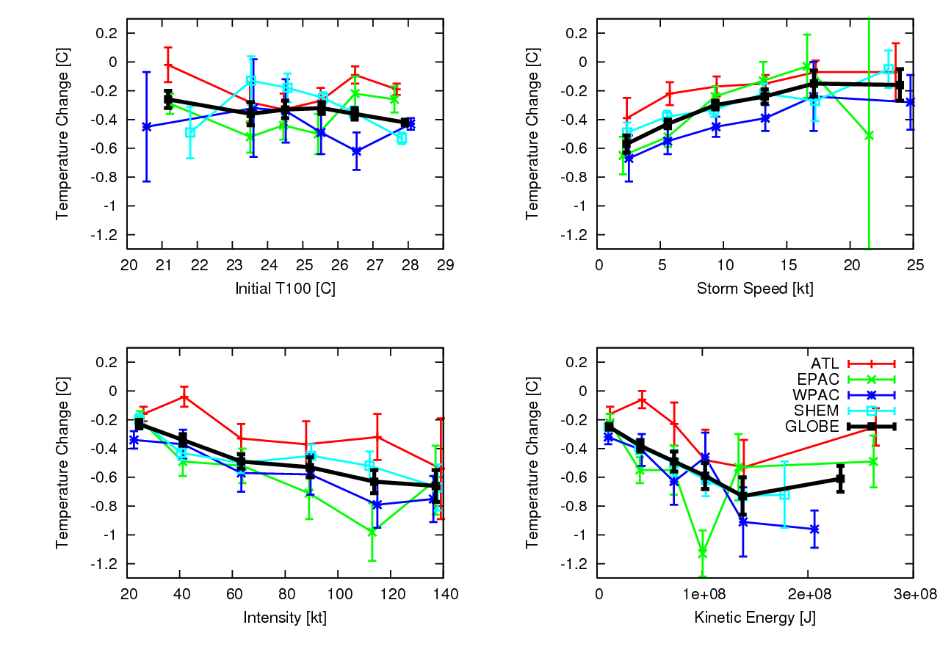
Figure 5. The 10-day T100M response to the passage of a tropical cyclone as a function of (top left) initial T100M, (top right) storm speed, (bottom left) intensity and (bottom right) kinetic energy. Mean values are indicated by the points and the bars indicate the 1 sigma value from the mean. Results are shown for the Atlantic (ATL, red), the east and central Pacific (EPAC, green), the northwest Pacific (WPAC, blue) and Southern Hemisphere (SHEM, magenta) TC basins as well as the global response (GLOBE, black).

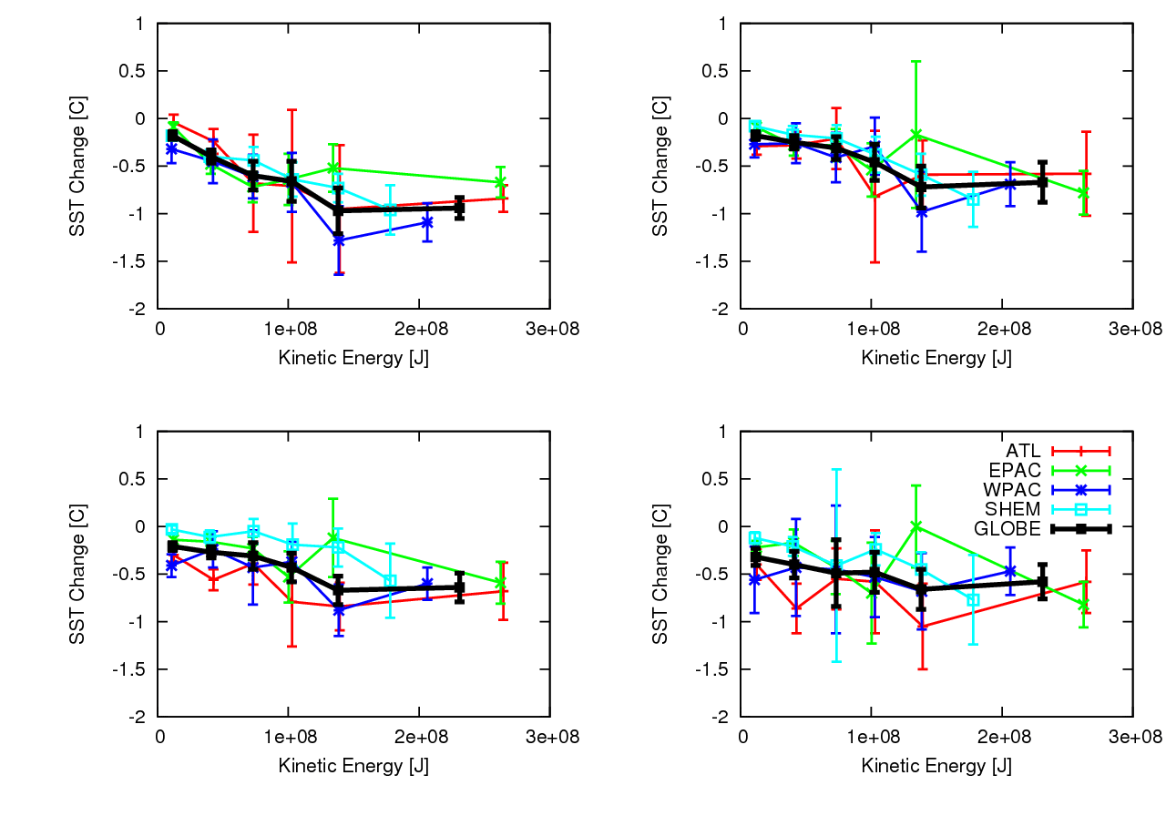
Figure 6. Mean SST changes as a function of KE (upper left) 10 days, (upper right) 20 days, (lower left) 30 days and (lower right) 60 days following TC passage. Mean values are indicated by the points and the bars indicate the 1 sigma value from the mean. Results are shown for the Atlantic (ATL, red), the east and central Pacific (EPAC, green), the northwest Pacific (WPAC, blue) and Southern Hemisphere (SHEM, magenta) TC basins as well as the global response (GLOBE, black).

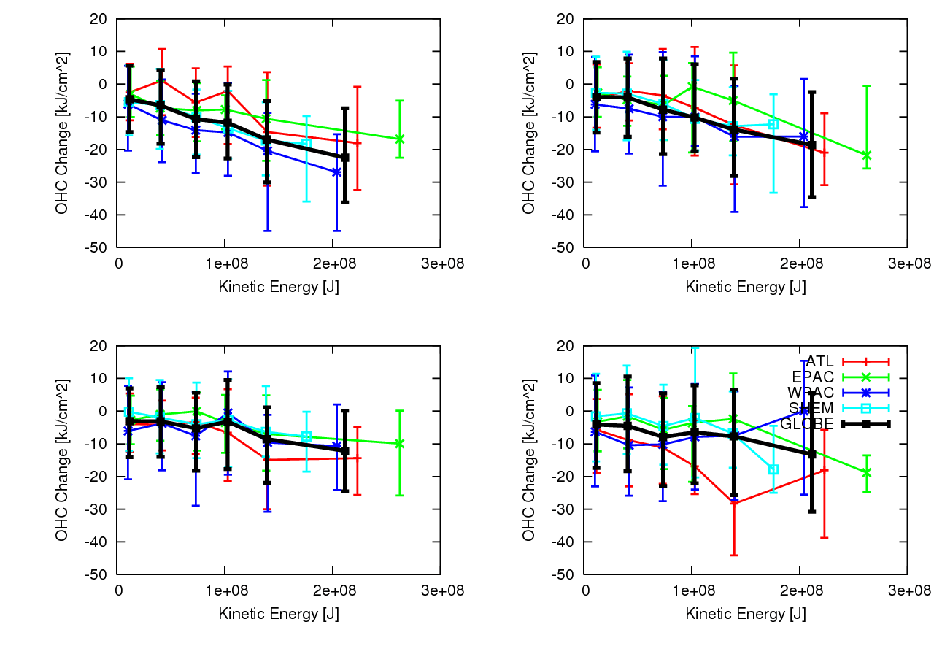
Figure 7. Typical OHC26C changes as a function of KE (upper left) 10 days, (upper right) 20 days, (lower left) 30 days and (lower right) 60 days following TC passage. Median values are indicated by the points and the bars indicate the quartile values from the median. Results are shown for the Atlantic (ATL, red), the east and central Pacific (EPAC, green), the northwest Pacific (WPAC, blue) and Southern Hemisphere (SHEM, magenta) TC basins as well as the global response (GLOBE, black).

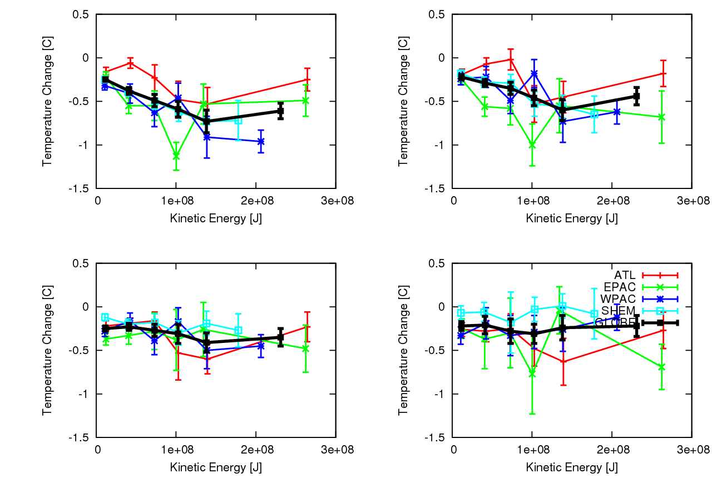
Figure 8. Identical to Fig. 6, except for T100M.

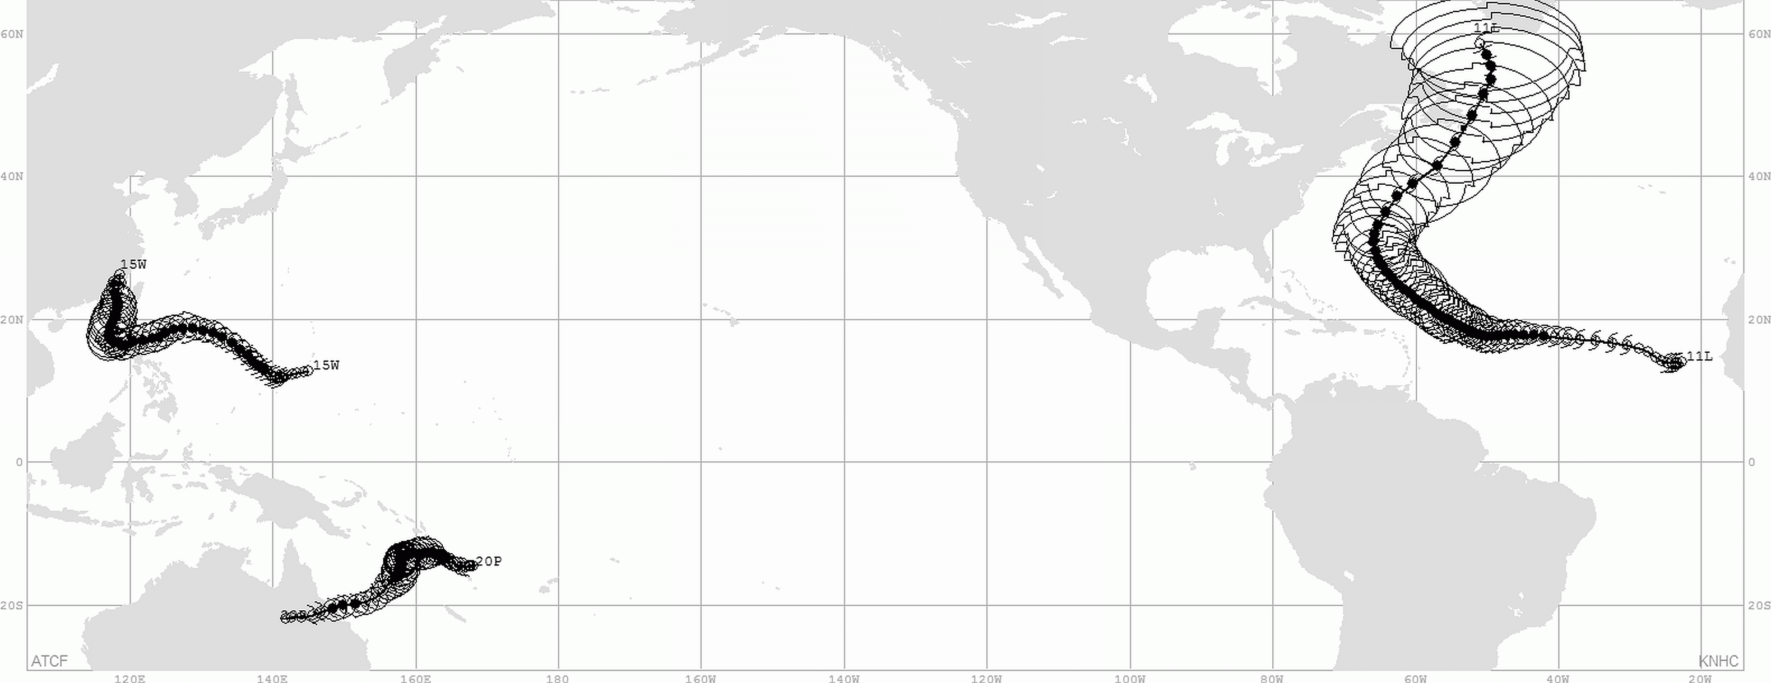
Figure 9. Best track locations and 34-kt wind radii for Typhoon Megi (15W, Western North Pacific), Tropical Cyclone Ului (20P, Southwest Pacific), and Hurricane Igor (11L, North Atlantic).

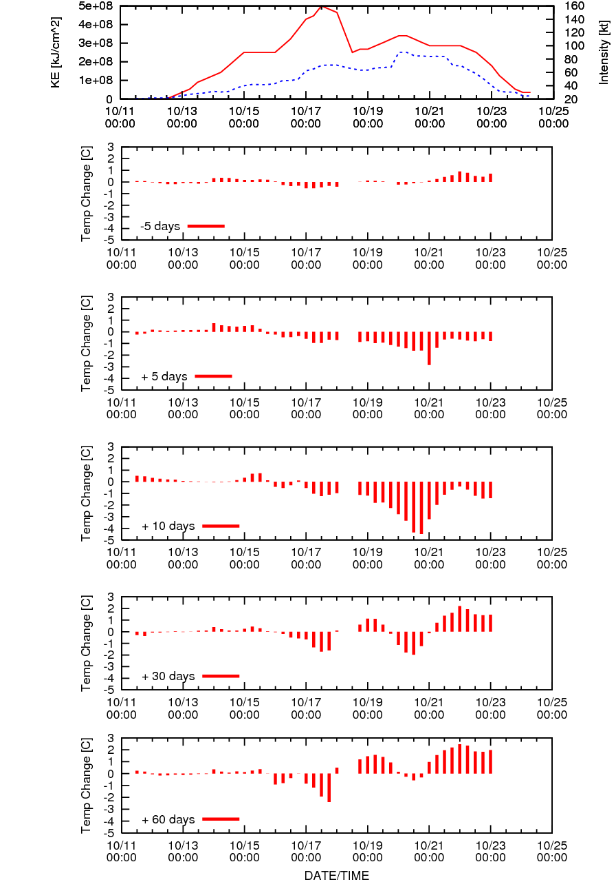
Figure 10. Time series associated with Typhoon Megi (15W). Shown are the (top panel) intensity and KE followed by the T100M changes observed 5 days prior to TC passage and 5, 10, 30, 60 days following TC passage.

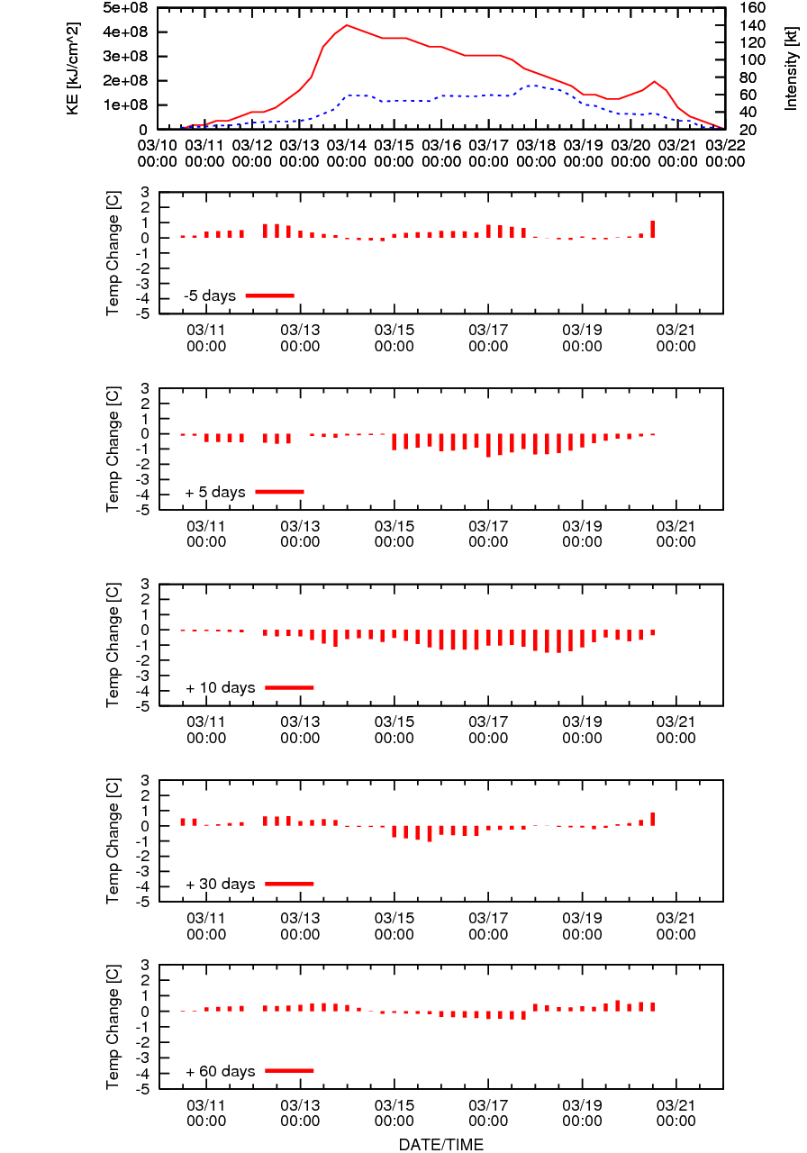
Figure 11. Same as Figure 10, except for Tropical Cyclone Uliu (20P).

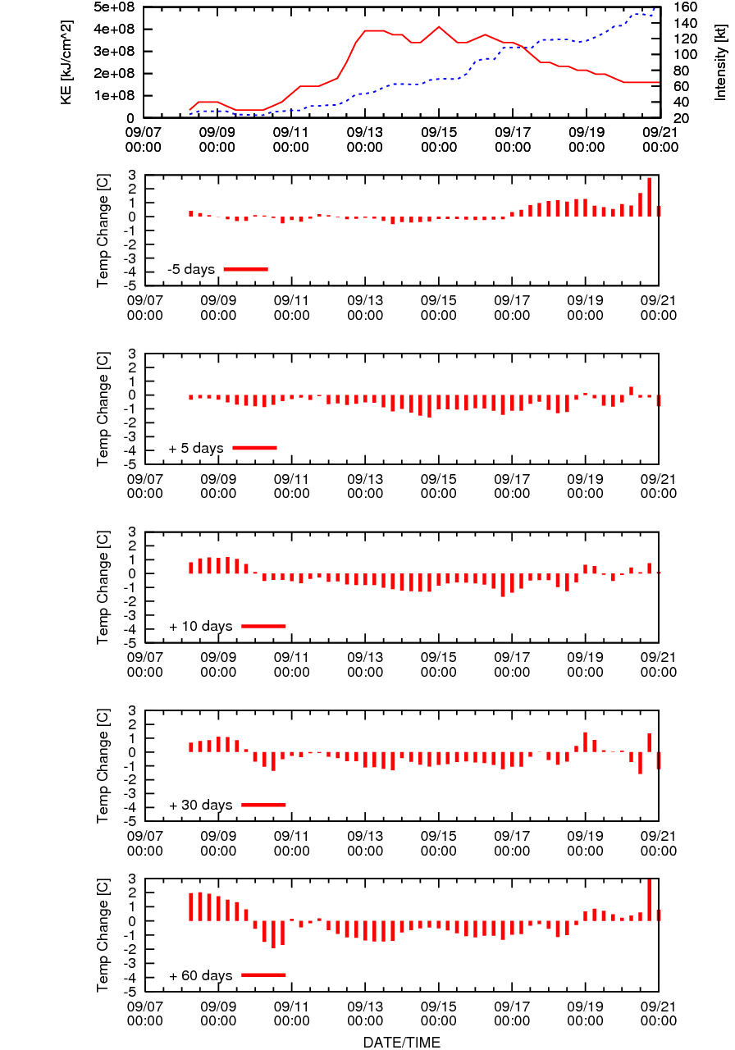
Figure 12. Same as Figure 10, except for Hurricane Igor (11L).

Corresponding Author: John Knaff, NOAA/NESDIS/RAMMB, Colorado State University, Campus Delivery 1375, Fort Collins, CO 80523-1375, John.Knaff@noaa.gov.
Leipper and Volgenau (1972) called this quantity “hurricane heat potential” . This quantity has also been referred to as “tropical cyclone heat potential” (see Goni et al. 2009, and references contained therein).
Best estimates of the maximum radial extent of 34- 50-, and 64-kt winds in quadrants around the TC. These have been reanalyzed post-season (i.e., best tracked) beginning in 2004 (Knaff et al. 2007)

