After a Decade Are Atlantic Tropical Cyclone Gale Force Wind Radii Forecasts Now Skillful?

John A. Knaff
NOAA Center for Satellite Applications and Research
Fort Collins, Colorado

and

Charles R. Sampson
Naval Research Laboratory
Monterey, California

Prepared for
Weather and Forecasting

Abstract

The National Hurricane Center (NHC) has a long history of forecasting the radial extent of gale force (or 34-knot) winds for tropical cyclones in the Atlantic basin out to 72 h. These are referred to collectively as gale force wind radii forecasts. These forecasts are generated as part of the 6-hourly advisory messages made available to the public. In 2004 NHC began a routine of post-analysis or “best tracking” of gale force wind radii that continues to this day. At approximately the same time, a statistical wind radii forecast, based solely on climatology and persistence, was implemented so that the NHC all wind radii forecasts could be evaluated for skill. This statistical wind radii baseline forecast is also currently used in several applications as a substitute to or to augment NHC wind radii forecasts.
This investigation examines the performance of the NHC gale force wind radii forecasts over the last decade. Results presented within indicate that NHC’s gale force wind radii forecasts have increased in skill relative to the best tracks by several measures, and now significantly outperform statistical wind radii baseline forecasts. These results indicate that it may be time to re-investigate whether applications that depend on wind radii forecast information can be improved through better use of NHC wind radii forecast information.

- Introduction

The estimation and forecast of surface winds associated with tropical cyclones (TCs) are important to a variety of public, private, and governmental stakeholders and applications. To provide information about TC risks, the National Hurricane Center (NHC) makes six-hourly forecasts of TC tracks, intensities and structures for all active TCs. The initial and forecast TC wind structures are provided in terms of the maximum radial extent of 34-, 50- and 64-kt or gale-force, damaging and hurricane-force winds in quadrants surrounding the TC. These are collectively referred to as wind radii. NHC forecasts hurricane-force wind radii through 36 hours, damaging and gale-force wind radii through 72 hours, while intensity and track are forecast through 120 hours.
Despite the difficulty of estimating wind radii from the available data, in 2004 NHC began post-season re-analysis (i.e., best-tracking) of wind radii, which provides an improved historical record of wind radii observations. Prior to that year, wind radii information was only available from the TC-vitals used for initializing model guidance. Like all best-tracking activities, the resulting estimates of wind radii are based on available technology and observations. The errors in those observations are thus a function of the methods, technology and observations available at the time. Because there are relatively few tools to estimate wind radii, errors associated with the best-track estimates may be as high as 25%–40% (Knaff and Harper 2010).
Accompanying the 2004 change in the best-tracking procedures was the development and operational implementation of the first purely statistical wind radii climatology and persistence or radii-CLIPER model (DRCL in ATCF; Knaff et al. 2007). DRCL has been run operationally at NHC since 2003 and offers a stable baseline forecasts to assess skill in other wind radii forecasts. In addition the DRCL has been used in the operational Monte Carlo wind speed probability product (DeMaria et al. 2009, DeMaria et al. 2013) that provides forecasts of the probability of hurricane-force, damaging and gale-force winds based on the official forecast, a 5-year sample of track and intensity errors, and the climatological errors associated with the variation of wind radii (via DRCL).
Significant TC intensity (DeMaria et al. 2014) and track forecast guidance improvements (Heming and Goerss 2010, and references within) have occurred. However, few attempts have been made to assess and document TC structure forecast skill or improvements. One such attempt, Knaff et al. (2006) found that NHC 2005 Atlantic gale force wind radii forecast errors were comparable to DRCL beyond 36 hours, that numerical weather prediction-based wind radii guidance was poor, and that if the best track intensity was known the DRCL forecast would have improved by 3 to 11 percent over the 72 hour forecast period. The latter point suggests that with improved intensity forecasts one would expect both DRCL and the official NHC wind radii forecast to also improve.
With a decade of best-tracked wind radii, this paper will examine the evolution of gale force wind radii prediction in the North Atlantic TC basin, where the observations of TC structure are arguably the most accurate. Official forecasts from the NHC will be examined in terms of mean absolute errors, mean error or bias, probability of detection and probability of false detection versus the performance of an operational baseline model, DRCL, to determine if there has been any improvement in the ability to forecast TC structure. Details of how the verification is conducted and results follow.

- Data and Methods

The verification of maximum extent of gale force winds (R34) is based on post-season/final best track data, operational forecasts made by NHC (OFCL), and operational forecasts made by DRCL during the period 2004-2013. R34 is estimated and forecasted in earth relative quadrants (Northeast, Southeast, Southwest, and Northwest) surrounding TCs that have intensities of 34 knots or greater. NHC makes OFCL forecasts of intensity and track through 120 hours and OFCL forecasts of R34 through 72 hours. The input data for each DRCL forecast is the corresponding OFCL track and intensity forecast and results in DRCL being available for all OFCL forecasts which insures a fair baseline forecast comparison can be constructed.
This study will concentrate on R34 verification statistics since R34 is likely best observed/estimated and is available more frequently. The authors are aware of the R34 quality and dependency issues and will attempt to address those issues throughout the manuscript. All the forecast data used in this study are contained in the Automated Tropical Cyclone Forecast system (ATCF; Sampson and Schrader 2000) databases and are freely available from NHC.
To calculate verification statistics, forecast values of R34 in each quadrant and at each forecast lead time are compared to the final best track values. The occurrence of zero valued-wind radii introduces an added complication of verifying wind radii. Zero-valued wind radii typically occur when storms are near the 34 knot intensity or storm translation speeds are large (i.e., > 8 ms⁻¹). For this study the following verification strategy is adopted. If any of the quadrants in the best track have non-zero wind radii, all quadrants for that case are verified. That strategy allows the individual quadrant statistics to be combined to form a single measurement of mean absolute error (MAE) and Bias (i.e., the mean error) for each 6-hourly forecast lead time and results in an approximately 20-25% increase in the number of cases. Since the forecast of R34 are in units of nautical miles [n. mi; 1 n. mi = 1.85 km] and of intensity in units of knots [kt; 1 kt = .514 ms⁻¹], these units will be used throughout.
To evaluate the ability of forecasts to discriminate the occurrence of R34 and to complement the MAE and Bias statistics, the Probability Of Detection (POD), Probability of False Detection (POFD) and Peirce Skill Score (PSS=POD-POFD) are also determined from 2 x 2 contingency tables.
To keep the verification statistics presented here succinct, this study presents just the combined, all quadrant statistics. MAE, Bias, POD, are POFD calculated for both OFCL and DRCL forecasts in a homogeneous manner (i.e., they include identical realizations). These basic statistics are then used to calculate the PSS, and the percent of forecast improvement relative to DRCL (SKILL). Using these results trend analysis is performed to determine if OFCL forecasts of R34 have improved over the last decade. The trends will be calculated using the sample sizes of the individual years so that the number of forecasts is accounted for explicitly. Statistical significance in this paper is assessed using a Student’s t test assuming one-tail and the 95% level. The results of that analysis are presented in the next section.

- Results

Since the number of cases and mean intensity of each year’s verification sample are important aspects of the statistical analyses and discussion, they are presented in Table 1. It is noteworthy that the mean intensity varies from 68 kt in 2004 to 43 kt in 2013. The annual variation of seasonal mean intensity is important since more intense TCs tend have more symmetric features (i.e., fewer missing quadrant values) and generally larger R34. For instance, in our verification sample the mean R34 increases approximately 1.3 n. mi per kt of intensity with a regression coefficient of r=0.52. Also, since the number of cases will influence the linear trends calculated from MAE and SKILL, one should note that active years like 2004, 2005, 2008, 2010 and 2012 will receive greater weight than inactive years like 2009 and 2013.
The first verification statistic examined is the annual time series of MAEs associated with the all quadrant R34 forecasts. Figure 1 shows those results for both DRCL and OFCL forecasts at lead times of 24-h, 48-h and 72-h accompanied by the linear trend associated with each time series. These plots show both upward trends in the DRCL errors and downward trends in the OFCL forecasts, both of which are statistically significant at all times. The upward trends in DRCL are thought to be primarily driven by changes in the mean annual intensity, which has been generally falling as shown in Table 1. In fact, DRCL MAEs decrease with increasing sample intensity with downward trends of -0.25, -0.55, and -.79 n. mi per kt explaining 11, 26, and 29% of the variance for 24-h, 48-h, and 72-h forecasts, respectively. The downward trends in OFCL MAEs over time are also statistically significant and are the first suggestion that R34 forecasts have been improving over the last decade.
Figure 2 shows the time series of OFCL and DRCL forecast biases for 24-h, 48-h and 72-h forecasts. It appears that the biases of both OFCL and DRCL are correlated from 2004-2009, with OFCL biases being generally closer to zero. This is particularly evident for the 72-h forecasts. In and around 2010 and thereafter, OFCL biases are noticeably closer to zero. This suggests that some of the reduction in MAE shown in Figure 1 may be the result of less biased forecasts of R34. One speculation is that the bias reduction is related to intensity forecast, which have also been improving (DeMaria et al. 2014).
Another way of investigating improvements in R34 forecasts is to construct skill diagrams, where SKILL is the percent improvement of MAE with respect to DRCL at each forecast lead time. SKILL trends are positive and statistically significant with annual improvements of 2, 3, and 3% for 24-h, 48-h, and 72-h forecast lead times, respectively. Figure 3 shows the multi-year SKILL of the OFCL forecasts. Here we have averaged the two three-year periods, 2004-2006 and 2007-2009, and one four-year period 2010-2013. Multi-year SKILL averages provide large enough samples to assess statistical significance, adjusted for 30-h serial correlation, and clearly illustrates that the most significant improvements occurred in the 2010-2013 time period. Much like the results presented in Knaff et al. (2006), the skill of the OFCL forecasts is statistically significant (larger markers) through 24-h in the first two time periods – suggesting little or no SKILL improvements during 2004-2009. However, the 2010-2013 OFCL forecast SKILL is both larger in magnitude at all time periods and the statistical significance extends through the 72-h forecast lead time.
To complete the evaluation, we investigate probability of detection and false alarms via the PSS. The PSS defines the accuracy of the forecast in predicting the correct category, relative to that of random chance. The PSS ranges from -100 to 100 %, and zero indicates no skill while a 100 % indicates perfect skill. In this case the category is the existence of non-zero R34 in the various quadrants. Figure 4 shows the time series of PSS for OFCL and DRCL for the 24-h, 48-h and 72-h forecast lead times. Trend lines, again weighted for the number of cases, are provided for each forecast lead time and model. Both OFCL and DRCL have skill at 24-, 48-, and 72-h based on this statistic, but the year-to-year variations are quite large. The only significant trends are DRCL (downward) at 24 hours, and both DRCL and OFCL (upward) at 72 hours. The 24-h downward trend of DRCL is likely related to the mean intensity of the seasons, whereas the improved PSSs at 72 hours is likely related to decreasing MAEs of the OFCL intensity forecast at 72 hours (Cangialosi and Franklin 2014).
One can also compare PSS of the OFCL and DRCL by constructing percent improvement of OFCL PSS relative to DRCL. While this is an uncommon statistical approach, in this case it offers some additional insight about the performance of the OFCL R34 forecasts over the last decade. Figure 5 shows the percent improvement of the OFCL PSS relative to the DRCL PSS for the 24-h, 48-h, and 72-h forecast lead times along with the associated linear trends. It shows that all lead times have statistically significant upward trends. However, the trends suggest that the OFCL forecast has only recently shown improvement over DRCL in its ability to forecast the occurrence of non-zero R34 values. The cross-over to skillful depiction of non-zero R34 values occurs in 2007, 2011, and 2012, for the 24-h, 48-h and 72-h forecasts. These statistics offer additional evidence that the OFCL R34 forecasts have been steadily improving relative to the R34 in the best tracks and have recently outperformed the purely statistical forecasts of DRCL. Also, the DRCL R34 forecasts tend to become more symmetric with forecast time, which are not necessarily realistic. The NHC wind radii look more realistic in the longer forecast leads, at least anecdotally.

- Conclusions, Discussion, and Recommendations

The results presented indicate that the NHC has reached a point where its 72-h gale force wind radii forecasts are generally better than DRCL or skillful. We recognize that there is some debate about whether the gale force wind radii in the best tracks can serve as ground truth for forecast evaluation because of concerns with sparse, intermittent and poor quality observations. In an independent study, Cangialosi and Landsea (2013) attempted to address the shortcomings in best track wind radii estimation by using only the highest quality best track data, and found that those wind radii forecasts demonstrated similar skill as was found in our work. We have also conducted experiments that introduce random errors (maximum of 40%) to the best track ground truth, but doing so does not alter our conclusions. Finally, there is concern that the gale force wind radii best tracks are dependent on the forecasts. We think that is a valid concern, but we also think that this effect fades as the forecast lead increases. Previous work has shown that wind radii persistence has an e-folding time of roughly 32 hours (Knaff et al. 2007). In our work we explicitly account for 30-h serial correlation in the best tracks and forecasts. Even with these sample size reductions, our conclusions still hold. Regardless of these issues, one can at minimum state that the NHC gale force wind radii forecasts have become more representative of the gale force wind radii in the best tracks to a point where they appear to be more representative than DRCL forecasts.
These results suggest that significant progress is being made in the ability to forecast gale force wind radii. In fact a cursory examination of gale force wind radii forecasts from several numerical weather prediction systems suggest that those forecasts were also skillful in the 2011-2013 time period. This certainly was not the case in 2005 (Knaff et al. 2006). Furthermore, since DRCL is available for all OFCL forecast times, it is used as a substitute for OFCL wind radii forecasts in for some applications (e.g., DeMaria et al. 2009, 2013), while other applications (e.g., Sampson et al. 2010) extrapolate the existing OFCL forecast wind radii to 120 h. Neither approach seems optimal given the probable advances in skill of the NHC OFCL gale force wind radii, and possibly of the other wind radii as well. Rather it appears that these algorithms would be better served by leveraging advances in NHC wind radii forecasts than the statistical proxies currently employed.
Finally, the progress indicated by this study’s results would not be possible without the decade long history of wind radii contained in the best track. Despite the purported issues with these measurements, they are invaluable for product development and validation. We therefore would like to encourage other forecast centers to produce post-season analyses of wind radii.

Acknowledgments: The authors would like to acknowledge the staff at the National Hurricane Center for their diligence in 10 years of best tracking the wind radii, and also Ann Schrader and Mike Frost for helping to make that process a bit easier. We also acknowledge the Office of Naval Research for funding efforts to improve tropical cyclone intensity forecasting. We also thank Jack Dostalek and Kate Musgrave of CIRA and James Franklin of NHC for comments on the initial manuscript. The views, opinions, and findings contained in this report are those of the authors and should not be construed as an official National Oceanic and Atmospheric Administration or U.S. Government position, policy, or decision.

References
Cangialosi, J. P. and J. L. Franklin, 2014: 2013 National Hurricane Center Forecast Verification Report, 84 pp.
Cangialosi, J. P. and C. W. Landsea, 2014: National Hurricane Center forecast wind radii verification. Proc. 31st Conference on Hurricanes and Tropical Meteorology 31 March-4 April 2014
DeMaria, M., J.A. Knaff, R. Knabb, C. Lauer, C.R. Sampson, R.T. DeMaria, 2009: A New Method for Estimating Tropical Cyclone Wind Speed Probabilities. Wea. Forecasting. 24, 1573–1591.
DeMaria, M., J. A. Knaff, M. Brennan, D. Brown, C. Lauer, R. T. DeMaria, A. Schumacher, R. D. Knabb, D. P. Roberts, C. R. Sampson, P. Santos, D. Sharp, and K. A. Winters, 2013: Improvements to the Operational Tropical Cyclone Wind Speed Probability Model, Wea. Forecasting, 28, 586-602. doi: http://dx.doi.org/10.1175/WAF-D-12-00116.1
Heming J. and J. Goerss, 2010: Track and Structure Forecasts of Tropical Cyclones. Global Perspectives on Tropical Cyclones: pp. 287-323. doi: 10.1142/9789814293488_0010
Knaff J.A., and B.A. Harper, 2010: Tropical cyclone surface wind structure and wind-pressure relationships. Proc. WMO Int. Workshop on Tropical Cyclones—VII, La Reunion, France, WMO, KN1, 35 pp. [Available online at http://www.wmo.int/pages/prog/arep/wwrp/tmr/otherfileformats/documents/KN1.pdf.]
Knaff, J. A., C. Guard, J. Kossin, T. Marchok, C. Sampson, T. Smith, and N. Surgi, 2006: Operational guidance and skill in forecasting structure change. Proc. WMO Int. Workshop on Tropical Cyclones—VI, San Juan, Costa Rica, WMO, 160-184. [Available online at http://severe.worldweather.org/iwtc/document/Topic_1_5_John_Knaff.pdf]
Knaff, J. A., C. R. Sampson, M. DeMaria, T. P. Marchok, J. M. Gross, and C. J. McAdie, 2007: Statistical tropical cyclone wind radii prediction using climatology and persistence. Wea. Forecasting, 22, 781–791.
Leith, C.E. 1973: The standard error of time-average estimates of climate means. J. App. Meteor., 12, 1066-1069.
Sampson, C. R., and A. J. Schrader, 2000: The automated tropical cyclone forecasting system (version 3.2). Bull. Amer. Meteor. Soc., 81, 1231–1240.
Sampson, C. R., P. A. Wittmann, and H. L. Tolman, 2010: Consistent tropical cyclone wind and wave forecasts for the U.S. Navy. Wea. Forecasting, 25, 1293-1306.

Figure Captions:

Figure 1. Time series of annual R34 forecast MAEs associated with OFCL (blue) and DRCL (red) forecasts for lead times of 24, 48 and 72 hours. Along with the annual MAEs linear trends for each model have been calculated based on the MAEs and the number of cases (see Table 1). Trend equations and R² statistics are provided for each trend.
Figure 2. Time series of annual R34 forecast biases associated with OFCL (blue) and DRCL (red) forecasts for lead times of 24, 48 and 72 hours.
Figure 3. Percent improvement of MAEs with respect to DRCL forecasts for the period 2004-2006 (blue), 2007-2009 (red), and 2010-2013 (green). Statistical significance, accounting for 30-h serial correlation, is indicated by the larger line markers.
Figure 4. Time series of yearly R34 PSS associated with OFCL (blue) and DRCL (red) forecasts for lead times of 24 (top), 48 (middle) and 72 hours (top). PSS temporal trends for each model have been calculated based on the PSSs and the number of cases (see Table 1) and are provided by the blue and red lines. Equations and corresponding R² statistics are provided for each trend. .
Figure 5. Time series of yearly percentage improvements in the PSSs associated with OFCL and DRCL forecasts for lead times of 24 (blue), 48 (red) and 72 (green) hours are provided as points. Linear trends for each forecast time have been calculated based on the MAEs and the number of cases (see Table 1) and are shown as blue, red, and green lines for 24, 48, and 72 hours respectively. Equations and R2 statistics are provided for each trend.
Table 1. Sample sizes (number of verification times), and mean best track intensity [knots] associated with the annual R34 verification subsets.
YEAR | SAMPLE SIZE |  |  | MEAN INTENSITY
 | 24-h | 48-h | 72-h
2004 | 301 | 250 | 218 | 68
2005 | 428 | 353 | 278 | 59
2006 | 194 | 163 | 128 | 54
2007 | 111 | 73 | 50 | 55
2008 | 292 | 240 | 194 | 60
2009 | 81 | 57 | 49 | 57
2010 | 292 | 240 | 194 | 60
2011 | 258 | 201 | 156 | 54
2012 | 333 | 267 | 213 | 53
2013 | 105 | 65 | 33 | 43

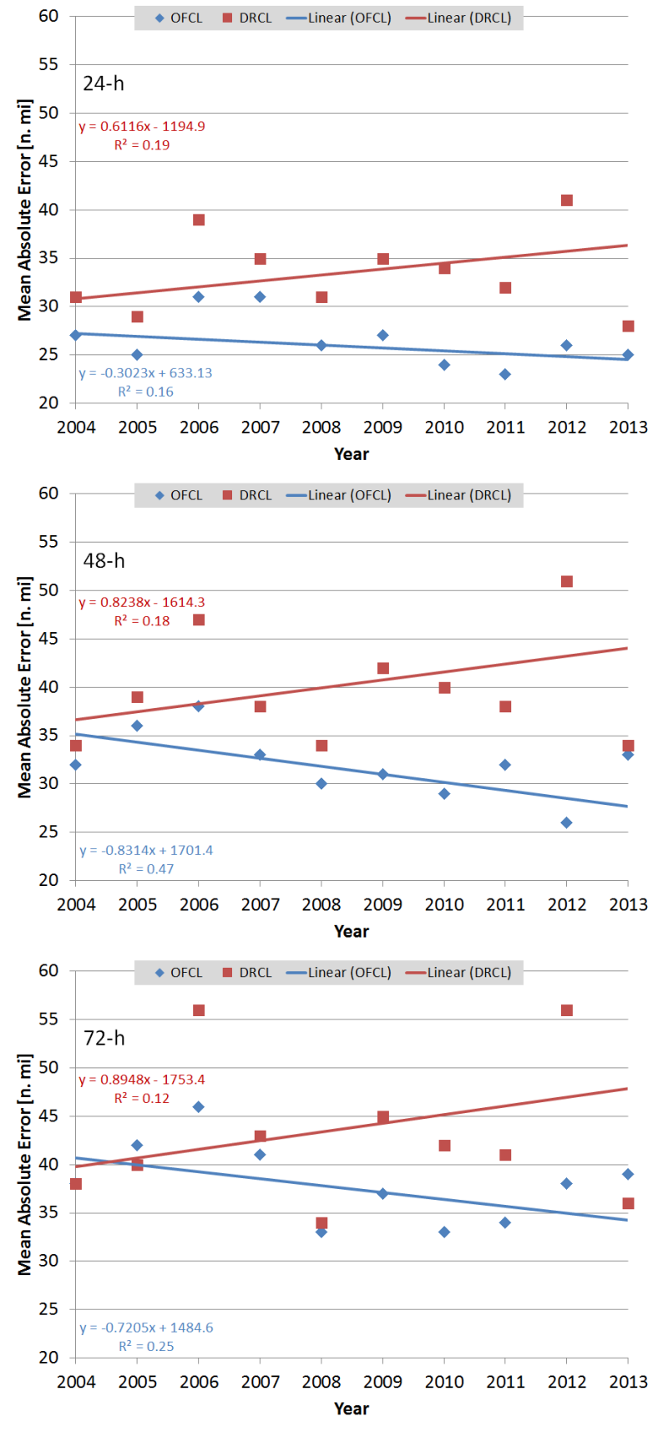
Figure 1. Time series of annual R34 forecast MAEs associated with OFCL (blue) and DRCL (red) forecasts for lead times of 24, 48 and 72 hours. Along with the annual MAEs linear trends for each model have been calculated based on the MAEs and the number of cases (see Table 1). Trend equations and R² statistics are provided for each trend.
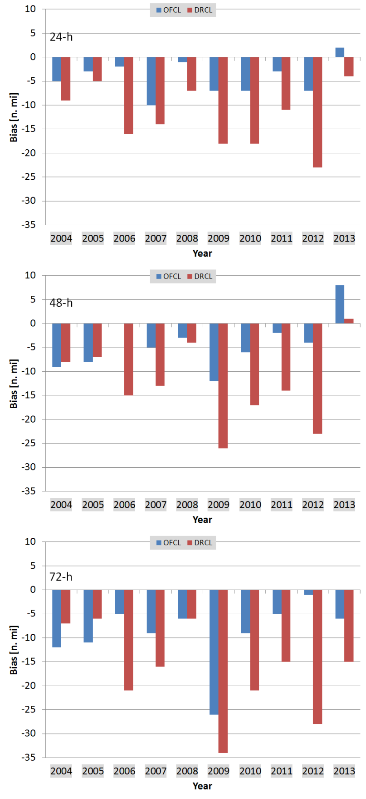
Figure 2. Time series of annual R34 forecast biases associated with OFCL (blue) and DRCL (red) forecasts for lead times of 24, 48 and 72 hours.
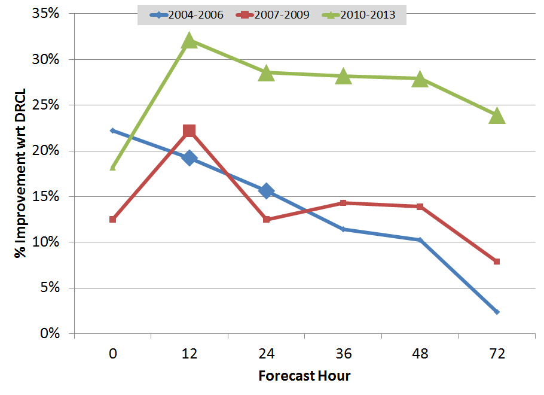
Figure 3. Percent improvement of MAEs with respect to DRCL forecasts for the period 2004-2006 (blue), 2007-2009 (red), and 2010-2013 (green). Statistical significance, accounting for 30-h serial correlation, is indicated by the larger line markers.

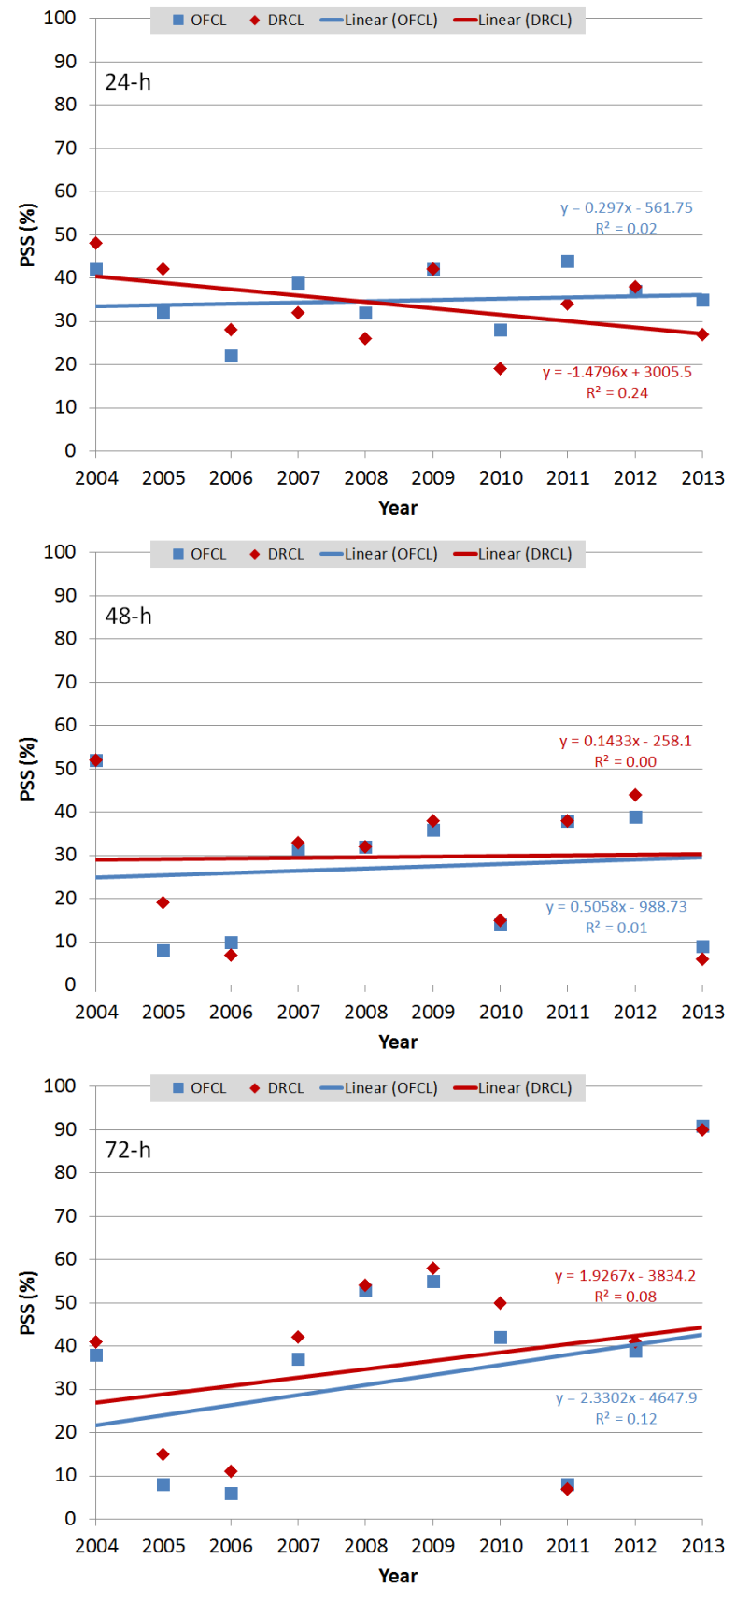
Figure 4. Time series of yearly R34 PSS associated with OFCL (blue) and DRCL (red) forecasts for lead times of 24 (top), 48 (middle) and 72 hours (top). PSS temporal trends for each model have been calculated based on the PSSs and the number of cases (see Table 1) and are provided by the blue and red lines. Equations and corresponding R² statistics are provided for each trend.
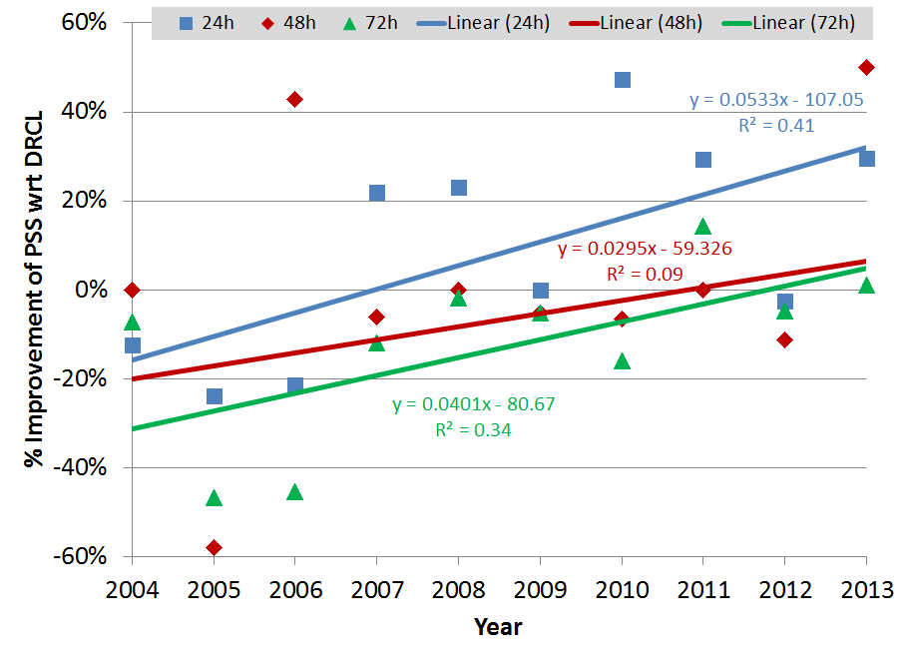
Figure 5. Time series of yearly percentage improvements in the PSSs associated with OFCL and DRCL forecasts for lead times of 24 (blue), 48 (red) and 72 (green) hours are provided as points. Linear trends for each forecast time have been calculated based on the MAEs and the number of cases (see Table 1) and are shown as blue, red, and green lines for 24, 48, and 72 hours respectively. Equations and R² statistics are provided for each trend.

In the Automated Tropical Cyclone Forecast (ATCF; Sampson and Schrader 2000) system these are the CARQ entries in the aid deck (adeck). TC vitals have also been referred to as “the bogus” in past literature.
The effective sample size used for the Student’s t test is estimated to be the number of 30 h samples contained in the dataset, which was described as the time between effectively independent samples (Leith 1973).

