10.35 µm: An atmospheric window with less moisture attenuation

Daniel T. Lindsey
NOAA/NESDIS/STAR/RAMMB, Fort Collins, Colorado

Timothy J. Schmit
NOAA/NESDIS/STAR/ASPB, Madison, WI

Wayne M. MacKenzie, Jr.
Earth Resources Technology, Inc., Laurel, MD

Christopher P. Jewett
University of Alabama-Huntsville, Huntsville, AL

Mat M. Gunshor
Cooperative Institute for Meteorological Satellite Studies, Madison, WI

Louie Grasso
Cooperative Institute for Research in the Atmosphere, Fort Collins, CO

Submitted to:
Journal of Applied Remote Sensing
May 2012

Abstract
With the launch of GOES-R expected in 2015, research is currently underway to fully understand the characteristics of every channel on its Advanced Baseline Imager (ABI). The ABI will have two infrared window bands centered near 10.35 µm and 11.2 µm. Since no broad-band space-borne sensor has a channel near 10.35 µm, radiative transfer model simulations are used to study the clear-sky gaseous absorption properties in this wavelength range. It is shown that water vapor preferentially absorbs radiation at 11.2 µm compared to 10.35 µm, making the 10.35 µm a “cleaner” window infrared band.

1. Introduction

Currently scheduled for launch in late 2015, the next generation of geostationary satellites, GOES-R, will become the first in a series of satellites for the National Oceanic and Atmospheric Administration (NOAA) carrying a state-of-the-art imaging payload. Among the new instruments aboard is the Advanced Baseline Imager (ABI, Schmit et al. 2005), offering significant spatial, temporal, and spectral improvements over the current GOES imager. Work is currently underway to design new algorithms for the ABI, so that when the satellite is launched, the new data and products will immediately begin flowing to the users (Goodman et al. 2012).
A list of the bands available on the ABI is provided in Table 1. Note that there are two bands within the traditional infrared (IR) window portion of the spectrum (10-12 µm): one centered near 10.35 µm (band 13) and another near 11.2 µm (band 14). The central wavelength is calculated via a weighted average and can routinely change from instrument to instrument based upon sensor characteristics. Currently, the expected central wavelength of band 13 for the first ABI is actually 10.33 µm. The term “window” refers to a band with relatively little atmospheric absorption by gases such as water vapor and carbon dioxide. Window IR channels are normally used for viewing both surface and cloud features, and their brightness temperatures are often used as a proxy for the radiating temperatures of these features, since emissivity values in this wavelength range are typically 0.96-1.0 (Nerry et al. 1990). Bands near 11.2 µm can be found on a variety of imagers, including GOES-8 to -15 (10.7 µm), MSG/SEVIRI (10.8 µm), MODIS (11.0 µm), and VIIIRS (10.8 and 11.4 µm). However, no broad-band space-borne instrument has a band centered near 10.3 µm, meaning research is necessary to fully understand the relative advantages of the two ABI window bands. The MODIS Airborne Simulator (MAS, King et al. 1996) was flown aboard aircraft in the early 1990’s and had a channel centered at 10.55 µm, but this band was ultimately not chosen for the MODIS instrument. This MAS band was used as heritage to the band selected on the ABI. Another option is to simulate the broad bands using high-spectral resolution instruments, such as IASI or CrIS (Hilton et al. 2012). The ABI data will be remapped to a fixed projection. At the satellite sub-point, the pixel spacing will be 1 km for ABI bands 1, 3 and 5, and ABI band 2 will be at 0.5 km. All other ABI spectral bands will be at 2 km.
The goals of this paper are to address three questions: 1) What are the relative advantages of the 10.35 µm and 11.2 µm channels? 2) Should one of them be the default atmospheric window IR band on the ABI? 3) For algorithm development, which window band is more appropriate, or should both be used? To help answer these questions, we will make use of three different radiative transfer models (RTM). Section 2 will present the RTM results, section 3 will discuss other factors such as cloud absorption, and a summary is found in section 4.
Band | Approximate Central Wavelength  (µm) | FWHM at 50% minimum  (µm) | FWHM at 50% maximum  (µm)
1 | 0.47 | 0.45 | 0.49
2 | 0.64 | 0.60 | 0.68
3 | 0.86 | 0.85 | 0.88
4 | 1.38 | 1.37 | 1.39
5 | 1.61 | 1.59 | 1.63
6 | 2.25 | 2.23 | 2.27
7 | 3.90 | 3.80 | 4.01
8 | 6.16 | 5.78 | 6.59
9 | 6.93 | 6.72 | 7.14
10 | 7.34 | 7.25 | 7.44
11 | 8.50 | 8.31 | 8.70
12 | 9.61 | 9.43 | 9.81
13 | 10.33 | 10.17 | 10.48
14 | 11.2 | 10.8 | 11.6
15 | 12.3 | 11.9 | 12.8
16 | 13.3 | 13.0 | 13.6
Table 1. Summary of the ABI wavelengths, based on the Prototype Flight Model (PFM). Full Width at Half Maximum (FWHM) minimum and maximum values are also listed.
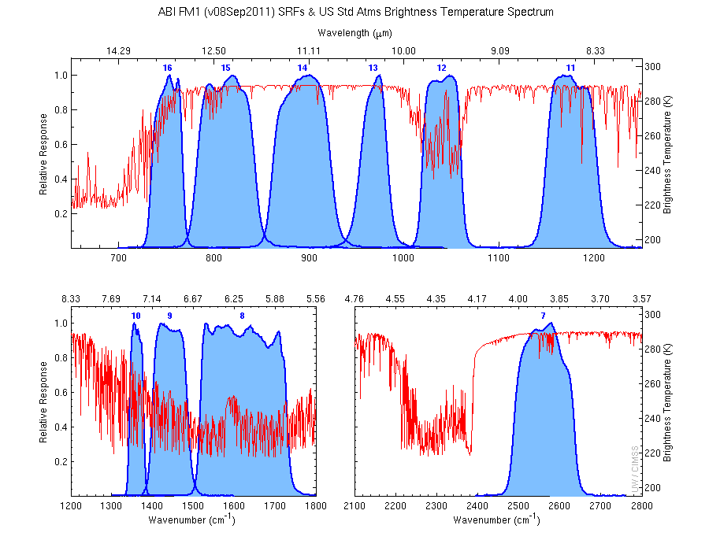
Figure 1. Spectral response functions for the ABI IR bands (blue curves) along with the calculated absorption lines (red) from the LBL (line-by-line) model using the standard U.S. Atmosphere.

2. Radiative Transfer Model Simulations

Results from three different RTMs will be presented to avoid any model-specific biases. The goal is to investigate what gases contribute to the absorption characteristics within the 10.35 µm and 11.2 µm bands.
a. Wisconsin RTM (PFAAST)
Fig. 2 shows a simulation using the Wisconsin RTM (Hannon et al. 1996), including the spectral response functions (SRF) for the ABI 10.35 µm, 11.2 µm and GOES-13 10.7 µm bands. The 10.35 µm SRF is more spectrally narrow than both the 10.7 µm and 11.2 µm SRF and includes no information from any absorption lines greater than around 11.0 µm. Note also that the left tail of the 10.35 µm SRF is just less than 10.0 µm, where ozone absorption begins to become significant. The 11.20 µm SRF extends above 11.6 µm and therefore includes some water vapor absorption lines that are common in the region between 11.0 and 12.5 µm. A more detailed examination of the relative contributions of each absorbing gas is found in the next subsection.

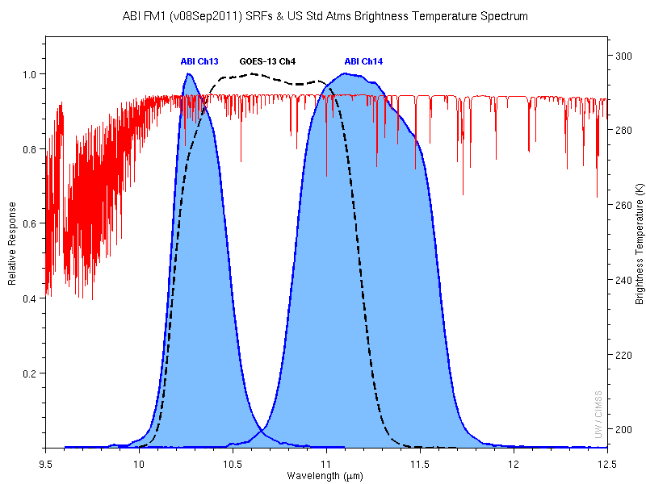
Figure 2. Spectral response functions for the ABI band 13 (10.35 µm, blue curve on the left) and band 14 (11.2 µm, blue curve on the right), along with the GOES-13 Imager band 4 (10.7 µm, black dotted line), and the calculated absorption lines (red) from the LBL ( line-by-line) model using the standard U.S. Atmosphere.

b. Line-by-Line RTM
In the next series of experiments, the Line-by-Line RTM (LBLRTM) is used to understand what gases contribute to the brightness temperatures observed at both ABI IR window bands. The LBLRTM heritage is based on FASCODE (Clough et al. 1981, 1992, 2005), and uses the HITRAN database (Rothman et al. 2008) to determine the spectral properties of the various atmospheric constituents. This model allows for high spectral resolution when performing the line calculations. For this study, a spectral resolution of 0.1 cm⁻¹ was used to ensure that the brightness temperature calculations were accurate. Surface emissivity values are set to 1.0 for all simulations. Fig. 3 shows the sounding used in the simulations in this section. It is a mid-summer morning sounding from Birmingham, AL, with a surface temperature of 291 K, so although the low-level water vapor content is relatively large, the low-level temperature lapse rate is fairly stable. This is important because the effect of water vapor absorption on satellite-observed brightness temperatures is accentuated with unstable lapse rates, so although the effect of water vapor will be evident in the RTM simulation results, the magnitude would be significantly larger if an afternoon sounding had been used.

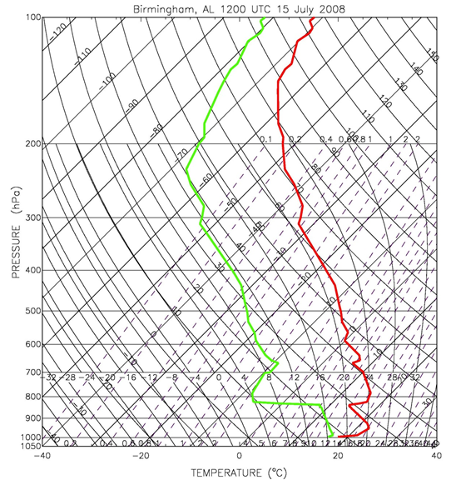
Figure 3. Sounding from Birmingham, AL, at 1200 UTC on 15 July 2008. Red is the temperature profile and green is the dew point profile. This sounding was used in all of the experiments using the LBLRTM.

Simulation results are presented in Fig. 4. When all absorbing species are included (Fig. 4a), the 10.35 µm brightness temperature is approximately 1 K warmer than at 11.2 µm, suggesting more gaseous absorption at 11.2 µm. When all gases besides water vapor are removed (Fig. 4b), the spectrum of absorption appears largely the same above about 10.8 µm. Comparing the integrated brightness temperatures at 11.2 µm using all species (285.90 K) with that using only water vapor (285.95 K), it is evident that water vapor is responsible for essentially all gaseous absorption within this band; other gases are responsible for only 0.05 K additional cooling in this simulation. At 10.35 µm, however, gases besides water vapor are responsible for 1.13 K cooling, a more significant value.
The two other major atmospheric constituents that absorb longwave radiation with then 10.35 μm channel are ozone and carbon dioxide. For Figs. 4c and 4d, profiles of ozone and carbon dioxide were set to the 1976 U.S. Standard Atmosphere values. Fig. 4c shows the results when only ozone is included. The ozone absorption region around 9.5 µm extends to around 10.0 µm, so as was mentioned above, the 10.35 µm band experiences a small amount of ozone absorption. Comparing the two brightness temperatures, ozone is responsible for about 0.5 K cooling relative to the 11.20 µm band, which has no absorption at all in this simulation. Carbon dioxide also has some small absorption lines between 10.0 and 11.0 µm (Fig. 4d) which produce about 0.7 K cooling in the 10.35 µm band in this simulation, while the 11.20 µm remains almost completely unaffected. The combined cooling from ozone and carbon dioxide is about 1.2 K in the 10.35 µm band, and near zero in the 11.2 µm.

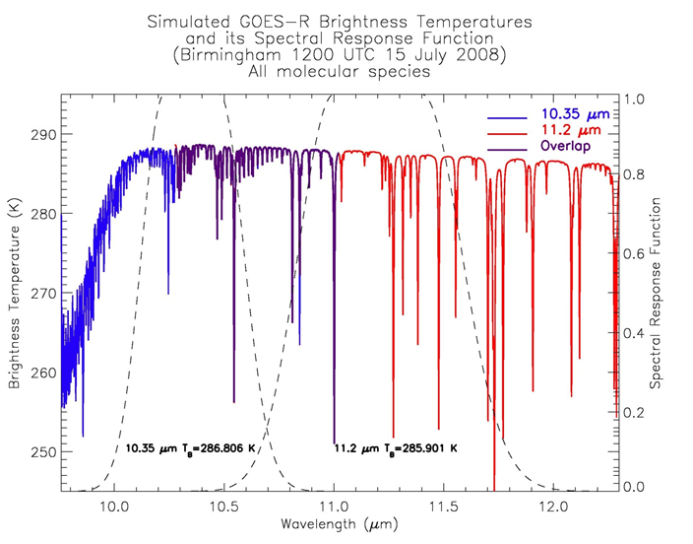
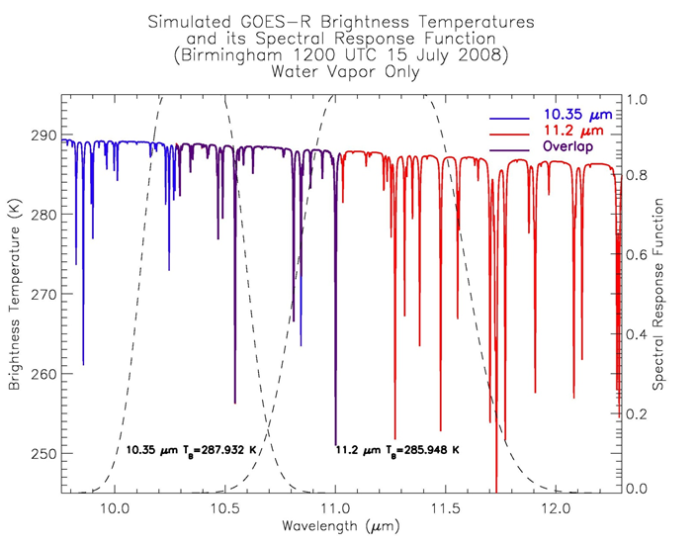
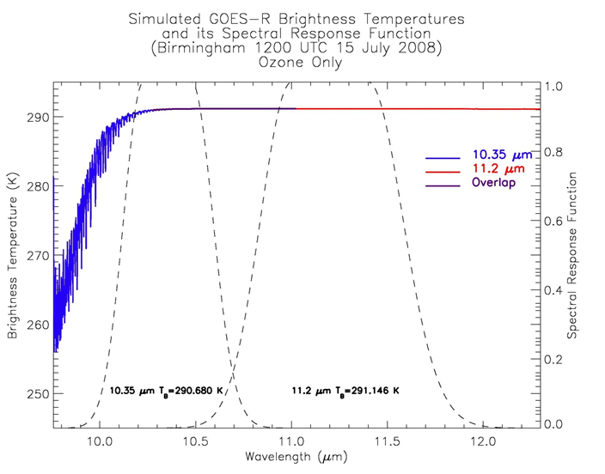
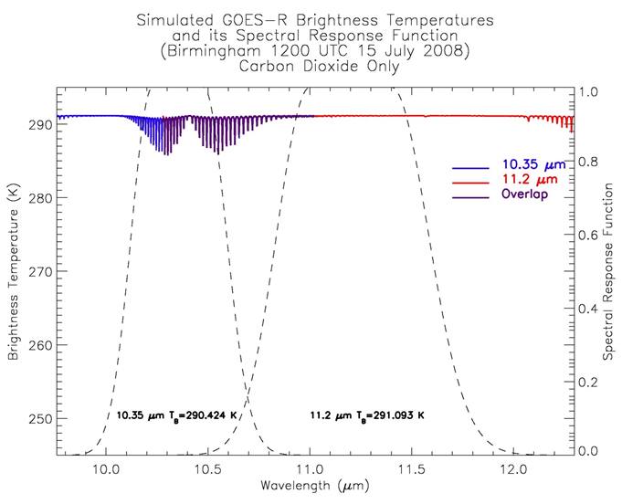

Figure 4. Results of the LBLRTM using the sounding from Fig. 3. On every plot, the dashed lines are the approximate 10.35 µm and 11.2 µm SRFs. The blue line represents the line-by-line brightness temperatures (K) at 10.35 µm, the red line at 11.2 µm, and the purple line in the region overlapped by both 10.35 and 11.2 µm. The estimated band-integrated satellite-observed brightness temperatures are also indicated for each band. a) includes absorption by all species, b) only water vapor, c) only ozone, and d) only carbon dioxide.

In summary, water vapor absorption is more significant in the 11.2 µm band compared to the 10.35 µm band, and the magnitude of the cooling associated with water vapor depends strongly on the temperature and water vapor profiles. A closer examination of water vapor absorption appears in the following subsection. Slight cooling associated with ozone and carbon dioxide occurs at 10.35 µm, but given that these gases are relatively horizontally homogeneous, the magnitude of cooling is easily predicted and could be corrected for in satellite radiance measurements.
c. OPTRAN
A third RTM run at the Cooperative Institute for Research in the Atmosphere (CIRA) makes use of OPTRAN (McMillin et al. 1995) to calculate gaseous absorption. The three gas types are water vapor, ozone, and “dry gases,” which refer to all gases besides water vapor and ozone. In these experiments, the goal is to quantify the cooling associated with water vapor absorption at the 10.35 and 11.2 µm bands. Fig. 5 shows the 10 soundings used in the sensitivity tests. The temperature profiles are identical in each one, but the dew point profiles exhibit increasing total precipitable water. Sounding 0 has zero water vapor in the column. For simplicity, surface emissivity values are set to 1.0 for both bands.

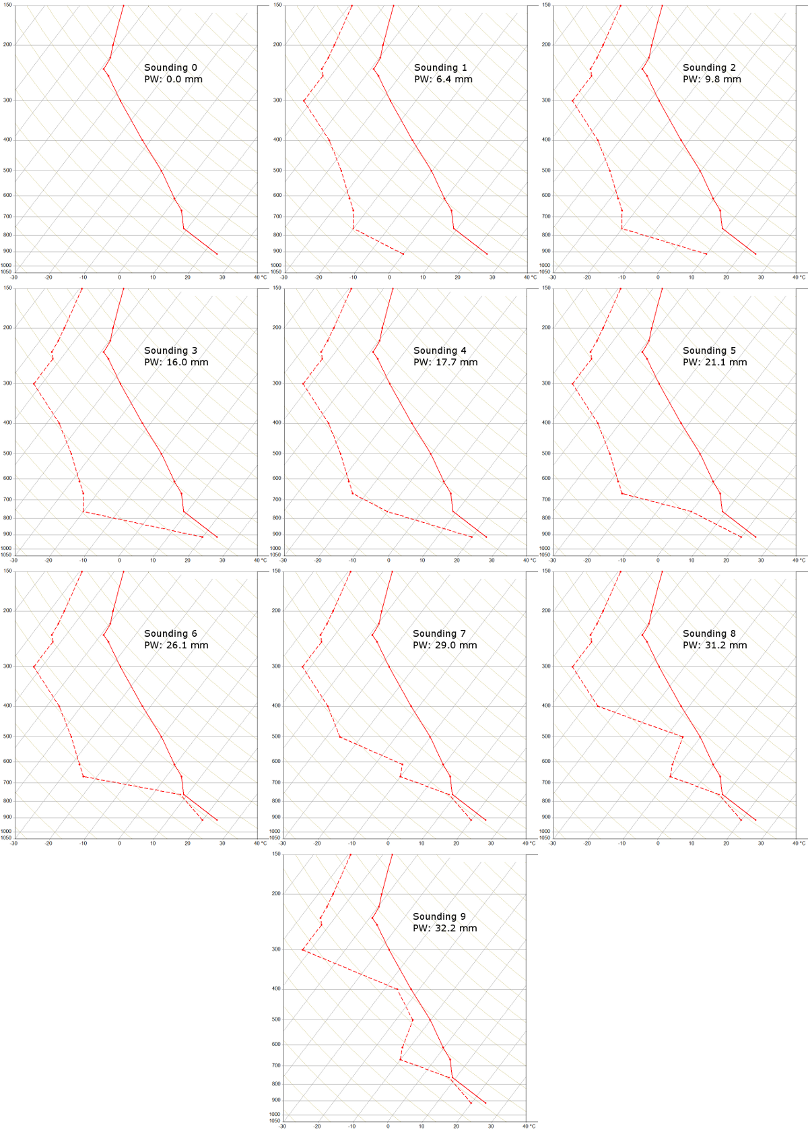
Figure 5. Ten temperature (solid) and dew point (dashed) soundings used in the OPTRAN sensitivity tests. The total precipitable water (PW) is indicated for each one. Sounding 0 contains no water vapor, so a dew point profile was not plotted. The temperature profiles are identical in each sounding.

For the initial set of simulations, all absorbing species besides water vapor are removed; the results are shown in Fig. 6. For sounding 0 (zero water vapor), the 10.35 and 11.2 µm brightness temperatures are the same, verifying that no differential absorption is occurring in the atmosphere (by design). For each additional sounding having increasing PW, the 11.2 µm brightness temperature decreases more rapidly than the 10.35 µm brightness temperature, and the magnitude of the difference is about 1.3 K for sounding 9. This shows that water vapor indeed preferentially absorbs radiation in the 11.2 µm band compared to the 10.35 µm band, and that 10.35 µm is a cleaner channel in terms of water vapor. Referring back to Soundings 8 and 9 in Fig. 5, note that the only difference is an increase in the dewpoint in the 400-500 hPa range. Fig. 6 shows that this mid-level increase in moisture causes very small cooling at both 10.35 and 11.2 µm, showing that low-level dewpoint increases have a more significant impact on satellite-observed brightness temperatures than mid- or upper-level moisture changes.

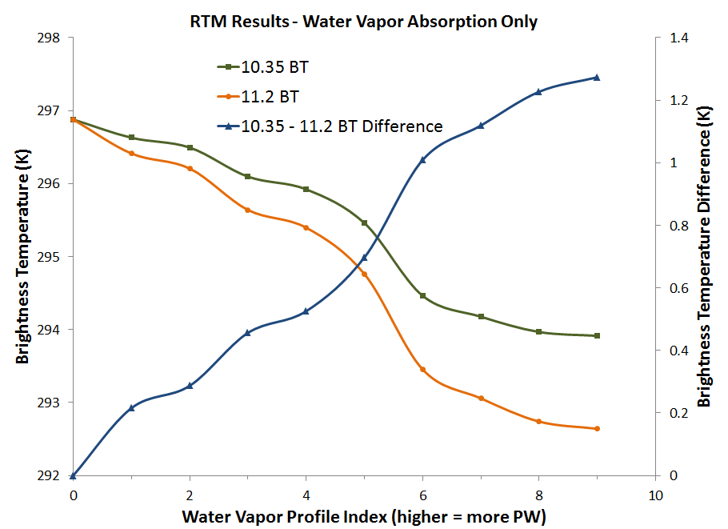
Figure 6. Simulated brightness temperatures at 10.35µm (green) and 11.2 µm (orange), and the brightness temperature difference between 10.35 and 11.2 µm (blue) from OPTRAN, using the 9 different input soundings shown in Fig. 5. Water vapor is the only absorbing gas used in these simulations.

Increasing the complexity, Fig. 7 shows the results after allowing dry gas absorption in addition to water vapor. The water vapor-only results are shown again with the light shaded lines for reference. Note that the 10.35 µm brightness temperatures cool about 0.5 K for all water vapor amounts, while the 11.2 µm brightness temperatures cool only a fraction of 1 K. This effect is consistent with the LBLRTM’s cooling due to carbon dioxide absorption. Given the 0.5 K cooling, the 10.35 µm brightness temperatures are cooler than the 11.2 µm brightness temperatures for soundings 0 to 3, but for the remaining sounds, cooling due to water vapor absorption exceeds 0.5 K and the 11.2 µm becomes cooler than the 10.35 µm values.

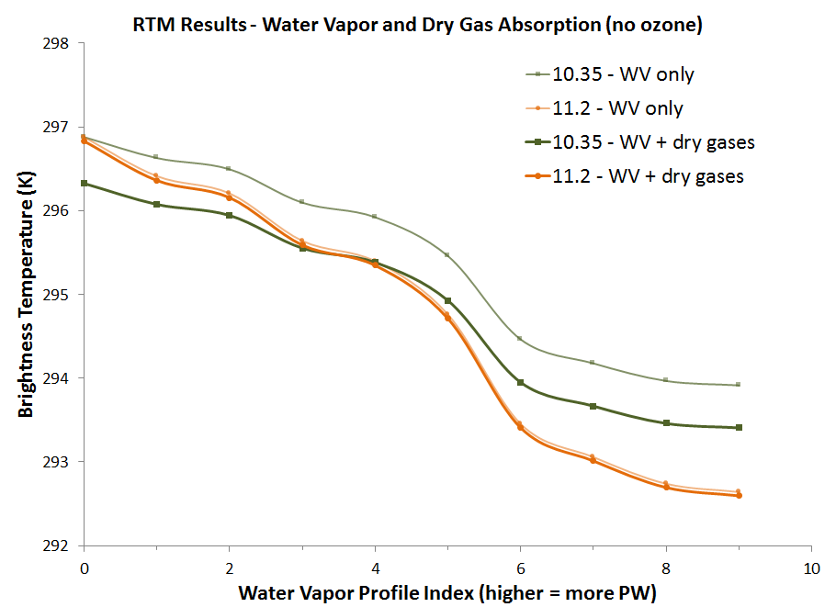
Figure 7. Similar to Fig. 6, except that dry gas absorption is added. The light green and orange lines show the same data as in Fig. 6 for reference, and the dark green and dark orange lines show the results including both water vapor and dry gas absorption.

For the final set of experiments, all absorbing species (water vapor, dry gases and ozone) are included (Fig. 8). Ozone provides no cooling at 11.2 µm because no ozone absorption lines exist within its SRF (Fig. 4c), but the 10.35 µm brightness temperature cools an additional 0.2 K for all water vapor values. The net result of dry gas and ozone absorption is therefore a 0.7 K cooling at 10.35 µm and only negligible cooling at 11.2 µm.
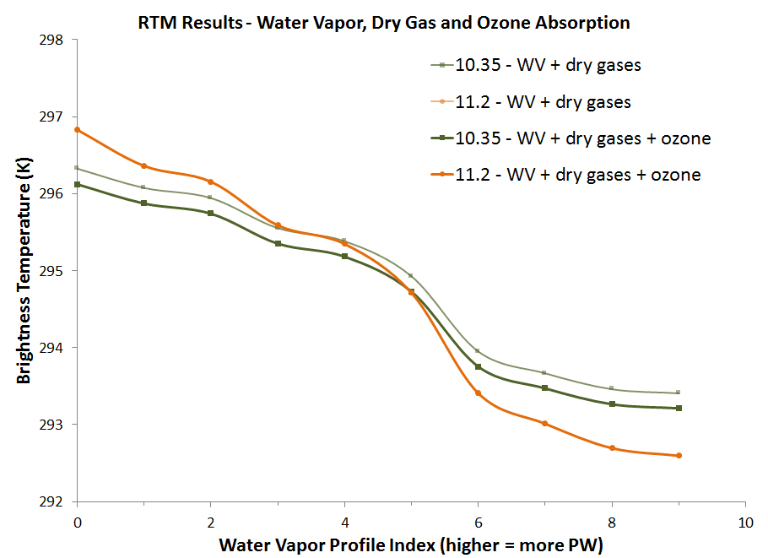
Figure 8. Similar to Fig. 7, except that the dark green and orange lines show the results including all absorbing species (water vapor, dry gases, and ozone).

3. Other Factors
In addition to gaseous absorption, outgoing radiation may be absorbed or scattered by cloud particles, and the characteristics of absorption and scattering are strongly a function of wavelength. Figure 9 shows the imaginary portion of the index of refraction, which is proportional to absorption, for liquid water and ice. Absorption by liquid water and ice is very similar near 8.5 µm, slightly different around 10.35 µm, and the most different at 11.2 µm, with ice being a more effective absorber. Strabala et al. (1994) suggest taking advantage of these absorption characteristics between 8 and 12 µm in order to retrieve cloud properties, such as cloud phase. In particular, the GOES-R Cloud Phase algorithm makes use of the ratio of derived spectral emissivities at the 8.5 µm and 11.2 µm bands (Pavolonis 2010 and http://www.goes-r.gov/products/ATBDs/baseline/Cloud_CldType_v2.0_no_color.pdf). Other GOES-R cloud property retrieval algorithms make use of various combinations of ABI bands between 8.5 and 13.3 µm, including both the 10.35 µm and 11.2 µm bands.
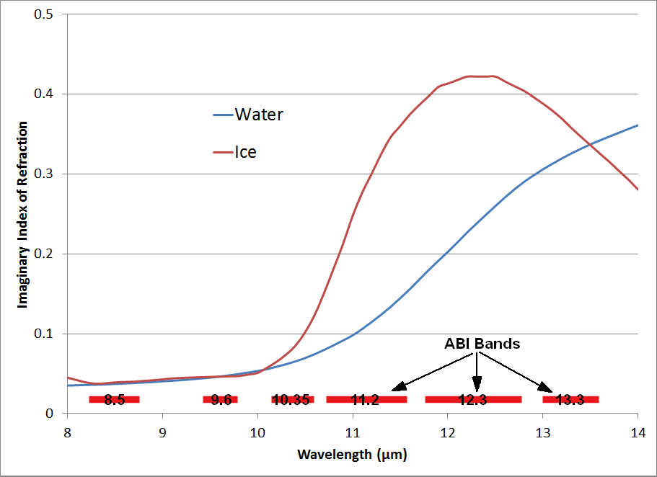
Figure 9. Imaginary index of refraction for ice (red) and liquid water (blue) as a function of wavelength. Also shown are the wavelength ranges covered by the bands on the Advanced Baseline Imager within this wavelength range.
Another variable that must be considered for satellite remote sensing applications is land surface emissivity. Seemann et al. (2008) introduced a global land surface emissivity database having high spectral and spatial resolution. Their Figure 4 shows that emissivity values vary greatly in the wavelength range between 8 and 12 µm. It is therefore critical to use this a priori information when retrieving atmospheric properties for all situations besides the instance of optically thick clouds.
These bands can also be affected by dust and other aerosols, although the details of which are not covered here (Sokolik et al. 1993).

4. Summary
The GOES-R ABI will have two window IR bands at 10.35 and 11.2 µm, and given that a channel centered near 10.35 µm has never been aboard a broad-band space-borne imager, research is needed to understand the relative advantages of each band. Three questions were introduced earlier, and are repeated here with answers.
1) What are the relative advantages of the 10.35 µm and 11.2 µm channels?
More outgoing radiation at 11.2 µm is absorbed and re-emitted by water vapor compared to 10.35 µm, making the 10.35 µm a “cleaner” channel with respect to water vapor absorption. There is also a very small amount of ozone and carbon dioxide absorption at 10.35 µm, but the amount of cooling that results is typically less than 1 K and could be corrected for due to the homogeneity of ozone and carbon dioxide. The 11.2 µm channel is useful in many cloud property retrievals due to the cloud particle absorption characteristics in this wavelength range.

2) Should 10.35 µm or 11.2 µm be the default atmospheric window IR band on the ABI?
Since the 10.35 µm band is cleaner than the 11.2 µm band, we recommend that forecasters default to the 10.35 µm band when simply looking at a window IR loop. But when a more detailed physical retrieval is being designed, characteristics of both bands need to be carefully considered. That said, both bands (in fact all bands from the ABI) are planned to be available for use by forecasters and others.

3) For algorithm development, which window band is more appropriate, or should both be used?
In general, both bands should be considered for use when designing GOES-R ABI algorithms, as each have unique advantages and characteristics depending on the particular application. Combining the information from both bands might be the preferred approach.

Acknowledgements

[I will add acknowledgements before submitting this—should include a thanks to the GOES-R Project Office.] The views, opinions, and findings in this report are those of the authors, and should not be construed as an official NOAA and or U.S. Government position, policy, or decision.
REFERENCES

Schmit, T. J., M. M. Gunshor, W. P. Menzel, J. Li, S. Bachmeier, and J. J. Gurka, 2005: Introducing the Next-generation Advanced Baseline Imager (ABI) on GOES-R. Bull. Amer. Meteor. Soc., 8, 1079-1096.
Goodman, S. and co-authors, 2012: The GOES-R Proving Ground: Accelerating User Readiness for the Next Generation Geostationary Environmental Satellite System. Bull. Amer. Meteor. Soc., accepted.
Nerry, F., J. Jabed, and M. P. Stoll, 1990: Spectral properties of land surfaces in the thermal infrared. 2. Field method for spectrally averaged emissivity measurements. J. Geophys. Res.-Solid Earth and Planets, 95, 7045-7054. DOI: 10.1029/JB095iB05p07045.
Hilton, F. and co-authors, 2012: Hyperspectral Earth Observation from IASI: Five Years of Accomplishments. Bull. Amer. Meteor. Soc., Volume 93, Issue 3, pp. 347-370. doi: http://dx.doi.org/10.1175/BAMS-D-11-00027.1
King, M. D., W. P. Menzel, P. S. Grant, J. S. Myers, G. T. Arnold, S. E. Platnick, L. E. Gumley, S. Tsay, C. C. Moeller, M. Fitzgerald, K. S. Brown, and F. G. Osterwisch, 1996: Airborne scanning spectrometer for remote sensing of cloud, aerosol, water vapor, and surface properties. J. Atmos. Ocean. Tech., 13, 777-794.
Hannon, S., L. L. Strow, and W. W. McMillan, 1996: Atmospheric infrared fast transmittance models: A comparison of two approaches. Proceedings of SPIE, 2830, 94-105.
Clough, S. A., M. W. Shephard, E. J. Mlawer, J. S. Delamere, M. J. Iacono, K. Cady-Pereira, S. Boukabara, and P. D. Brown, Atmospheric radiative transfer modeling: a summary of the AER codes, Short Communication, J. Quant. Spectrosc. Radiat. Transfer, 91, 233-244, 2005.

Clough, S.A., M.J. Iacono, and J.-L. Moncet, Line-by-line calculation of atmospheric fluxes and cooling rates: Application to water vapor. J. Geophys. Res., 97, 15761-15785, 1992.
Clough, S.A., F.X. Kneizys, L.S. Rothman and W.O. Gallery, Atmospheric spectral transmittance and radiance:FASCOD1B, In Proceedings of the SPIE 277, 152, 1981.
Rothman, L. S., I.E. Gordan, A. Barbe et al., The HITRAN 2008 molecular spectroscopic database, Journal of Quantitative Spectroscopy and Radiative Transfer, vol. 110, pp. 533-572 (2009).
McMillin, L.M., L.J. Crone, M.D. Goldberg, and T.J. Kleespies, 1995: "Atmospheric transmittance of an absorbing gas, 4: OPTRAN: A computationally fast and accurate transmittance model for absorbing gases with fixed and variable mixing ratios at variable viewing angles." Appl. Opt., 34, 6269-6274.
Strabala, K. I., S. A. Ackerman, and W. P. Menzel, 1994: Cloud properties inferred from 8-12-µm data. J. Appl. Meteor., 33, 212-229.
Pavolonis, M. J., 2010: Advances in extracting cloud composition information from spaceborne infrared radiances – A robust alternative to brightness temperatures. Part I: Theory. J. Appl. Meteor. Climat., 49, 1992-2012.
Seemann, Suzanne W.; Borbas, Eva E.; Knuteson, Robert O.; Stephenson, Gordon R. and Huang, Hung-Lung. 2008: Development of a global infrared land surface emissivity database for application to clear sky sounding retrievals from multispectral satellite radiance measurements. J. Appl. Meteor. Climat., 47, 108-123.
Sokolik, I., Andronova, A., and Johnson, T. C.: Complex refractive index of atmospheric dust aerosols, Atmos. Environ. A, 27, 2495–2502, 1993.

Corresponding author address: Daniel T. Lindsey, CIRA/Colorado State University, 1375 Campus Delivery, Ft. Collins, CO 80523-1375; email: Dan.Lindsey@noaa.gov

