Thermodynamic Evolution of the Hurricane Inner-Core during Eyewall Replacement Cycles and the Ramifications of the Relict Wind Maximum

Matthew Sitkowski*,1,3, James P. Kossin2,3, Christopher M. Rozoff 3, and John Knaff 4

1Department of Atmospheric and Oceanic Sciences, University of Wisconsin- Madison, Madison, WI

2NOAA’s National Climatic Data Center, Asheville, NC

3Cooperative Institute for Meteorological Satellite Studies, University of Wisconsin-Madison, Madison, WI

4NOAA/NESDIS Regional and Mesoscale Meteorology Branch, Fort Collins, CO

*Corresponding author address: Matthew Sitkowski, Cooperative Institute for Meteorological Satellite Studies, University of Wisconsin-Madison, 1225 West Dayton Street, Madison, WI 53706 E-mail: matts@ssec.wisc.edu

Jim Kossin, Cooperative Institute for Meteorological Satellite Studies, University of Wisconsin-Madison, 1225 West Dayton Street, Madison, WI 53706

Chris Rozoff, Cooperative Institute for Meteorological Satellite Studies, University of Wisconsin-Madison, 1225 West Dayton Street, Madison, WI 53706

John Knaff, NESDIS/STAR – RAMMB, CIRA/Colorado State University, Campus Delivery 1375, Fort Collins, CO 80523-1375

Abstract
Flight-level aircraft data are used to examine inner-core dynamic changes associated with eyewall replacement cycles (ERCs). At the start of an ERC a warm, dry eye is encircled by intense, peaked winds. As the ERC progresses, the storm weakens and the eye undergoes a dramatic moistening and cooling process. The moat, the region between the inner and outer wind maxima, gradually warms and eventually may contain similar relative humidity values of the eye. Near the end of an ERC the mean relative humidity difference between the eye and moat can be < 5%, but the mean equivalent potential temperature can be 10 K greater in the eye than in the moat. These two air masses are separated by the inner eyewall remnant circulation, or relict wind maximum, after the completion of the ERC.
The relict wind maximum exists as a subtle departure from the near linear slope of winds from storm center to the radius of maximum wind. Despite the relatively weak winds the relict wind maximum exhibits very high inertial stability. This may restrict horizontal mixing within the post ERC eye, and furthermore, it may restrict subsidence over the storm center, where the minimum central pressure is located. The intensification of the outer eyewall can occur independently of the minimum central pressure behavior and this may result in an anomalous pressure-wind relationship. When the relict wind maximum dissipates the air masses in the eye are free to homogenize and subsidence can resume over the storm center.

1. Introduction
Willoughby et al. [1982] were the first to investigate the axisymmetric physics of eyewall replacement cycles (ERCs). Since their work, an expanding collection of aircraft data and the advent of microwave instrumentation aboard polar orbiting satellites, which provide a view of the inner-core convective structure beneath a cirrus canopy, have revealed that ERCs occur often, especially for major hurricanes [Kossin and Sitkowski, 2009; Hawkins et al., 2006]. The replacement of a weakening, preexisting eyewall by an intensifying, contracting outer eyewall typically produces an intensity oscillation. An expansion of the wind field also coincides with the replacement [Maclay et al., 2008; Sitkowski et al., 2011]. Several observational works have documented these inner-core changes [Willoughby et al., 1982; Willoughby, 1988, 1990; Hawkins et al., 2006; Black and Willoughby, 1992; Houze et al., 2006, 2007; Dodge et al., 1999; Kuo et al., 2009; Sitkowski et al., 2011]. Sitkowski et al. [2011], referred to hereafter as SKR11, provided a comprehensive climatology of ERC intensity and structure changes. Their examination of 24 ERCs revealed that, in general, ERCs could be divided naturally into 3 phases: intensification, weakening, and reintensification. The phase names refer to the behavior of the maximum intensity of the storm. The entire cycle takes on the order of 36 h.
Willoughby et al. [1982] hypothesized that the developing outer eyewall can act as a barrier to high entropy inflow streaming towards the inner eyewall causing it to weaken. This notion is supported by empirical works that have shown equivalent potential temperature (θe) to decrease inward of rainbands located beyond the RMW [Barnes et al., 1983; Powell, 1990a, 1990b]. Furthermore, several studies assert that the outer eyewall consumes high θe air that would have otherwise been consumed by the inner eyewall [Franklin et al., 1993; Barnes and Powell, 1995; Samsury and Zipser, 1995; Zhu et al., 2004; Rozoff et al., 2008; Chen et al., 2011; Zhou and Wang, 2011; Zhou et al., 2011].
Willoughby et al. [1982] and Willoughby [1988] also theorized that the upper-level outflow from the secondary circulation of the outer eyewall moves toward storm center and impinges the outflow of the inner eyewall. Rozoff et al. [2008] derived an analytical solution of the transverse circulation equation associated with a balanced vortex model and showed that the inertial stability of the developing outer eyewall slows and constricts the outflow from the inner eyewall nearer to the outer eyewall than the inner eyewall. Rappin et al. [2011] found that weaker intensification rates occur when the outflow layer was located in a region of high inertial stability.
As inner eyewall convection wanes, it begins to lose its ability to gather angular momentum, tangential winds decrease, and the storm struggles to maintain a centralized warm core [Rozoff et al., 2008]. This spindown process was examined by Montgomery et al. [2001]. They ran several numerical simulations that varied the drag coefficient, intensity, and depth of axisymmetric hurricane-like vortices. Their results broadly confirm theoretical predictions on the magnitude and timing of the spindown as a consequence of friction dissipation. They found the time required for a hurricane-like vortex to reduce its intensity by half decreases as intensity increases. Once the inner eyewall resembles a much weaker, less convective version of itself it is referred to as the relict wind maximum, a term coined by Willoughby et al. [1982]. This paper refers to the relict wind maximum as the inner eyewall remnants at the end of and subsequent hours following an ERC.
Zhu et al. [2004] performed a numerical model simulation that reproduced an ERC during Hurricane Bonnie (1998) and Chen et al. [2011] simulated Hurricane Wilma (2005). Their analyses investigated the inner-core during and post ERC. Their results touch on many key points that will be examined further in this paper. These include: the resiliency of the relict wind maximum, the effects of the inertially stable region of the relict wind maximum, and the impact this feature has on the short-term structure and intensification of the storm. Section 2 briefly describes the dataset used in the study and section 3 provides a general overview of the dynamic evolution of the inner-core during an ERC. Section 4 details the role of the relict wind maximum on the thermodynamic structure and intensification of the inner-core. A summary appears in section 5.

2. Dataset
Flight-level kinematic and thermodynamic aircraft data, a subset of the SKR11 dataset, are utilized. All of the data in this study were collected at a constant pressure surface near 700 hPa. Storm-relative tangential winds and thermodynamic data are distributed into three hundred 0.5-km grid bins from storm center out to 150 km. Instrument wetting errors, a known limitation to the flight-level thermodynamic data, are reduced following a correction outlined by Zipser et al. [1981]. The best-track dataset, a historical record of tropical cyclone 6-hourly hurricane location and maximum intensity estimates, is also utilized [HURDAT; Jarvinen et al., 1984].

3. Inner-Core Evolution During an ERC
The inner-core flight-level thermodynamic structure underwent profound changes for many of the SKR11 ERCs. While inner-core dynamics (e.g., repetitive ERCs or the location of the inversion level in the eye) can induce variability, a general evolution is laid out for each of the 3 ERC phases prescribed by SKR11. Hurricane Rita (2005) is used to illustrate the evolution of the dynamic structure within 100 km of storm center during and after an ERC (Fig. 1).
a. Intensification Phase
At the start of an ERC the inner eyewall typically contains intense, peaked winds with a rapid decrease towards storm center (Fig. 1a). The air in the eye is warm and dry, a stark contrast to the surrounding moist environment (Fig. 1a). The large dewpoint depressions are a result of enhanced warming produced from subsiding air. The flight-level θe profile consists of dual maxima associated with the primary eyewall (Fig. 1a). This structure was identified as Regime I by Kossin and Eastin [2001]. They note that this structure is often observed near maximum intensity.
b. Weakening Phase
The most dramatic inner-core thermodynamic changes occur during the weakening phase. According to Jordan [1961], who documented the thermodynamic changes that take place in the eye of an intense storm when it begins to weaken. A relatively cloud-free eye soon becomes cloud-filled as tangential winds decrease. The eye cools and moistens as the central pressure steadies or rises. As a result of the moistening, θe can increase substantially in the eye creating a maximum near storm center (Fig. 1b). Eye θe may exceed eyewall θe by more than 10 K. Kossin and Eastin [2001] referred to this structure as Regime II. They hypothesized that the transition from Regime I to Regime II occurs because barotropic instability can result in mixing of air between the eye and eyewall. Many of the ERCs examined in SKR11 transitioned from Regime I to Regime II near the end of the intensification phase. The role of this transition as it relates specifically to ERCs however remains an open question.
The θe in the moat, a relatively convection-free region between the inner and outer wind maxim, also increases during this phase due to warming and moistening (Fig. 1b). The warming can be great enough to slightly reduce the relative humidity. In this sense, the moat region is becoming more eye-like at 700 hPa. The relative humidity values of the eye and moat begin to trend toward one another, primarily a result of the drastic moistening in the eye. A vertical depiction of the changes in Rita (2005) appears in Houze et al. [2007]. Dropwindsonde data provides a vertical measurement of moisture content in the eye near peak intensity on 21 Sep. and 24 h later when the storm is weakening. Relative humidity increased in the eye by more than 30% during this period (see Houze et al. [2007], Fig. 2). A moisture profile was also taken in the moat region while the storm was weakening on 22 Sep. and contains similar relative humidity values as the 22 Sep. eye. Although there is no moat profile on 21 Sep. to compare, analysis of the SKR11 ERCs suggests that the moat region undergoes less impressive changes than the eye at 700 hPa. Eventually, the eye and moat may contain similar relative humidity values, but they remain two distinct air masses.
c. Reintensification Phase
During this phase, thermodynamic structure changes of the eye and moat are a continuation from the weakening phase. The eye may be saturated and is still identifiable as a θe maximum (Fig. 1c). The moat continues to warm and dry during this phase. In the case of Rita (2005) the moat is not as well-defined as other ERCs at 700 hPa, but there are unsaturated regions just inward of the outer wind maxima (Fig. 1c). As this phase concludes, the relict wind maximum becomes increasingly difficult to distinguish in the tangential wind profile, but its affects are clearly identifiable as the bulge of θe in the new, larger eye (Fig. 1d).
Composite analysis of 176 flight-level radial legs of relative humidity of the SKR11 ERCs reveals that mean relative humidity in the moat is 15% greater than in the eye at the start of the ERC (first 2 h, 92 legs) and this difference is reduced to less than 5% at the end (last 2h, 84 legs) of the ERC. Despite similar relative humidity values, the composite mean θe in the eye is ~ 10 K greater than in the moat. This difference can be maintained for several hours following an ERC.

4. Relict Wind Maximum Ramifications
Three microwave images capture the inner-core convective structure during and after an ERC in Hurricane Wilma (2005) over a 23 h period (Fig. 2). The inner eyewall at 0152 UTC 20 Oct. is a robust convective feature during the weakening phase and a clear, circular moat is established (Fig. 2a). The weakening of the inner eyewall is rapid. By 0800 UTC 20 October the inner eyewall is more than 10 m s⁻¹ weaker than the outer eyewall (Fig 3a). Despite the intensity difference, a ‘wall’ of high inertial stability, much greater than that of the outer eyewall, is located at the radius of the inner eyewall (Fig. 3a). The reduced radius maintainsthe high inertial stability, which likely restricts horizontal motions and allows the air mass within the inner eyewall to preserve its identity well after the ERC concludes.
Since hurricane reconnaissance flights are typically conducted at constant pressure, the dramatic changes and differences between the eye and moat could be the consequence of the aircraft flying through different air masses separated by an inversion. However, dropwindsonde profiles of temperature and dewpoint taken near storm center on 20 Oct. (not shown) suggest that a pronounced inversion is not present, and that air is saturated from ~730 hPa to near the sea surface with drying evident above that level.
The inner eyewall evolves into the relict wind maximum, a subtle departure from the near linear slope of winds from storm center to the RMW (Fig. 3b). Microwave imagery at 1845 UTC 20 Oct. depicts a slight temperature minimum in the eye that is associated with the relict wind maximum. Warm brightness temperatures that once made up the moat now encompasses much of the new, larger eye (Fig. 2b). Despite its small size and relatively weak winds, the relict wind maximum still encircles a rich θe air mass (>385 K) and the range of θe in the eye exceeds 20 K (Fig 3b). The inhomogeneity of the eye air mass is a remarkable example of how the relict wind maximum may have a role in governing the thermodynamic structure of a post-ERC eye. The inertial stability of the relict wind maximum is still greater than the primary eyewall and θe has increased along the periphery of the eye (i.e., the former moat) (Fig. 3b). Zhou and Wang [2011] argue that this increase is essential in order for the storm to reintensify; the new eyewall must have the ability to maintain a warm core over the former moat and previous eye.
When aircraft sampled the inner-core of Wilma near 1000 UTC 21 Oct., the thermodynamic structure had changed significantly. The relict wind maximum has finally dissipated and inertial stability is significantly lower near storm center (Fig. 3c). In their simulation of Hurricane Wilma, Chen et al. [2011] estimate the dissipation of the relict wind maximum at 2140 UTC 20 Oct. A more homogenous air mass exists in the eye and there is no evidence of convection within the eye at 0056 UTC 21 Oct. (Fig. 2c). The temperature and θe range across the eye is less than 5ºC at 2140 UTC 20 Oct (Fig. 3c). A minimum of inertial stability exists in the eye accompanied by a slight local maximum of θe that signals a transition toward a Regime I profile (Fig 3c).
The relict wind maximum is a resilient feature and can take a long time to spindown. This was observed by Zhu et al. [2004] in their simulation of Bonnie (1998). They found the complete dissipation of the relict wind maximum was required before maximum surface wind speeds increase. However, flight-level data for Wilma, and many other SKR11 ERCs, show that the most intense winds can be located in the outer eyewall, while the relict wind maximum is still present. However, the minimum central pressure of these hurricanes does not decrease in accordance with the increasing wind speeds. The best track data for Wilma shows the intensity of the storm remains 67 m s⁻¹ for 24 h (0600 UTC 20 Oct to 0600 UTC 21 Oct) while the minimum central pressure rises 29 mb (Fig. 4). The rising pressure continues well after the outer eyewall became the primary wind maxima. The former moat region, identified as the warm (blue) brightness temperatures along the periphery of the eye (Fig 2b) and large dewpoint depressions (Fig 3b), suggest that subsidence is strong in the new eye. However, the more saturated air within the relict wind maximum and rising minimum central pressure, suggest that strong subsidence is not occurring near the storm center. The inertial stability of the relict wind maximum may be preventing primary eyewall outflow from subsiding and warming near storm center. In this case, the intensification of the outer eyewall is occurring simultaneously with the weakening of the relict wind maximum, which results in a remarkably atypical pressure-wind relationship develops – 20 to 30 mb lower than typically expected at the times of Fig2a-b [Knaff and Zehr, 2008]. A detailed examination of the pressure-wind relationship specifically for Wilma was conducted by Kieu et al. [2010]. Once the relict wind maximum completely dissipates the inertial stability is greatly reduced and subsidence is less restricted over the storm center. In the case of Wilma, a slight decrease of the best-track pressure is observed just after the dissipation of the relict wind maximum (Fig 4). A new ERC, evident in both microwave (Fig 2c) and flight-level data (Fig 3c), may explain the decrease of the best-track intensity observed at this time.

5. Summary
Flight-level aircraft data are used to examine dynamic changes associated with the 3 phases of ERCs. As a hurricane transitions between intensification and weakening phases, dramatic thermodynamic changes are observed in the eye. The flight-level radial profile exhibits a θe minimum in the eye near storm center (Regime I) due to a dry air mass. This profile transitions to a maximum in the eye (Regime II) at the start of the weakening phase. The transition is detailed by Kossin and Eastin [2001]. The thermodynamic changes in the eye trend toward a more moat-like environment, where the air is closer to saturation. The moat region is also undergoing changes, although they are less dramatic. Moisture increases in the moat, but subsidence-induced warming actually can cause the relative humidity to decrease. This is a trend toward a more eye-like state. Eventually the eye and moat can have similar relative humidity values, but the air masses remain fairly isolated form one another.
Hurricane Wilma (2005) is used as an example to illustrate the effects of the relict wind maximum that some of the SKR11 ERCs exhibited. The relict wind maximum proves to be a resilient feature that produces a region of high inertial stability near storm center that may prevent horizontal mixing within the newly developed eye after an ERC. High inertial stability near storm center may also limit the amount of subsidence from outer eyewall outflow. As a result, pressure can rise even when the maximum intensity of the storm, located in the intensifying outer eyewall, increases. At times, the relict wind maximum is barely detectable in the radial leg tangential wind profile and satellite, microwave, and radar presentations may even suggest the eye contains a homogenous air mass. However, it is believed that a homogenous mass, a return to a Regime I structure, and a decrease in sea level pressure cannot take place until the relict wind maximum has completely dissipated and the inertial stability is minimized near the storm center.

Acknowledgements. This work was supported by XXXXX. Discussion with Jonathon Vigh, Derrick Herndon, and Dan Vimont were very much appreciated. Hua Chen and Da-Lin Zhang provided Hurricane Wilma (2005) Skew-T diagrams. The views, opinions, and findings contained in this report are those of the authors and should not be construed as an official National Oceanic and Atmospheric Administration or U.S. government position, policy, or decision.

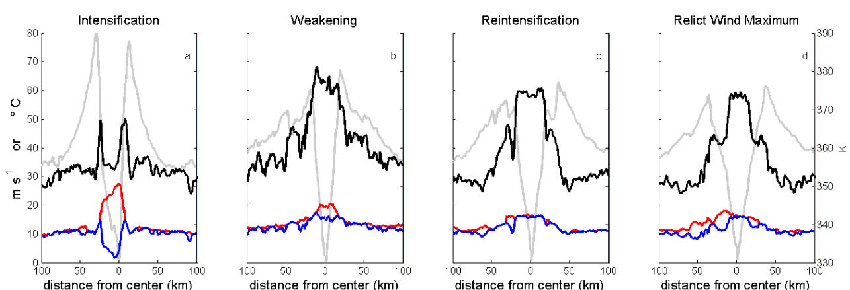
Fig. 1. Flight-level tangential wind, θe, temperature, and dewpoint represented by the gray, black, red, and blue lines respectively for 4 passes though Hurricane Rita (2005). The passes occurred during each ERC phase and one pass captures the relict wind maximum. The aircraft was near storm center on a) 1937 UTC 21 Sep, b) 1619 UTC 22 Sep, c) 0145 UTC 23 Sep, and d) 0600 UTC 23 Sep.

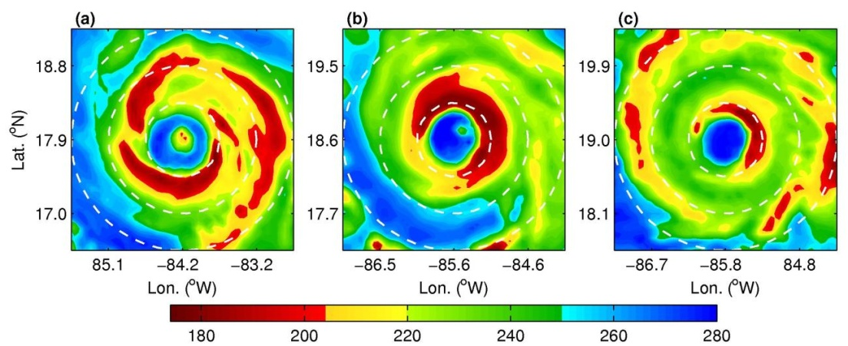
Fig. 2. 300 x 300 km storm-centered 85 GHz SSMI imagery of brightness temperatures (K) taken at a) 0152 UTC 20 Oct, b) 1845 UTC 20 Oct, and c) 0056 UTC 21 Oct. White range rings denote radial distances from storm center of 50, 100, and 150 km.

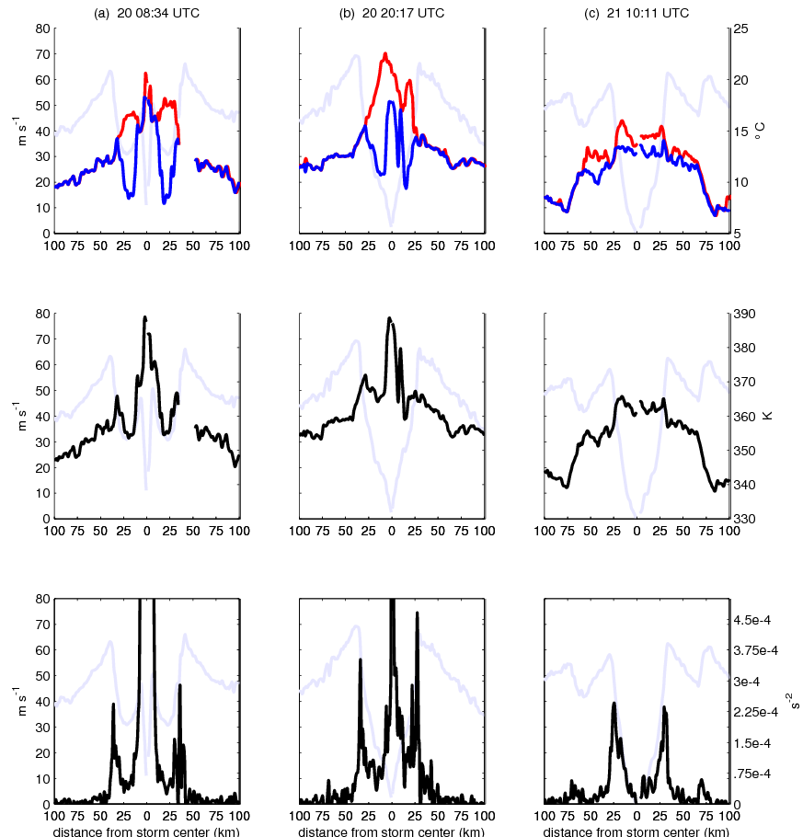

Fig. 3. Hurricane Wilma (2005) flight level aircraft data appears in each column taken near a) 0834 UTC 20 Oct, b) 2017 UTC 20 Oct, and c) 1011 UTC 21 Oct. Top row, temperature, dewpoint, and tangential wind appear as red, blue and gray lines respectively. Middle row, θe and tangential wind appear as black and gray lines respectively. Bottom row, inertial stability and tangential wind appear as black and gray lines respectively. All data was measured from near 700 mb and extends from storm center out 100 km.

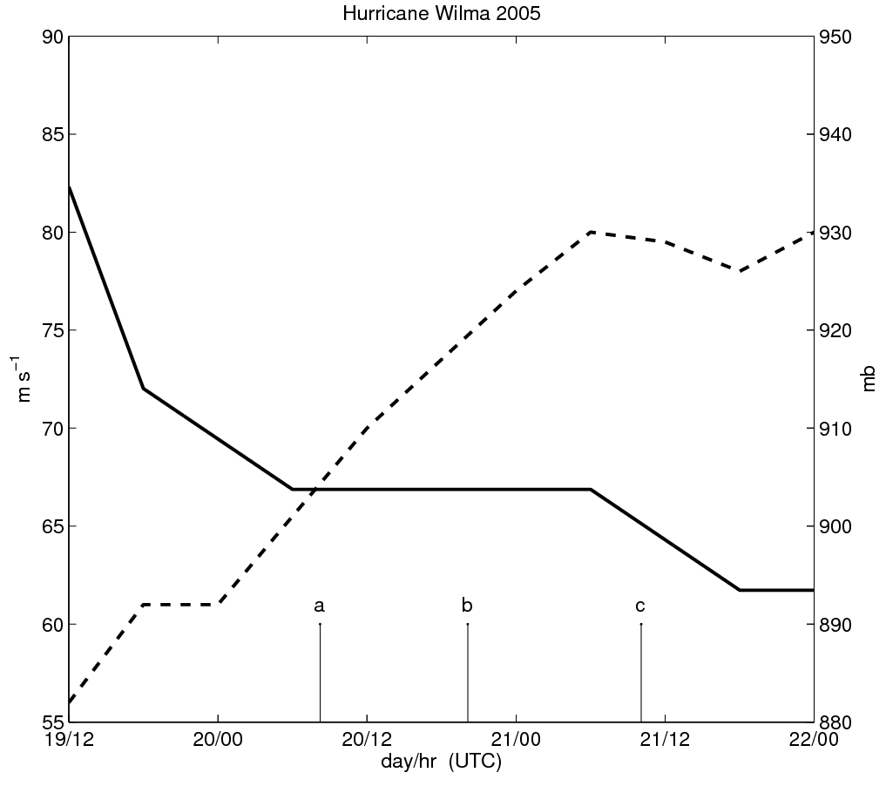
Fig. 4. Hurricane Wilma best-track intensity (solid line, left axis) and pressure (dashed line, right axis). The lettered vertical lines correspond with each column of Fig. 3.

References

Barnes, G. M., D. P. Jorgensen, and F. D. Marks Jr., 1983: Mesoscale and convective structure of a hurricane rainband. J. Atmos. Sci., 40, 2125-2137.

Barnes, G. M. and M. D. Powell, 1995: Evolution of the inflow boundary layer of Hurricane Gilbert
(1988). Mon. Wea. Rev., 123, 2348-2368.

Black, M. L., and H. E. Willoughby, 1992: The concentric eyewall cycle of Hurricane Gilbert. Mon. Wea. Rev., 120, 947-957.

Chen, H., D.-L. Zhang, J. Carton and R. Atlas, 2011: On the Rapid Intensification of Hurricane Wilma (2005). Part I: Model Prediction and Structural Changes. Wea. Forecasting, in press.

Dodge, P. R. W. Burpee, and F. D. Marks Jr., 1999: The kinematic structure of a hurricane with sea level pressure less than 900 mb. Mon. Wea. Rev., 127, 987-1004.

Franklin, J. L., M. L. Black, and K. Valde, 2003: GPS dropwindsonde wind profiles in hurricanes and their operational implications. Wea. Forecasting, 18, 32-44.

Hawkins, J., M. Helveston, T. F. Lee, F. J. Turk, K. Richardson, C. Sampson, J. Kent, and R. Wade, 2006: Tropical cyclone multiple eyewall configurations. Preprints, 27th Conference on Hurricanes and Tropical Meteorology, Monterey, CA.

Houze, R. A., Coauthors 2006: The Hurricane Rainband and Intensity Change Experiment [RAINEX]: Observations and modeling of Hurricanes Katrina, Ophelia, and Rita (2005). Bull. Amer. Meteor. Soc., 87:1503–1521.

Houze, R. A., S. S. Chen, B. F. Smull, W.-C. Lee, and M. M. Bell, 2007: Hurricane intensity and eyewall replacement. Science, 315, 1235-1239.

Jarvinen, B. R., C. J. Neumann, and M. A. S. Davis, 1984: A tropical cyclone data tape for the North Atlantic basin, 1886-1983: Contents, limitations, and uses. NOAA Tech. Memo. NWSNHC 22, Miami, FL, 21 pp. [Available from National Technical Information Service, 5285 Port Royal Rd., Springfield, VA 22151].

Knaff, J.A. and R.M. Zehr, 2008: Reply. Wea.Forecasting, 23, 762-770.

Kossin, J. P., and M. Sitkowski, 2009: An objective model for identifying secondary eyewall formation in hurricanes. Mon. Wea. Rev., 137, 876-892.

Kuo, H.-C., C.-P. Chang, Y.-T. Yang, and H.-J. Jiang, 2009: Western North Pacific typhoons with concentric eyewalls. Mon. Wea. Rev., 137, 3758-3770.

Maclay, K.S., M. DeMaria and T.H. Vonder Haar, 2008: Tropical cyclone inner core kinetic energy evolution. Mon. Wea. Rev., 136, 4882-4898.

Powell, M. D., 1990a: Boundary layer structure and dynamics in outer hurricane rainbands. Part I: Mesoscale rainfall and kinematic structure. Mon. Wea. Rev., 118, 891-917.

Powell, M. D., 1990b: Boundary layer structure and dynamics in outer hurricane rainbands. Part II: Downdraft modification and mixed layer recovery. Mon. Wea. Rev., 118, 918-938.

Rappin, E., M. C. Morgan, and G. Tripoli, 2011: The impact of outflow environment on tropical cyclone intensification and structure. J. Atmos. Sci., 68, 177-194.

Rozoff, C. M., W. H. Schubert, and J. P. Kossin, 2008: Some dynamical aspects of tropical cyclone concentric eyewalls. Q. J. R. Meteorol. Soc., 134, 583-593.

Samsury, C. E., and E. J. Zipser, 1995: Secondary wind maxima in hurricanes: Airflow and relationship to rainbands. Mon. Wea. Rev., 123, 3502-3517.

Willoughby, H. E., J. A. Clos, and M. G. Shoreibah, 1982: Concentric eyewalls, secondary wind maxima, and the evolution of the hurricane vortex. J. Atmos. Sci., 39, 395-411.

Willoughby, H. E., 1988: The dynamics of the tropical cyclone core. Aust. Met. Mag., 36, 183-191.

Willoughby, H. E., 1990: Temporal changes of the primary circulation in tropical cyclones. J. Atmos. Sci., 47, 242-264.

Zhou, X., B. Wang, X. Ge and T. Li, 2011: Impact of Secondary Eyewall Heating on Tropical Cyclone Intensity Change. J. Atmos. Sci., 68, 450-456.

Zhou, X., and B. Wang, 2011: Mechanism of concentric eyewall replacement cycles and associated intensity change. J. Atmos. Sci., 68, 972-988.

Zhu, T., D.-L. Zhang, F. Weng, 2004: Numerical simulation of Hurricane Bonnie (1998). Part 1: Eyewall Evolution and intensity changes. Mon. Wea. Rev., 132, 225-241.

Zipser, E. J., R. J. Meitin, M.A. LeMone, 1981: Mesoscale motion fields associated with a slowly moving GATE convective band. J. Atmos. Sci., 38, 1725-1750.

