AMS Joint Short Course
February 16 & 17, 2022
Instructors Biography

Sherrie Morris NOAA/NESDIS is the GOES-R Series Satellite Training Coordinator & User Liaison with the GOES-R Product Readiness and Operations (PRO) Team at Goddard Space Flight Center and develops a variety of training courses and workshops.

Gary McWilliams NOAA/NESDIS is the JPSS program science training coordinator and is responsible for organizing JPSS participation in technical conferences and the development of training workshops and short courses.

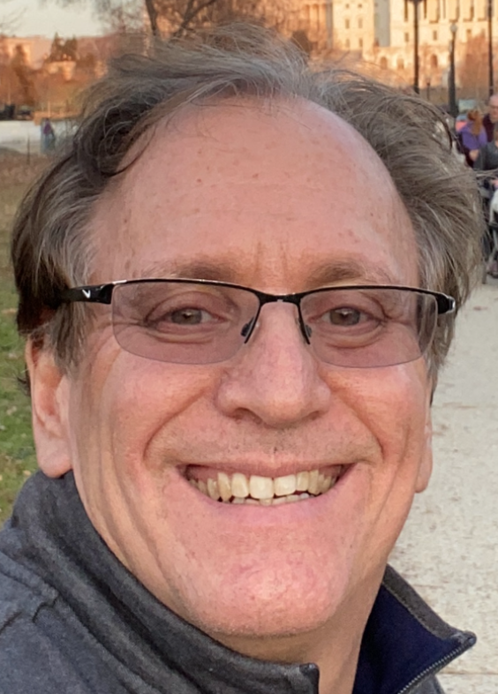
Dr. Mitch Goldberg NOAA/NESDIS
Dr. Mitch Goldberg is the NOAA Senior Scientist for Environmental Satellites. Dr. Goldberg serves as an expert and lead representative of the NOAA/NESDIS science and user communities and coordinates NESDIS applied science.

Dr. Goldberg has received three Gold Medals, one Silver Medal, and seven Bronze Medals from the Department of Commerce including the 2010 NOAA Administrator’s Award for leadership in developing the international Global Space-based Inter-Calibration System (GSICS). He received the University of Maryland Most Distinguished Alumnus Award from the Department of Atmospheric and Oceanic Science in 2004.

He leads the NESDIS Satellite Proving Ground program to improve NOAA services by facilitating collaboration between users and product developers to optimize the use of satellite data. Dr. Goldberg is involved in a number of international coordinating groups including the World Meteorological Organization (WMO), Coordination Group for Meteorological Satellites (CGMS), and the Committee on Earth Observation Satellites (CEOS). Dr. Goldberg is a Fellow of the American Meteorological Society (AMS), and the current chair of the AMS Satellite Meteorological, Oceanography, and Climatology Committee.

Dr. Goldberg earned his B.S. from Rutgers University, and M.S. and Ph.D. degrees from the University of Maryland. His scientific expertise is in developing scientific algorithms to derive atmospheric soundings of temperature and water vapor from satellite platform microwave and infrared sounders.

William Straka II, CIMSS/SSEC
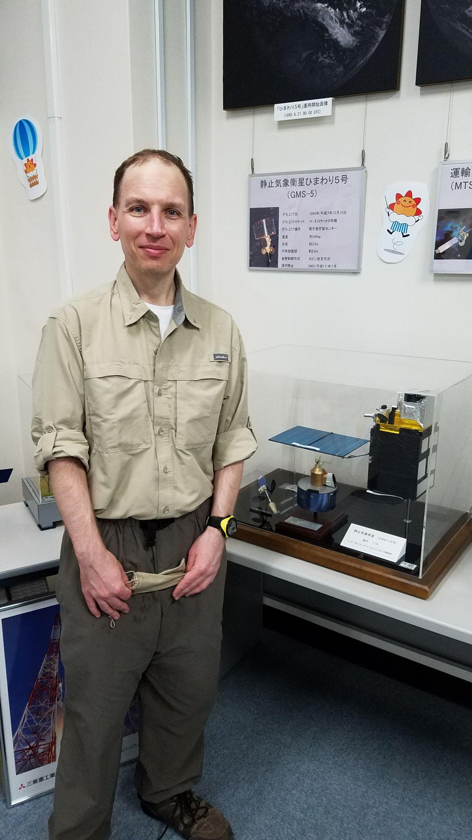
William Straka is a researcher with the Cooperative Institute for Meteorological Satellite Studies (CIMSS), where he has been working for over 15 years. Currently, he focuses on a number of topics, including the utilization of the Day Night Band as well as interacting with the US National Weather Service as well as US and international emergency response stakeholders such as FEMA, IPNE (Brazil) and several agencies within the United Nations regarding the distribution and utilization of the NOAA LEO/GEO Flood Product as other US satellite products for disaster monitoring and response.

Scott Lindstrom, CIMSS at the University of Wisconsin-Madison
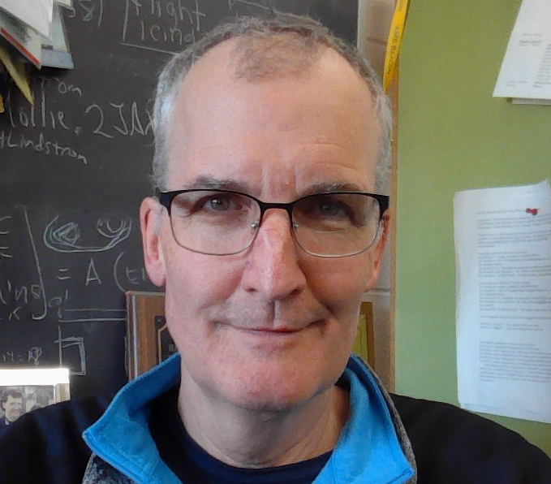
Scott Lindstrom is an Information Technologist and trainer at the Cooperative Institute for Meteorological Satellite Studies (CIMSS) at the University of Wisconsin-Madison. The best part of his job is looking at beautiful satellite imagery every day and describing how its use can help in the forecast process. This is done both in writing on blogs and in training webinars. He holds a B.S. in Meteorology (and one in Computer Science) from Penn State, and an M.S. and Ph.D. in Meteorology from the University of Wisconsin-Madison.
Find him on Twitter: @WxSatChat.

Ivan Csiszar, NOAA/NESDIS/STAR

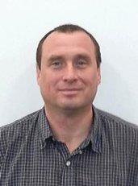
Ivan Csiszar is the Branch Chief of the Environmental Monitoring Branch of the Satellite Meteorology and Climatology Division at NOAA/NESDIS Center for Satellite Applications and Research (STAR). His early research included atmospheric sounding and the retrieval of cloud optical and microphysical properties. He currently works on land surface observations from NOAA’s new generation environmental satellites, with a particular focus on active fire mapping and monitoring from JPSS Visible Infrared Imaging Radiometer Suite (VIIRS) and GOES-R Advanced Baseline Imager (ABI) measurements.

Amy Huff, IMSG at NOAA/NESDIS/STAR
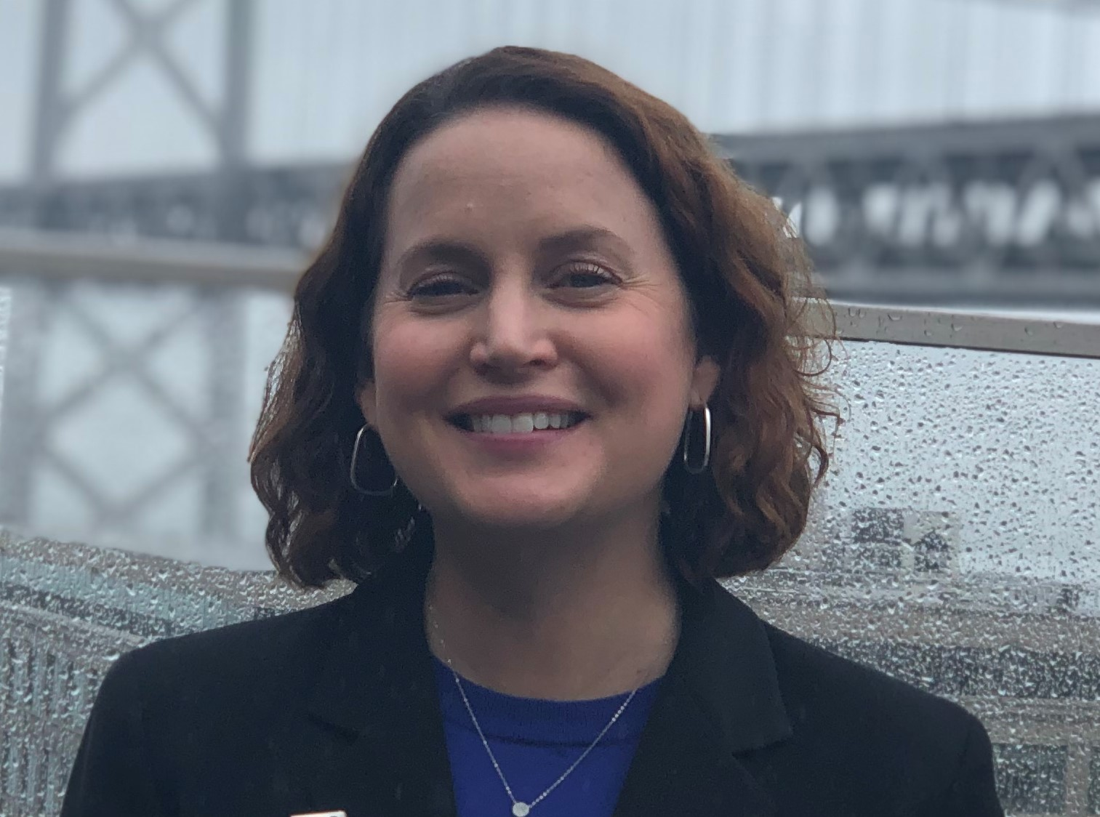
Amy Huff, IMSG at NOAA/NESDIS/STAR
Dr. Amy K. Huff is a Senior Research Scientist at I.M. Systems Group, a contractor for the NOAA NESDIS Center for Satellite Applications and Research (STAR). She has a Ph.D. in chemistry from the University of California at San Diego and a M.S. in meteorology from Penn State. Currently, Dr. Huff is the outreach representative for STAR's aerosol and atmospheric composition science team. She acts as a liaison to satellite data end users and promotes utilization of satellite products through training sessions and social media (Twitter: @AerosolWatch). Her research involves air quality applications of aerosol and trace gas observations from geostationary and polar-orbiting satellites

