JPSS Alaska Summit Meeting
JPSS Training Resources and Reference Materials
*Note: some training resources/materials can apply to multiple applications.
Near Real Time Weather Forecasting Applications (Imagery, Sounding, Aviation, Weather, Fire & Smoke)
CIMSS – Suomi NPP NUCAPS Profiles and ABI Legacy Profiles in AWIPS (2018)
http://cimss.ssec.wisc.edu/goes/blog/archives/27658

NUCAPS Soundings in AWIPS at HWT (Revised, 2018)
www.ssec.wisc.edu/~scottl/NUCAPS2018/presentation_html5.html

Loading NUCAPS and NUCAPS Gridded Data in AWIPS (2018)
https://drive.google.com/file/d/1YB0j9HzYpodGIWY8JaBAR_xCVNcJY4Ys/view?usp=sharing
NUCAPS Quick Guide (2018)
http://cimss.ssec.wisc.edu/goes/OCLOFactSheetPDFs/QuickGuide_NUCAPS.pdf
NUCAPS in gridded AWIPS format for Anticipating Convection (2018)
https://hwt.nssl.noaa.gov/ewp/training_2018/HWT2018_GriddedNucaps_Training.pdf
VIIRS Day Land Cloud Fire RGB Quick Guide (2018)
https://drive.google.com/file/d/1CcNe3f7CQIvFyR21oiiDyyKQI8W53dtU/view?usp=sharing
VIIRS Fire Temperature RGB Quick Guide (2018)
https://drive.google.com/file/d/1qAo-0q-dXvW6Cq5VJku5xFJZ-a4W4d-b/view?usp=sharing
VIIRS Snow/Cloud Discriminator (2018)
https://drive.google.com/file/d/1aQjJ7UYGiazkCgqVWNIYE6_hNFUNTbZu/view?usp=sharing

COMET module: Advances in Space-Based Nighttime Visible Observation (2017) (heavy focus on DNB)
https://www.meted.ucar.edu/training_module.php?id=1327

CIMSS, SSEC: NUCAPS (2017)
http://www.ssec.wisc.edu/~scottl/NUCAPS2017/presentation.html

NUCAPS Training Videos – Gridded NUCAPS (NASA-SPoRT) (2016-2018)
https://drive.google.com/drive/folders/1KC2-ynvBDVMUXdcsKTw2muc2Mg_eyemM?usp=sharing

VIIRS Active Fire Quick Guide (2016)
https://rapidrefresh.noaa.gov/hrrr/HRRRsmoke/VIIRSActiveFireQuickGuide-FinalForm-.pdf

NASA SPoRT Training: JPSS Satellite Products for Extratropical Transition (2016)
https://nasasporttraining.wordpress.com/2016/07/21/jpss-satellite-products-for-extratropical-transition/

VISIT Training: Introduction to NCC DNB VIIRS Imagery in AWIPS (2016)
http://rammb.cira.colostate.edu/training/visit/training_sessions/introduction_to_ncc_dnb_viirs_imagery_in_awips/

VISIT Training: NUCAPS Soundings in AWIPS (2015)
http://rammb.cira.colostate.edu/training/visit/training_sessions/nucaps_soundings_in_awips/

VISIT Training: Use of VIIRS Imagery for Tropical Cyclone Forecasting (2015)
http://rammb.cira.colostate.edu/training/visit/training_sessions/use_of_viirs_imagery_for_tropical_cyclone_forecasting/

VISIT Training: VIIRS Imagery Interpretation of Super Typhoon Vongfong (2014)
http://rammb.cira.colostate.edu/training/visit/training_sessions/viirs_imagery_interpretation_of_super_typhoon_vongfong/

NASA-SPoRT: Gridded NUCAPS Quick Guide (2014)
https://nasasporttraining.files.wordpress.com/2016/03/gridded_nucaps_hwt_sport_quickguide_v2.pdf
VISIT Training: The use of JPSS Soundings in the Forecast Process (NUCAPS) [Youtube Link] (2014)
https://www.youtube.com/watch?v=JpQ0KUJXOhQ&feature=youtu.be

COMET module: Introduction to VIIRS Imaging and Applications (2013)
https://www.meted.ucar.edu/training_module.php?id=1075
COMET module: Advanced Satellite Sounding: The Benefits of Hyperspectral Observation – 2nd Edition (2013)
https://www.meted.ucar.edu/training_module.php?id=1071
VISIT Training: VIIRS Satellite Imagery in AWIPS (2013)
http://rammb.cira.colostate.edu/training/visit/training_sessions/viirs_satellite_imagery_in_awips/

COMET module: Imaging with VIIRS: A Convergence of Technologies and Experience, 2nd Edition (2012)
https://www.meted.ucar.edu/training_module.php?id=953

VISIT Training: MODIS Products in AWIPS (2006)
http://rammb.cira.colostate.edu/training/visit/training_sessions/modis_products_in_awips/

COMET module: Polar Satellite Products for the Operational Forecaster: Microwave Analysis of Tropical Cyclones (2004)
https://www.meted.ucar.edu/training_module.php?id=159

Hydrology, River Ice and Flooding Applications
APRFC - Satellite Hydrology Quick Guide (2018)
https://drive.google.com/file/d/1IPLh4zX-ifzUxlFim1JqYOZlFQ-mCtH9/view?usp=sharing

VISIT Training: CIRA - Advected Layered Precipitable Water (2017)
http://rammb.cira.colostate.edu/training/visit/training_sessions/advected_layer_precipitable_water_product/

COMET module: JPSS River Flood and Ice Products (2016)
https://www.meted.ucar.edu/training_module.php?id=1178

VIIRS Flood Detection Quick Guide (2016)
https://docs.google.com/document/d/1nBZx-6HvtvlT_9YMQVGmFRknmYnKn_PgUd3vDCBwILA/edit?usp=sharing
VISIT Training: AWIPS Blended Rain Rate Product (2012)
http://rammb.cira.colostate.edu/training/visit/training_sessions/awips_blended_rain_rate_product/

VISIT Training: MIMIC TPW (2010)
http://rammb.cira.colostate.edu/training/visit/training_sessions/morphed_tpw_detection/

VISIT Training: Blended TPW Product (2009)
http://rammb.cira.colostate.edu/training/visit/training_sessions/blended_tpw_products/

Oceans and Coasts /Arctic Applications

COMET module: Microwave Remote Sensing: Land and Ocean Surface Applications (2nd Edition) (2015)
https://www.meted.ucar.edu/training_module.php?id=1100

GINA: Alaska Direct Broadcast Quick Guides (2015)
https://drive.google.com/drive/folders/0B5Jv6widBhU1NkdDLWJFT1pMU2M?usp=sharing

NASA-SPoRT: NESDIS Snowfall Rate Product Quick Guide (2014)
https://nasasporttraining.files.wordpress.com/2015/12/qg_sfr_alaska.pdf
VISIT Satellite Chat: Cold Air Aloft Product and synthetic imagery over Alaska (2014)
http://rammb.cira.colostate.edu/training/visit/satellite_chat/20141218/

COMET module: Microwave Remote Sensing: Overview (2nd Edition) (2012)
https://www.meted.ucar.edu/training_module.php?id=979

COMET module: Jason-2: Using Satellite Altimetry to Monitor the Ocean (2009)
https://www.meted.ucar.edu/EUMETSAT/jason/

COMET module: Microwave Remote Sensing Resources (2007)
https://www.meted.ucar.edu/training_module.php?id=260

COMET module: Microwave Remote Sensing: Clouds, Precipitation and Water Vapor (2006)
https://www.meted.ucar.edu/training_module.php?id=226
COMET module: Advances in Microwave Remote Sensing Ocean Wind Speed and Direction (2005)
https://www.meted.ucar.edu/training_module.php?id=184

Miscellaneous Training
COMET Module: Operational Environmental Monitoring Applications using the Community Satellite Processing Package (CSPP) (2018)
https://www.meted.ucar.edu/training_module.php?id=1321
COMET module: JPSS Capabilities and Applications Course (a mix of 4 modules) (2017)
https://www.meted.ucar.edu/training_course.php?id=54

COMET module: SatFC-G: GOES-R Impacts on Satellite Data Assimilation (2016) (includes short JPSS info also)
https://www.meted.ucar.edu/training_module.php?id=1259#.WP4rS_nyupo

VISIT Training: GPM Mission Overview, (2014) http://rammb.cira.colostate.edu/training/visit/training_sessions/gpm_mission_overview/ )
COMET module: How Satellite Observations Impact NWP (2014) https://www.meted.ucar.edu/training_module.php?id=1016#.WP4sUPnyupo
CrIS Temperature, Moisture and Cloud Retrieval User Guide (2013)
https://www.star.nesdis.noaa.gov/smcd/spb/nsun/snpp/CrIS/cris_sdr_USERS_GUIDE_draft12.pdf
COMET module: Multispectral Satellite Applications: RGB Products Explained (2013)
https://www.meted.ucar.edu/training_module.php?id=568

COMET module: Suomi-NPP: A New Generation of Environmental Satellites (2012)
https://www.meted.ucar.edu/training_module.php?id=948
COMET module: Monitoring the Climate System with Satellites (applications focused rather than instrument focused, but includes good amount of polar orbiter info) (2012)
https://www.meted.ucar.edu/training_module.php?id=895

COMET module: An introduction to the EUMETSAT Polar System (2006)
https://www.meted.ucar.edu/training_module.php?id=222

Satellite Foundational Course for JPSS (SatFC-J)
New training to be available, 2018.

JPSS Training Modules
Objective 1: Introduction to Microwave Remote Sensing
- Introduction to Microwave Remote Sensing with a focus on Passive Sensing
- Oxygen and water vapor absorption bands
- Surface Emissivity
- Influence of clouds and precipitation
Objective 2: Introducing Suomi NPP, JPSS, GCOM and GPM.
- Orbits and data availability
- Instrumentation – VIIRS
- Instrumentation – CrIS and ATMS
- Instrumentation – AMSR2
- GPM
Objective 3: Beneficial Products and their Applications
- Uses for imagery
- Day/Night Band (DNB) / VIIRS NCC
- Influence in numerical weather prediction
- NUCAPS

JPSS Product Applications
JPSS Quick Guides (QG) and Quick Briefs (QB)
- ATMS (MiRS) Precipitable Water (Alaska LDM delivery) (QG/QB)
- ATMS (MiRS) Rainfall Rate (Alaska LDM delivery) (QG/QB)
- ATMS (MiRS) Sea Ice Concentration (Alaska LDM delivery) (QG/QB)
- ATMS (MiRS) Snow Water Equivalent (Alaska LDM delivery) (QG/QB)
- GPM GMI Microwave Imagery (36.5 V/H) (QG/QB)
- GCOM AMSR-2 Microwave Imagery (36.5 V/H) (QG)
- GPM GMI Microwave Imagery (89.0 V/H) (QG/QB)
- GCOM AMSR-2 Microwave Imagery (89.0 AV/AH) (QG)
- Jason Significant Wave Height (QG/QB)
- RADARSAT-1 Synthetic Aperture Radar Winds (QG/QB)
- Sentinel-1A Synthetic Aperture Radar Winds (QG)
- VIIRS NCC (QG/QB)
- VIIRS Volcanic Ash: Detection & Height (QG/QB)
- GCOM AMSR-2 Sea Surface Wind (QG/QB)
- VIIRS Active Fires (QG/QB)
- VIIRS Flood Areal Extent (LDM Users Only) (QG/QB)
- NUCAPS (QG/QB)
- Blended TPW (QG/QB)
- Snowfall Rates (QG/QB)
- ATMS (MiRS) Snow Cover (Alaska LDM delivery) (QG)
- GCOM AMSR-2 Sea Surface Temperature (QG)
- GCOM AMSR-2 Total Precipitable Water (QG)
- ATMS (MiRS) Cloud Liquid Water (Alaska LDM delivery) (QG)
- GCOM AMSR-2 Cloud Liquid Water (QG)
- VIIRS Ice Surface Temperature (QG)
- VIIRS Ice Age / Thickness (QG)
- VIIRS Ice Concentration (QG)
- GCOM AMSR-2 Sea Ice Characterization (QG)
- VIIRS Nighttime Microphysics RGB (QG/QB)
- VIIRS Volcanic Ash RGB (QG/QB)
- VIIRS Natural Color (Day Land Cloud) RGB (QG/QB)
- VIIRS True Color RGB (QG/QB)
- VIIRS Daytime Microphysics (QG)
- VIIRS 24-hour Microphysics (QG)

Access Polar Training in the CLC and NOAA VLAB

JPSS Training Modules, access via CLC: http://www.wfm.noaa.gov./e-learning/
JPSS Quick Guides/Briefs and Job Aids access via NOAA VLAB: https://vlab.ncep.noaa.gov/group/stor/home
- For Quick Guides, click Quick Training < Quick Guides < Polar.
- For Quick Briefs, click Quick Training < Quick Briefs < Polar.
- For Job Aids, click Quick Training < Job Aids < Polar.
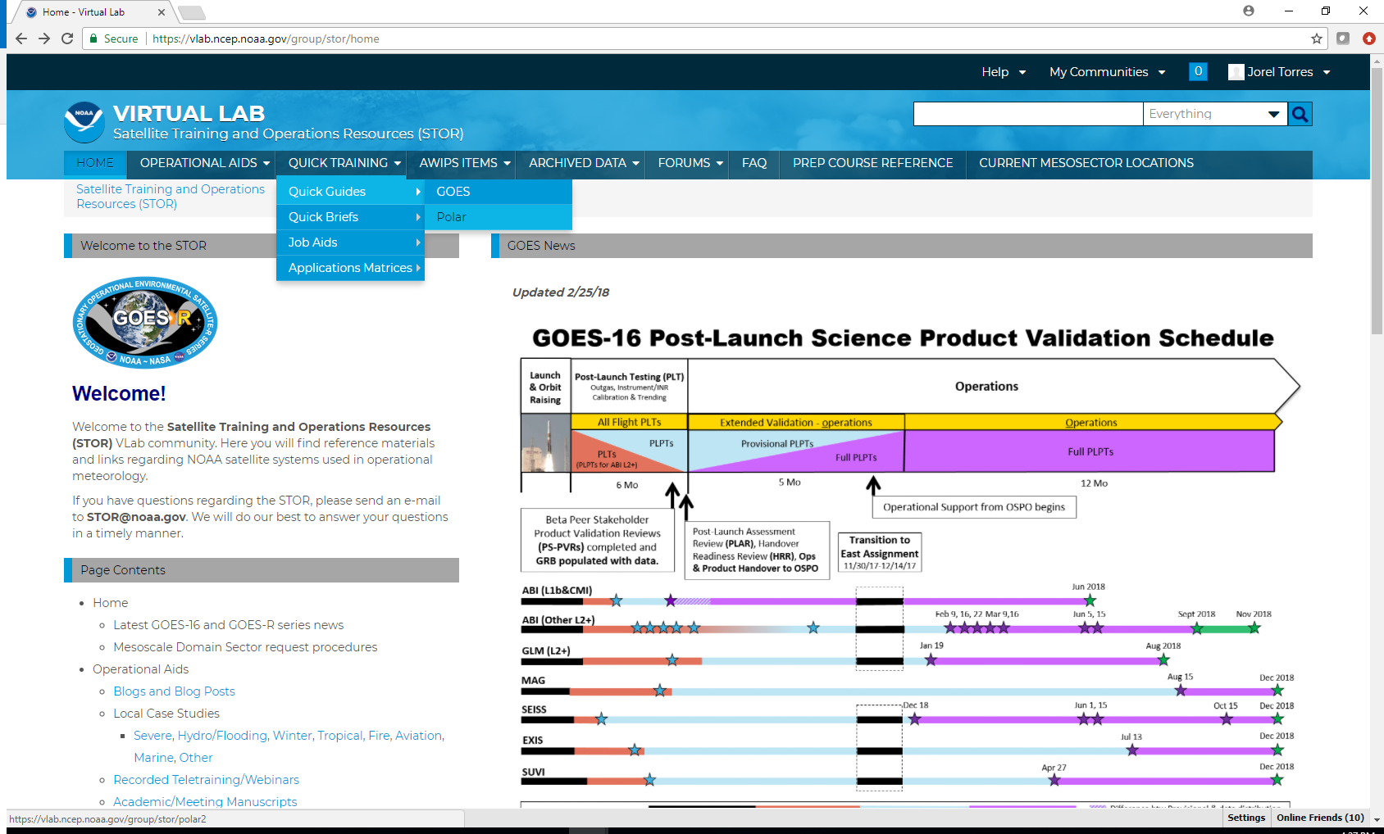
Access Polar Training (for non - AWIPS users)
JPSS Training Modules
- http://rammb.cira.colostate.edu/training/shymet/training_sessions/satfc-j.asp
JPSS Quick Guides / Quick Briefs
- http://rammb.cira.colostate.edu/training/visit/quick_guides/
- http://rammb.cira.colostate.edu/training/visit/quick_briefs/

