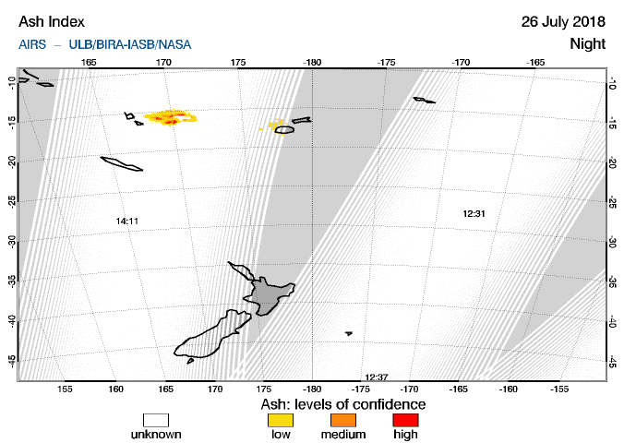

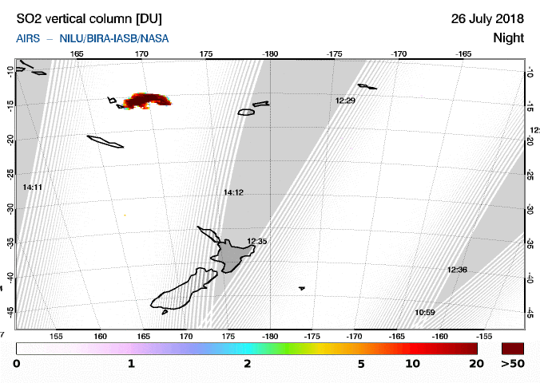

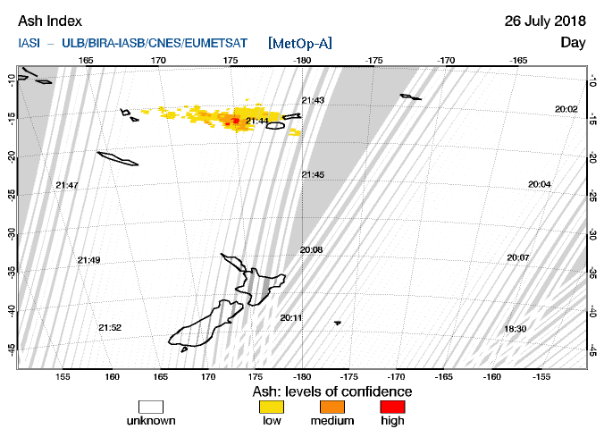

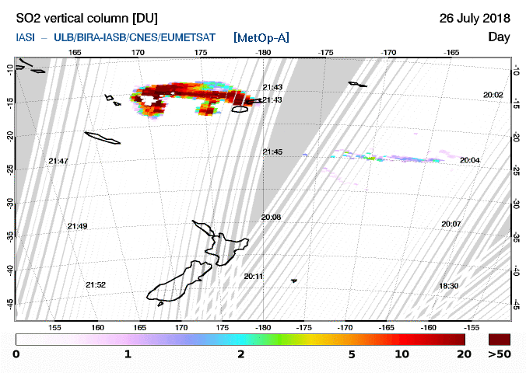

Images courtesy of SACS: El Servicio de Control en Apoyo de la Aviación (SACS para “Support to Aviation Control Service”) hosted by the Royal Belgian Institute for Space Aeronomy (BIRA-IASB) is a project initiated by the European Space Agency (ESA) aiming at supporting the Volcanic Ash Advisory Centers. https://sacs.aeronomie.be/

